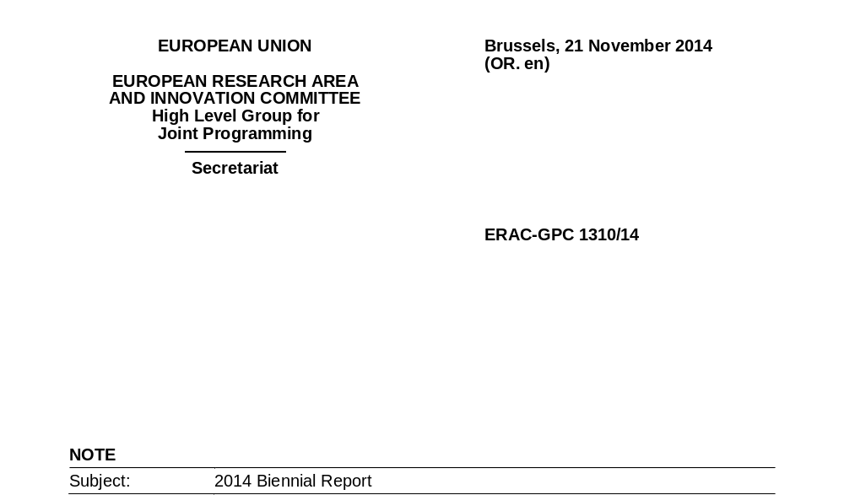
Delegations will find in the annex the 2014 Biennial Report of the High Level Group for Joint Programming (GPC), as adopted by the GPC on 14 November 2014 via written procedure.
Biennial Report 2014 - Team:
Martin Schmid (Lead), GPC Vice-Chair, Austria
Giorgio Clarotti, European Commission
Fulvio Esposito, GPC Chair, Italy
Lutz Gross, GPC Member, Germany
Mogens Horder, JPND, Denmark
Peter Keet, GPC Member, Netherlands
Pat Kelly, GPC Member, Ireland
Kristine Naterstad, GPC Member, Norway
Gunhild Kiesenhofer-Widhalm, GPC Member, Austria

Foreword by the GPC Chair
This Biennial Report marks the transition from the ”start-up” phase to a more mature phase of the GPC life cycle. While the “start-up” phase was mainly dedicated to the identification and selection of the proposals for Joint Programming Initiatives (JPIs), to the launch of the 10 JPIs and to the production of a set of Voluntary Guidelines for implementing the framework conditions for joint programming, the current phase aims at consolidating the strategic role of the GPC as a forum for Member States, Associated Countries and the Commission to oversee the Joint Programming Process. This function corresponds to the wish expressed by the Council to see alignment of national strategies, priorities and research programmes with the jointly agreed strategic research agendas, in order to tackle major societal challenges.
Over the last months, the GPC has gone through a self-assessment of its activities, the results of which are an integral part of this Report. Among other interesting outputs, the exercise indicated a widespread willingness to enhance and streamline the cooperation between the GPC and the other ERA-related Groups, including ERAC, to produce a more comprehensible and coherent picture. Furthermore, the GPC clearly expressed its wish to see its mandate updated, according to the requirements of the new scenario, and to be involved in the preparation of the relevant aspects of the ERA Roadmap.
Now that the ERA, with its priorities, has been established, we can clearly see that the activities conducted by the GPC fit perfectly within priority area 2: “Optimal transnational co-operation and competition”. Indeed, the GPC has recognised ante litteram transnational co-operation as a priority for substantiating EU added value, as witnessed by the recommendations of the ad hoc Working Groups of the GPC. The Working Groups’ recommendations constitute another pillar of this Biennial Report, and the GPC is committed to translating them into operational steps of action in its work programme for the next biennium.
Given the friendly atmosphere based on mutual trust within the Group, I am fully confident that we will achieve our ambitious objective of providing the Council with handy, manageable and feasible solutions.

Finally, I would like to thank all Members and Observers of the GPC for their extraordinary level of activity (both in terms of quantity and quality) during this last biennium, within the Working Groups as well as through their instructive and constructive participation in the debates during the plenary meetings.
Last but not least, I wish to express my gratitude to the members of the ”Biennial Report Team”, passionately led by Mr. Martin Schmid, the GPC Vice-Chair, for preparing a Report that not only summarises our last biennium, but represents an important input to our future actions and activities. I would also like to express my sincere thanks to the Secretariat, led by Mrs Anna Fogiel, who went far beyond what is commonly understood by ”secretarial assistance”.
Fulvio Esposito, chairperson of the GPC

Executive Summary
At the end of the year 2014, all ten Joint Programming Initiatives (JPIs) launched in 2010 -2011 have fully functioning governance systems in place. Eight JPIs have adopted a Strategic Research Agenda (SRA), the remaining two are planning to adopt their SRAs in 2015. Together, the JPIs have launched 25 joint calls or joint actions, many more are being planned or being prepared.
The GPC considers the results mentioned above a remarkable success. However, the GPC also sees these results as representing the achievement of only part of the objectives of the Joint Programming Process (JPP). Following up on the report of the Independent Expert Group and the results of the 2013 Dublin Conference on Joint Programming, the GPC, in its third biennium, has focused on the development of the full potential of JPIs and the JPP.
To this end, the GPC has established new working methods in order to become more operational. Four Working Groups (WGs) were set up in the areas (1) “How to pursue and deepen relations between the GPC and JPIs”; (2) “Alignment”; (3) “Framework Conditions for Joint Programming” and (4) “Measuring JPIs’ Progress and Impact”. Their task was to define more clearly and in detail the objectives of the JPP, and to make recommendations on how they can be achieved. The GPC adopted the final reports of its four WGs in September 2014.
Building on the WGs’ reports, the GPC considers inter alia the following elements as being crucial for the development of the full potential of the JPP:
- Commitment and support from both Member States (MS)/Associated Countries (AC) and the EC towards the JPP and the JPIs must be strengthened;
- As a consequence of the adoption of joint research agendas in the context of Joint Programming, MS (and AC) should follow a strategic approach to, when appropriate, adapt their national programmes, priorities or activities, with a view to implementing changes to improve efficiency and effectiveness of investment in research at the level of Member States and of the ERA as a whole (“Alignment”);
- JPIs must become strategic hubs or platforms for research and innovation in their respective challenge and be used as such by all relevant actors and stakeholders;

- The interoperability of national research systems should be spurred also by reducing the degree of divergence of terminology, rules and procedures for funding R&I throughout MS and AC;
- Effective methods, parameters and indicators for measuring the impact of the JPIs on their respective societal challenge and of the JPP in general must be developed and implemented.
The GPC is planning to install Implementation Groups, in order to build on the work of the previous WGs and to promote and facilitate full implementation of their recommendations. The work of the Implementation Groups should be coherent with the priority area of the ERA “Optimal trans-national co-operation and competition – jointly addressing grand challenges”.
- Work of the GPC
  - The Beginnings
As a follow-up to the Green Paper on the European Research Area (2007), the Communication of the Commission to the Council of 15 July 2008 “Towards Joint Programming in Research: Working together to tackle common challenges more effectively” proposed an ambitious new approach for making better use of Europe's limited public R&D investments through enhanced cooperation to tackle common societal challenges. The Council Conclusions on Joint Programming of 2 December 2008 welcomed the concept and objectives as formulated in the Commission Communication and launched Joint Programming as a Member States-driven process, supported by the Commission, carried out on a voluntary basis and according to the principle of variable geometry and open access.
A dedicated configuration of the European Research Area Committee (ERAC, formerly CREST), the High Level Group for Joint Programming (GPC), was established with a view to identifying and substantiating a limited number of Joint Programming Initiative (JPI) themes. With ten themes selected by the GPC, the Council launched in a first wave four JPIs. In parallel the GPC undertook to develop guidelines on Framework Conditions for Joint Programming. The first Biennial Report (ERAC-GPC 1311/10), covering 2009 and 2010 describes the main achievements on these two principal tasks.

  - Building-up Phase
During the subsequent phase of the Joint Programming Process (JPP), a second wave of six JPIs was launched. The focus at this stage was to build up JPIs, their governing structures and to start their strategic work. Furthermore the GPC adopted new rules of procedures, with an elected chair and vice-chair and a 24-months rolling work programme. An independent Expert Group set up by the Commission analysed the progress of the Joint Programming Process in 2012 and made recommendations as to how Members States (MS), associated countries (AC) and the European Commission (EC) could improve the JPP. The second Biennial Report (ERAC-GPC 1301/13) describes in detail the developments of the building-up phase in the years 2011 and 2012.
  - JPIs ToCoWork
In 2012, the “JPIs ToCoWork” project was launched, with the objective to support the approved JPIs in applying the Framework Conditions. The project was funded under the 7th Framework Programme and was carried out by a multinational consortium. With several workshops and its accompanying analytical work, the project contributed to rationalising the JPP, and to initiating a mutual learning process among JPIs. The results of the “JPIs ToCoWork” project have also been used by the GPC Working Group on Framework Conditions (see below). The manifold documents of the project, which ended in May 2014, can be found on the project’s web site http://www.jpis2cowork.eu/
  - The Dublin Conference
In spring 2013, the Irish Presidency of the EU - in collaboration with the EC - held a conference on Joint Programming which received outstanding attention. Under the title “Agenda for the Future & Achievements to Date”, a large number of representatives from MS, AC, the scientific community and other relevant stakeholders discussed how to further develop and speed up the JPP and steer it in the right direction. The conclusions of the Dublin Conference, as set out by the Irish Presidency, read as follows:

Conclusions
Since its start in 2008, the Joint Programming Process and the Joint Programming Initiatives have gained considerable momentum and have led to the development of strategic research agendas, visions ahead and first joint activities, which in general have taken the form of common calls. Even if these have been the major criteria to prove that the JPIs are functioning, it became evident during the Dublin conference that these steps do not suffice.
The way ahead in Joint Programming has to lead to alignment of national research programmes and implementation. These are the two cornerstones of success.
Despite the tremendous efforts having been invested in Joint Programming so far, the process has come to crossroads: where the concepts and strategies of JPIs have to turn into implementation. Unless concrete steps are taken, the ultimate goal of Joint Programming – achieving societal impact through efficient use of resources in the fields of the grand societal challenges - will not be met.
Barriers need to be overcome at all levels: at the level of the JPIs, which have to prove their impact and added value, at the level of national policy makers, who will have to consider strategic research agendas as instruments to leverage national programmes and at the level of the European Commission, who is asked to clarify the whole “ERA picture” and to enable maximum synergies with Horizon 2020.

The time is now to move forward to real cross-border alignment of strategies and research programmes and their joint implementation. Single calls will not bring the process further, but real dedication and commitment to joint work and joint outputs through Joint Programming. Thus, everyone involved in Joint Programming is asked to step up efforts and to be open to new approaches and ways of working together

  - New Working Methods
Considering the need for intensified work for the GPC in the light of the recommendations given by the Expert Group and the Dublin Conference, the GPC started a process of improving its working methods and making its work more effective and efficient.

It was taken into account that the GPC is the platform facilitating the JPP in general as well as the establishment and implementation of JPIs in particular, and that it should act as an intermediary between politics, policies and practice. Therefore cooperation and interaction should be strengthened with JPIs, national (funding) organisations, the EC and other actors at national, multilateral and European level.
The GPC thus adopted an opinion on its functioning and working methods on 6 September 2013 (ERAC-GPC 1304/13). The central point of the opinion is that the GPCs main activities should be pulled by a GPC member (“rapporteur”) responsible for the preparation of GPC discussions, reports, proposals and opinions. Working groups could be formed to support the rapporteurs. Furthermore a strong commitment of GPC members and observers to the work of the GPC is considered crucial for its success.
  - Conclusions from Expert Group Report, Biennial Report, Dublin Conference – Setting up of Working Groups
At its 23rd meeting, held on 21 March 2013, the GPC initiated a reflection on actions that would take forward the JPP, on the basis of the conclusions and recommendations of the Biennial Report and the Dublin Joint Programming Conference, as well as of the findings of the independent Expert Group on the Joint Programming process, which presented its report in October 2012. To build on this, the Irish and the French delegations identified a shortlist of priority actions which the GPC should address in its Work Programme. The rationale behind their selection process was to focus on the main actions for which the GPC could both take responsibility and have an influence on the outcome, and, notably, on actions addressed to the GPC or to its members.
These actions fell into four broad categories:
- securing a sustainable commitment of MS and AC to the JPP and fostering a changed mind-set;
- favouring the development of Strategic Research Agendas (SRAs) and related implementation plans by JPIs;
- promoting the application of the improved Guidelines on Framework Conditions for Joint Programming;

- ensuring that JPIs have a societal impact.
On the basis of the synthesis of these recommendations, the GPC decided to establish Working Groups to bring forward the actions that had been identified. The following four Working Groups (WGs) have been established:
- Relations between the GPC and JPIs
- Alignment
- Framework Conditions
- Measuring JPIs’ Progress and Impact
The WGs started their work in September 2013. Between July and September 2014, they submitted the reports of their findings to the GPC. The GPC adopted the reports by written procedure. The main recommendations are set out below. The full reports are annexed to the Biennial Report (Annexes 1-4).
    - Working Group “How to pursue and deepen relations between the GPC and JPIs’”
The GPC was tasked by the Council with matters relating to the JPP and the JPIs’ organisation and management, including conducting various assessments. From a political perspective, the GPC plays a critical role in ensuring political recognition and support for the JPIs.
The GPC is considered as the forum where exchange of information about developments at national level in priority areas takes place, in order to harmonise national research strategies with the JPIs’ Strategic Research Agendas’ agreed priority areas. The contribution of the JPIs to the completion of the ERA has recently been noted by the Council. In its Conclusions of 20 and 21 February 2014, the Council considered that the development of the ERA Roadmap should take into account alignment, where possible, of national strategies and research programmes with the Strategic Research Agendas of the JPIs.

All JPIs have now established their individual internal structures; therefore it is time to create stronger ties - both vertical and horizontal - between the GPC, JPIs and the Commission services.

Key Recommendations
- A properly structured relationship between the actors involved in Joint Programming is needed
Feedback from the consultations undertaken with the GPC, JPIs and EC officials indicates that there is room for improvement with regard to relations / communications between these three partners in the Joint Programming Process (JPP) in order to ensure the best possible fulfilment of their respective mandates.

- The role of the Commission in supporting the JPP can be further improved
The WG identified the EC as a key player which has both the resources and the ability to bring all parties together. Moreover, under the Treaty, the EC is responsible for taking any useful initiative to promote such coordination to ensure that national policies and Union policy are mutually consistent.

- Stronger political support at Member States level is needed
The JPP should continue to be a Member States-driven initiative. This places an onus on the GPC, as the political and strategic forum for Joint Programming, to have a clear vision and determined and sustained political commitment from the MS. There is a need for a determined and sustained political commitment to ensure that:
- the political environment within the MS is supportive of the work of the JPIs,
- it facilitates the required activities within the MS’ research programming policies and activities, and

- adequate resources (both human and financial) are in place to support active participation of MS in JPIs.
- The 2008 commitment of the MS towards Joint Programming should be renewed and strengthened as soon as possible
- GPC should be the key actor to help promote the implementation of JPIs
Equally, JPIs should consider the GPC as the political forum for addressing their difficulties, not only for registering their achievements and successes. JPIs should work closely with the GPC to address barriers to the implementation of their SRAs and to the alignment of national research and innovation agendas.
- Active participation by Member States and Associated Countries is needed
The WG considers that active participation by all MS which join JPIs is vital in order to promote cohesion, to maintain a high level of interest in Joint Programming, and to maximise the utilisation of resources. It is therefore important to keep the opportunity of future participation by MS open in JPIs. The principles of Open Access and Variable Geometry are valuable features of Joint Programming and should be enshrined in future Joint Programming mandates needed to secure sustainable commitment of the MS in this process.
    - Working Group “Alignment”
A crucial element of the Joint Programming Processes is the alignment of national and European strategies and research programmes with the Strategic Research Agendas of Joint Programming Initiatives. In view of reaching a better common understanding of alignment in the context of Joint Programming, the WG was tasked with drafting a report to the GPC.
The WG developed the following common definition of alignment:
“‘Alignment’ is the strategic approach taken by Member States’ to modify their national programmes, priorities or activities as a consequence of the adoption of joint research priorities in the context of Joint Programming with a view to implementing changes to improve efficiency of investment in research at the level of Member States and ERA.”

The state of alignment for a particular JPI changes and develops over time. This ongoing process of alignment is in line with the three phases of the Joint Programming Process as described in the Expert Group Review of 2012. However, the aim - i.e. the definition - of alignment of the SRAs of national programmes with the SRA of a JPI, in order to address the societal challenge in the best possible manner, is the same for all JPIs.
Key Recommendations
- … for the Member States for achieving alignment:
- Stronger inter-ministerial coordination involving commitment and funding.
- Development of a coordinated approach for institutional and project-based funding.
- Alignment is catalysed when there is a national top-down programme/strategy in the respective domain.
- … for the JPIs for achieving alignment:
- JPIs should look into aligning all actions spanning the programming cycle: from joint foresight, development of strategic research agenda to joint processes of research practices, funding, implementation and ex-post evaluation.
- Good practices of alignment should be further developed and eventually become best practices, shared among JPIs and promoted throughout Member States.
- … for alignment in the perspective of ERA and the role of alignment in the coherence of Horizon 2020 and JPIs
- Joint Programming is the most strategic and all-encompassing process developed within the ERA so far, and has the potential to be the vehicle for the other, more operational, elements of ERA.
- JPIs should become platforms for strategic programming and foresight for Member States working jointly together according to the identified good practices for alignment. This would be comparable to how the European Commission proceeds with the internal strategic programming of the Horizon 2020 Work Programmes.

- The European Commission should facilitate the process of alignment in Joint Programming. It could do so by mapping, monitoring and evaluating the synergetic actions taken in the domains of societal challenges between Member States and between Member States and the EU-level.
- … for monitoring of the progress of alignment
- The JPI should continuously define which good practices for alignment it will apply and then monitor their implementation. In due course, it can then test different alignment activities. Overall, JPIs will gain experience, and a growing number of good practices will be applied and implemented.
- Each MS should identify how much its own “programmes, priorities and activities” have changed since its commitment to the JPI and/or the adoption of the SRA, e.g. changes concerning the research content, the volume of research, the way the programme/activity is executed, and the research output.
- … for the role of the GPC for achieving alignment:
- It is essential that the GPC monitors and follows up on the alignment activities by MS and JPIs as recommended by this Working Group. The role of the GPC would not be to monitor alignment accomplished in different JPIs or in the different Member States, but to develop a common approach for monitoring alignment.
    - Working Group “Framework Conditions for Joint Programming”
The Council of the EU, in its Conclusions of 29 November 2010, welcomed the Voluntary Guidelines (VG) for Framework Conditions on Joint Programming and encouraged “their regular review in the light of new experience of the JPIs in applying them”. On the basis of this mandate by the Council, the GPC set up a Working Group to carry out such a review. The WG attempts to point out issues with regard to the Framework Conditions which are important for the further development of JP and JPIs, with a view to significantly contributing to the enhancement of the European Research Area.

The WG wishes to clearly point out that the term “Framework Conditions” has two aspects, both of which are covered by the VG to varying degrees. These two aspects have been named “Joint Programming Functions” and “Enabling Environment”. Whereas the former addresses the components of the “Joint Programming cycle” which have to be implemented by the JPIs, the latter addresses the “environmental conditions” for this implementation within the ERA. The two aspects are closely interdependent, and the WG has neither managed, nor intended to, avoid a certain overlap between them throughout the report. However, the WG considers that outlining and differentiating between these two aspects is vital for the future work of the GPC.
Key Recommendations:
- Joint Programming is a learning process. Its ambition is to substantively change the way to cooperate in the ERA. The JPIs are, or should be, strategic hubs or platforms for research and innovation in their respective challenge. Such an undertaking cannot be designed on the drawing board, but needs to be developed over time. Trust must be built, and new forms of collaboration must to be created. We therefore call for continued and determined commitment by all actors and stakeholders in the process.
- The degree of divergence of rules and procedures for funding R&I throughout MS and AC is such that it considerably impedes transnational collaboration in the ERA. The WG therefore calls for steps towards simplification of these rules and procedures, and for developing common guidelines on terminology, rules and procedures for R&I funding, to be applied throughout the ERA on all levels on a voluntary basis. The Horizon 2020 funding rules could be used as a basis for the discussion on such common guidelines.
- A well-balanced governance system which provides effective leadership is a prerequisite for success in achieving the objectives of a JPI. Continuous evaluation of the effectiveness of the governance system of each JPI is needed, taking into account developments or change of priorities over time. Furthermore we call for an open, transparent and inclusive approach in the JPI, while maintaining the principle of variable geometry for joint activities.
- The strategic process of translating an identified grand challenge into joint activities is the core task of every JPI. Its main elements are: defining strategic objectives, defining a vision, developing a Strategic Research (and innovation) Agenda, developing an implementation plan. The core elements of the strategic process need to be implemented by every JPI. The strategic process has to be understood as a continuous cycle. All steps need to be revised in the light of new developments and experience gained through implementation.
- Though the focus with regard to implementation of the SRAs or SRIAs has primarily been on the implementation of joint calls, JPIs have already carried out a large variety of joint activities. All these activities aim at the alignment of (national and European) resources. The WG therefore calls for a refined perspective of, and new indicators for, JPIs’ activities. The impact of JPIs should be measured by the amount of resources invested according to the strategic alignment activities of a JPI.
- The ultimate objective of JPIs is to contribute to overcoming societal challenges. JPIs can contribute to this objective by inducing (technological and/or societal) innovation, or by providing evidence (research findings, data) for political decision making. The WG therefore calls for design and implementation of strategies in each JPI with regard to the dissemination and use of research findings, and to innovation.
    - Working Group “Measuring JPIs’ Progress and Impact”
This Working Group’s (WG) mandate included (1) making suggestions for measuring the progress of JPIs (monitoring dimension); (2) making suggestions for assessing the impact of JPIs (ex-post evaluation dimension; and (3) contributing elements for the Terms of Reference of the JPI strategic evaluation foreseen by the Commission in the Horizon 2020 Work Programme for 2014-2015.
The group built on the work on Evaluation of JPIs which was undertaken by nine of the ten JPIs under the Coordination and Support Action (CSA) ”JPI to Co-Work”.
The WG focused its work on the development of a set of indicators and criteria both relevant and easy to use.
For the self-assessment of the JPIs see chapter 2, below.
Key recommendations:
- The purpose of the Self-assessment as well as of the Evaluation foreseen in 2015 is not to undertake a ranking of JPIs, but to assess all JPIs with respect to the Visions they presented to the GPC for their initial selection and with respect to the Council Conclusions which launched them.

- It appears that few JPIs have developed SMART objectives for their impact on the major societal challenge they are addressing. The Commission in its Communication of 2008 “Towards Joint Programming in Research” insisted that the JPIs should endeavour to find such objectives.
- Measuring the societal impact of research and Innovation actions takes time. The ”JPIs to Co-Work” CSA, additional experts consulted by the Working Group, as well as the conclusions from the session on Evaluation of JPIs in the 2013 Presidency Conference on Joint Programming all suggest that a good ”proxy” (i.e. with a strong correlation with future societal impact) is the implication of key stakeholders in the definition and in the governance of the JPI.
  - GPC Self-assessment
On 30 May 2013, the Council adopted a resolution on the advisory work for the European Research Area (doc. 10331/13) in which it agreed to review the ERA-related groups established by ERA. The GPC at its plenary meeting of 19 May 2014 decided to undertake a self-assessment exercise of its activities in order to contribute to the review. The self-assessment was carried out by means of a questionnaire covering all the tasks given to the GPC by the Council. 14 delegations provided answers to the questionnaire. On 18 September 2014, the GPC adopted a report on the self-assessment which is annexed to this report (ERAC-GPC 1307/14).
The Key messages of the self-assessment are the following:
- The GPC found that all the activities it was entrusted with by the Council in its mandate had been addressed. Some of the activities had either been completed successfully or were in progress, while others needed to be enhanced. Moreover, the respondents found that many of the GPC’s activities are of an ongoing nature.

- Although the GPC provides advice which contributes, either directly or indirectly, to the implementation and monitoring of progress of the Innovation Union, and more particularly the ERA, as well as to the debates of the Competitiveness Council, it was found that more high-profile Council level debates on the Joint Programming Process should be organised together with a more active advisory role of the GPC vis-à-vis the initiatives resulting from the Joint Programming Process (JPP).
- The cooperation between the GPC, ERAC and the other ERA-related groups should be enhanced and redesigned according to more formal and structured lines. It should also be backed by increased internal cooperation of all relevant delegates at national level.
- Although the GPC seems to function well, some changes could be useful. More delegates should be more actively involved, especially in context of the well-functioning system of the ad-hoc working groups which are highly appreciated.
- The GPC would wish to see its mandate updated. Should this be decided, the GPC would see itself as a strategic forum discussing not only the JPP, but also other relevant aspects of the European Research Area, in particular the area of transnational cooperation. The GPC would also like to see its role considerably strengthened in relation to the initiatives resulting from the JPP (hereafter "the initiatives").
- The GPC would wish to participate in the preparation of the relevant aspects of the ERA roadmap.
- Achievements of the Joint Programming Initiatives

This chapter does not aim at being a systematic record or ranking of JPI achievements, but rather at highlighting the main lessons learned through the Self-assessments provided by JPIs to the GPC. It will also give a first quantitative estimate feed-back on the commitments already made or foreseen by JPIs.

The questionnaire was designed by the GPC Working Group on JPI Progress and Impact, together with experts from the ”JPI to Co-Work” project. It comprised a descriptive part identifying the JPI’s Challenge, its EU Added Value, its Contribution to the European Research Area (the ERA) and its usage of Framework Conditions for Joint Programming, as described in the Guidelines adopted by the Competitiveness Council in 2010.
The questionnaire also asked for some factual descriptors estimating the resources already committed, or foreseen to be invested, in joint calls and joint actions and the Participation of third countries (i.e. non-EU Member States or Countries Associated to the EU Research Framework Programme).

Finally the questionnaire included eight questions addressing three key dimensions:
- The governance of the JPI: This was to ensure that the JPI strategy and joint actions take into account the views of researchers and stakeholders in the governance of the JPIs (through the Scientific Advisory Board and the Stakeholder Advisory Board) to address its Societal Challenge.
- The degree of alignment of national research and innovation programmes, priorities and activities to the JPI Strategic Research (and Innovation) Agendas: This should ensure a real EU added value for a JPI.
- Responsiveness and Innovation: The first JPI research projects were only launched in 2011, so concrete output and results are not available yet. Therefore the GPC Working Group on JPI Impact considered that the involvement of researchers and stakeholders in the governance of the JPIs is the best predictor of an effective impact of a JPI on the Societal Challenge it addresses. This part also explored steps taken by JPIs to consult and involve stakeholders beyond the advisory boards and/or to work on common standards for Intellectual Property Rights to be used by all JPI Joint Calls or Joint Actions.

- Main Lessons from JPI Self-Assessments
2.1.1. The Challenges Addressed
Eight of the 10 JPIs have adopted a Strategic Research (and Innovation, in some cases) Agenda or SR(I)A. The JPIs Urban Europe and JPI Oceans have required more time to map and analyse research in the European Research Area in order to define their agendas later in 2015.
2.1.2 Joint calls and actions
By the end of 2014, the 10 JPIs together will have launched a total of some 25 Joint Calls or Joint Actions, investing about € 200 million of national funds. The Commission supported them with 10 Coordination and Support Actions (CSAs) with a total of € 20 million.
Twenty more calls, or a total of at least € 300 million, are foreseen for the 2015-2016 period. The Commission will support 10 to 12 of these through ERA-NET Cofund actions (as set out in the 2014-15 Horizon 2020 Work Programme) with a total EU funding of about € 80 million.
2.1.3 Third-country participation
Most JPIs are interacting with third countries, i.e. countries which are neither members of the EU nor associated to the EU Research and Innovation Framework Programme, thus witnessing the attractiveness of joint European research when it designs common strategies.
Canada is a formal partner of three JPIs, all in the health area. The United States, Argentina, South Africa, Australia, New Zealand, India and China are currently negotiating their participation in JPIs or in some of their actions, thus ensuring that each continent is currently associated to at least one JPI.
In addition, JPI FACCE (on “Food Safety, Agriculture and Climate Change') is running joint calls or actions with multilateral organisations such as the Belmont Forum.
2.1.4 JPI Governance
For all JPIs, researchers and stakeholders feel they have been fully or partially (around 75%) involved in the definition of the JPI’s agendas and of its priority actions, thus ensuring that the programming of the research reflects the views of both communities.

The involvement of decision makers and key partners has been more challenging.
Several JPIs comment that they miss key players from the research ministry around the table, or more often, that it was not possible to involve all relevant programme owners (such as ministries) or programme managers (i.e. research agencies) in the governance of the JPI.
This is particularly true for JPIs addressing complex challenges spanning several ministerial responsibilities (”A Healthy Diet for a Healthy Life”, ”More Years Better Lives”, ”Urban Europe” …).
2.1.5 Using Framework Conditions for Joint Programming
The JPI self-assessments suggest all JPIs have been using the six Framework Conditions identified in 2010, whilst not striving to specifically identify which of the practices suggested by the Guidelines each JPI has used. The self-assessments are therefore a practical compendium indicating how JPIs can be ”Mini-ERAs” addressing all the critical dimensions of research programming.
All JPIs are supported by CSAs which include an evaluation task and have therefore a complete set of criteria for individual evaluation.
One condition which is less developed, in general, is exploitation. Whilst all JPIs have developed websites and networks to disseminate their calls and studies, it might be necessary to address the harvesting and exploitation of results.
2.1.6 Alignment of national programmes
Alignment of national research has been the focus of most JPIs since 2013. They have worked with the relevant GPC Working Group to define the concept which is now clearer to all.
The first JPIs, particularly the pilot on Neurodegenerative Diseases and FACCE, have made much progress thanks to dedicated working groups, and they are highly aware of which member countries are aligning their programmes, and how.
Other JPIs have mapped national programmes, thus allowing the definition of the Strategic Research Agendas; however, the modification of these SRAs to reflect decisions taken by the JPI is just starting to happen as policy cycles progress at different speeds in each country.

This alignment is proving particularly difficult for JPIs addressing complex challenges with a wide variety of programmes and actors, such as JPI Oceans or "More Years Better Lives".
Many JPIs recognise the need to mobilise institutional funding programmes (or in-kind funding). This is challenging for most JPIs and Member States. The model posited by the European Energy Research Alliance under the Strategic Energy Technology Plan for Europe, might be used, for example, for alliances for Climate, or for Urban research.
2.1.7 Quantifying coordination or alignment across ERA
When launching the JPIs, Commission Recommendations made a first mapping of the total investment in research programmes, addressing each JPI’s Societal Challenge, and estimated how much of it was coordinated through public-public partnerships or the EU Framework Programme.
It appears that only three JPIs - Neurodegenerative Diseases, FACCE and Water JPI – have updated this data more recently, thus allowing a first quantitative indicator of the coordination of resources.
For some JPIs, such as Oceans and Urban Europe, the simple mapping of programmes and harmonisation of data is requiring more time, and figures will not be available before 2015.
It appears that questions in the ”Selfie” on the possible measure of resources spent more effectively, or saved thanks to the coordination resulting from the JPI, had not been considered before by JPIs. Such quantification will have to be addressed by the Evaluation foreseen by the Commission in 2015.
- JPI Progress
This chapter focuses on identifying the main features of each JPI, highlighting some possible good practices. The budget and percentage figures given below are approximated values.
2.2.1 JPI on Neurodegenerative Diseases
This pilot JPI was launched in December 2009 and has set up a 3-year Implementation Plan for which € 100 million have been committed by the member countries in several Joint Calls and Joint Actions. Canada is a full Member, and the US NIH is involved in some calls.

The JPI coordinates 10% of all public investment in the ERA and has fully evaluated the impact of the JPI in terms of research and cure in the member countries.
Its call concerning biomarkers for Alzheimer’s disease has attracted much interest form major industrial players.
Alignment is carefully monitored, with 6 countries implementing national strategies on neuro-degeneration. Specific actions and groups support other members towards that goal.
2.2.2.”Food Safety, Agriculture and Climate Change” (FACCE)
This JPI was launched in October 2010 and is now carrying out a 3-year Implementation Plan for which € 70 million have been committed by the member countries. The Belmont Forum, USA, Canada and New Zealand participate in two activities.
The JPI coordinates 10% of all public investment in the member countries in this area. Its Implementation Plan has classified actions in three categories:
- Priority topics where Member States have a lot of relevant activities. These will be aligned using Knowledge Hubs and Thematic Networks rather than Joint Calls;
- Emerging research areas where Working Groups will explore possible actions;
- Areas where there is a need to invest more: These will be the subject of Joint Calls with or without Commission top-up funding. Investment in common infrastructures is also considered.
Three countries (IE, FI and UK) are explicitly taking up FACCE’s priorities in their national programmes.
The MACSUR Knowledge Hub is an interesting joint action, bringing together 365 individuals from 71 institutions from 18 countries. It combines € 8 million of ”fresh” research funding with € 7 million of institutional funding for undertaking joint modelling work.
2.2.3.”A Healthy Diet for a Healthy Life”
This JPI was launched in October 2010. It has recently adopted a 3-year Implementation Plan which will feature 10 Joint Calls and actions, for which only part of the funding (€ 38 million) have been already committed by the member countries, which include Canada. New Zealand is an observer.

An inventory of all relevant programmes is still underway, as it is challenging to identify all ministries addressing diet and health issues in the member countries.
In 2012, this JPI has closed a joint action on Determinants of Diet and Physical Activity, which combined € 7 million in cash and € 10 million of institutional funding.
2.2.4. Cultural Heritage and Global Change
This JPI was launched in October 2010 and adopted its Strategic Research Agenda in 2012. Several third countries and the United Nations participated in its joint actions.
Its priorities and evaluation criteria are shared widely through a ”heritage portal”. Amongst other things, this portal provides access to a Forward Looking Activity at United Nations level addressing ”the future of Cultural Heritage”.
The JPI has launched two Joint Calls, one of which is the first ERA-NET Plus action co-funded by the European Commission in 2013.
Five countries or institutions have strategies taking into account the JPI’s SRA.
2.2.5.”More Years Better Lives”
This JPI was launched in September 2011 and adopted its Strategic Research Agenda in 2014. Canada is a full member.
It has launched two ”fast-track” joint actions and is envisioning three Joint Calls, one of which will be an ERA-NET Cofund action.
The JPI’s strategy and mapping have been a key contribution to the EC’s actions and to the strategy of the European Innovation Partnership on ”Active and Healthy Ageing”.
Five member countries (including Canada) have strategies aligned to the JPI.
2.2.6. Anti-Microbial Resistance
This JPI was launched in December 2011 and adopted its Strategic Research Agenda in 2014. Negotiations are underway with Canada, India, Argentina, South Africa and Australia.

This JPI foresees two Joint Calls, one of which will be an ERA-NET Cofund action, totalling € 30 million.
During the launching conference of the JPI’s SRA, the UK Chief Scientist suggested that it be taken as a blueprint for a WHO level strategy under the ”One Health” approach. Alignment of national programmes, which exist in most member countries, will be discussed under this remit.
2.2.7. Water Challenges for a Changing World
This JPI was launched in December 2011 and adopted its first Strategic Research and Innovation Agenda in 2013. It has launched several joint actions and calls for a total that should reach € 80 million in 2015, including two ERA-NET Cofund calls. South-Africa participates in one call.
This JPI has carefully mapped research in the ERA in terms of investments (€ 360 million/year by MS and € 130 million/year by the EC), totalling € 500 million/year. The JPI is monitoring these investments and estimates it will coordinate 20% of this budget by 2020.
Uniquely, this JPI has also mapped the collaborations between European researchers in the area in terms of joint publications, thus allowing tracking the impact of the JPI’s activities on the Societal Challenge in the future.
2.2.8. Healthy and Productive Oceans
This JPI was launched in December 2011 and covers research in an area which was, at that time, the one which was the least coordinated of the areas of the 10 JPIs.
The JPI has therefore focused on the mapping of an area which was still to be fully defined. It should eventually adopt a Strategic Research and Innovation Agenda by 2015.
This JPI has also worked on joint actions, using institutional funding rather than Joint Calls. It has in particular launched a joint action on Ecological Aspects of Deep-sea Mining worth some € 10 million. Eleven member countries will use some 90 days of a German research vessel for joint research, pooling ”fresh” research funding and in-kind contributions.

2.2.9. JPI Climate
This JPI was launched in December 2011 and adopted its Strategic Research Agenda in 2011.
It has already launched a joint action and a joint call for a total of € 12 million, proving the potential of the JPI partners to collaborate.
Lately, together with the European Commission, this JPI is focusing on the development of a large ERA-NET Cofund action on Climate Services in the € 50-75 million range, aiming at combining Joint Calls and the mobilisation of institutional funding through in-kind contributions.
Launching such a large ERA-NET Cofund should contribute to the alignment of national strategies from most of the JPI’s member countries member.
2.2.10. JPI Urban Europe
This JPI was launched in December 2011 and has focused on a better definition of possible research actions in an area which is complex and multi-sectorial. It has deliberately postponed the definition of its Strategic Research and Innovation Agenda to a later date, now foreseen for 2015.
Several joint actions and joint calls have confirmed the potential of this JPI, which has to date committed € 23 million and expects to commit more than € 50 million in addition in two upcoming ERA-NET Cofund actions.
Stakeholders have been engaged through Forward Looking Activities on ”Urban Megatrends”, finding that, contrary to the EU in general, the EU’s major cities will be getting younger on average, and therefore more open to innovation and the development of innovative markets.
An Urban Europe Research Alliance is being developed in order to align national institutional funding.

- Joint Programming and the ERA
When the JPP was launched in 2008, there was a clear political consensus on the need for deepened collaboration among MS with regard to research and innovation in response to major societal challenges. However, it was highly unclear at that stage which methods and instruments should be applied in order to achieve this deepened collaboration.
The JPP clearly turned out to be a learning process, both for the policy makers as well as for research funding and research performing organisations. When this process has gained a certain level of maturity the objective to invest increasing amounts of national public research funds through JPIs becomes realistic. With the critical conclusions of the JP independent Expert Group (2012) as well as the committed discussions at the Dublin JP Conference (2013), it finally became clear that the JPP resides in the commitment 1) of MS and AC to align their national research and innovation strategies, programmes and activities, and 2) of the EC to promote convergence between the agreed Joint Programming agendas and the priorities of the Framework Programmes. Only a coherent approach pursued by all the involved actors can significantly contribute to providing effective answers to major societal challenges as well as to the advancement of the ERA.
While the first point above, concerning the alignment of MS and AC research and innovation strategies, programmes and activities has been confirmed by the Council in its Conclusions of 20 and 21 February 2014, when it stated that “the development of the ERA Roadmap should take into account alignment, where possible, of national strategies and research programmes with the Strategic Research Agendas of the JPIs”. The second point, asking the EC ‘to clarify the whole “ERA picture” and to enable maximum synergies with Horizon 2020’ (as stated in the Conclusions of the Dublin Conference on JP) remains to be fully operationalised. The GPC considers that Joint Programming can be a “test bed” to show how far transnational collaboration in the ERA can be developed. The ambition of reaching substantive alignment within the field of grand societal challenges through joint, coordinated or mutually opened programmes, are important steps forward in the development of the ERA, as they directly contribute to the ERA key priority on “Optimal transnational cooperation and competition”, and indirectly to all ERA priorities.

- Preparing for Future Challenges
  - The Need for a Renewed Mandate for the GPC
As reported in paragraph 1.6 above, the first Main Recommendation of the GPC WG on “How to pursue and deepen relations between the GPC and JPIs”, based upon the outcome of a major consultation with the key stakeholders, deals with the urgent need for a renewed mandate for the GPC.
The rationale for this is rooted in the exigency for the GPC to be explicitly empowered “to monitor, and report to the Council, the extent to which MS are implementing the Council’s expressed desire [CC of February 2014] to see alignment, where possible, of national strategies, priorities and research programmes with the JPIs’ strategic research agendas to tackle major societal challenges”.
There has been no objection to this recommendation to thus empower the GPC. It is indicative of the renewed commitment of the MS to Joint Programming and the role of the GPC, as evidenced by the substantial work undertaken during 2013 by GPC Members and Observers to devise practical ways to implement the key recommendations from the Independent Expert Group on Joint Programming and the Dublin Conference on Joint Programming. This is a critical juncture for the future of the GPC. As a MS-led process, it must now take the initiative to equip itself to take the Joint Programming Process (JPP) to the next stage and ensure that it contributes to the further implementation of the ERA.
In conclusion,
- the tasks progressively assigned by the Council to the GPC,
- the persisting slow pace of economic growth in Europe, with its unavoidable impact on public investments in research and innovation and hence
- the persisting need for a more efficient and effective use of public resources,
- the growing interest shown by MS for the Joint Programming Process (JPP) and the
(co-)funding instruments supporting it (e.g. ERA-NET Cofund, Partnerships based on Articles 185 or 187 of TFEU), which entails

- the demand for a continuous monitoring and evaluation of the actual level of alignment of national/regional programmes and activities with the strategic research agendas agreed at European level and of
- the coherence between these latter and the framework programme for the EU research,
all are elements indicating the need for a rapid adoption of a renewed mandate for the GPC.
Further work on this should be closely linked with the results of the review exercise of the ERA-related groups and the results of the current discussion in ERAC on a possible new ERA-governance.
  - Identification of Possible New JPIs
The current mandate gives the GPC the task to identify themes for Joint Programming “according to a continuous process”. There is consensus among GPC members and observers that in the short to medium-term future, the GPC will take no initiative to launch a new process to identify themes for new JPIs. The reason for this is mainly that the current JPIs need to gain more experience in developing new forms of transnational collaboration before the launching of new initiatives can be considered.
The GPC is therefore of the opinion that a discussion on whether a new process to identify themes to be started should take place after the oncoming evaluation of JPIs. Should such a discussion lead to the decision to launch a new identification exercise, the GPC should then develop a systematic process, including a broad consultation among the different public and private stakeholders. The GPC should deliver proposals to the Council for discussion at the political level. This discussion should be used to build ownership of, and commitment to, the new initiatives and finally lead to the adoption of those initiatives which receive sufficient political support.
  - Minimum Conditions for JPIs
The GPC is of the opinion that Joint Programming requires a balance between standardised and tailored approaches. As each societal challenge is different and may involve different sub-systems and players, JPIs need a considerable degree of flexibility. However, there are essential elements in the implementation of a JPI which need to be carried out by each and every JPI. Several of these
essential elements have been identified by the GPC Working Group on Framework Conditions. The GPC will therefore initiate a process to develop minimum conditions for JPIs.
  - Creating an Enabling Environment for Multilateral Cooperation
In its Conclusions of 21 Feb. 2014, the Competitiveness Council called on Member States, in close cooperation with the Commission, to take the implementation of ERA fully into account when developing national strategies, and to facilitate transnational cooperation: “aligning, where possible, national strategies and research programmes with the strategic research agendas developed within the Joint Programming Initiatives to cope with major societal challenges and improving the interoperability between national programmes to facilitate transnational cooperation and sharing of information about activities in priority areas;
This point is also an overarching theme in all of the four Working Group reports (see chapter 1.6.). As a consequence, the GPC considers this point as a major challenge to be addressed in the coming years. With the basic conceptual issues settled (relevance, scope and meaning of alignment) and the enhanced interaction with the Joint Programming Initiatives and other relevant bodies acting in this area, the GPC will take up the task of acting as a platform for MS and AC, with the aim of facilitating the JPP. By acting as an intermediary between politics, policies and practice, the GPC should contribute to reducing fragmentation and to eliminating duplication of research initiatives.

List of Annexes:
Annex 1 Report of GPC WG on Relations between the GPC and JPIs
Annex 2 Report of GPC WG on Alignment
Annex 3 Report of GPC WG on Framework Conditions
Annex 4 Report of GPC WG on Measuring JPIs’ Progress and Impact
Annex 5 Report on GPC Self-assessment
Annex 6 JPI development

ANNEX 1
JOINT PROGRAMMING

How to pursue and deepen relations
between the GPC and JPIs

FINAL
REPORT
of the GPC Working Group

chaired by Patrick Kelly
(GPC Delegate for Ireland)

MEMBERS and OBSERVERS
of the GPC Working Group

NAME | First Name | Organisation | Country
BORG CAMILLERI | Joe | MCST | MT
DE LA CONCHA | Serafin | CDTI | ES
ENACHE | Virginia | MEN-ROST | RO
KELLY | Patrick | Dept. of Jobs, Enterprise & Innovation | IE
UCCELLATORE | Maria | MIUR | IT
WEISS | Brigitte | BMVIT | AT
AMOUYEL* | Philippe | 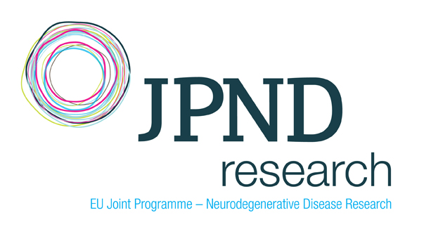 | [JPI]
CORONER* | Florence |  | [JPI]
SCHWARZ* | Hans-Günther |  | [JPI]

* Observer status

GLOSSARY

AC | Associated Country
AT | Austria
CIRCABC | Communication and Information Resource Centre for Administrations, Businesses and Citizens
DDG | Deputy Director General
EC | European Commission
GPC | ‘Groupe de Programmation Conjointe’ – Council Group in charge of Joint Programming
HoU | Head of Unit
JP | Joint Programming
JPI | Joint Programming Initiative
JPIs-To-CoWork | Funded under the FP7 ERA-net-2011 scheme
JPND | Joint Programming initiative ‘Alzheimer and other neuro-degenerative diseases’
MS | Member State
SRA | Strategic Research Agenda
WG | Working Group

TABLE of CONTENT

 | Page n°
Executive Summary | 7
1. Introduction | 11
1.1. Establishment of the Working Groups | 11
2. The Key Stakeholders (GPC, JPIs and the Commission services) | 13
2.1. State of Play | 14
3. Key issues from Consultations | 15
a) Need for Political Commitment | 15
b) Issues for the GPC | 16
1. Representation on GPC | 16
2. Function of GPC | 16
3. Role of the Institutions represented on GPC | 16
4. Information GPC should receive | 16
5. Information GPC should provide | 17
c) Issues for the JPIs | 17
1. JPIs’ Needs | 17
d) Issues for the Commission services | 18
1. Information the Commission services should receive | 18
2. Information / actions required from the Commission services | 18
3. Enhanced visibility and promotion | 19
e) Communication | 20
4. Conclusions and Recommendations | 21
MAIN RECOMMENDATION I | 21
I.1. GPC mandate | 21
I.2. Vision and Strategy for the future of Joint Programming | 22
I.3. JPIs and Article 185 | 22
I.4. Establish Single Contact Points | 22
I.5. National Forum for JP | 23
I.6. Monitoring and implementation of GPC Decisions | 23
I.7. Recommended Cycle of Annual Meetings | 23
MAIN RECOMMENDATION II | 24
II.1. JPIs’ focus on societal challenges | 25
II.2. JPI reporting to GPC | 25
II.3. JPI reporting to EC | 25
II.4. Commission services’ participation in JPI meetings | 25
II.5. JPIs’ outreach and promotion activities | 25
MAIN RECOMMENDATION III | 26
III.1. Establish an EC Joint Programming Task Force | 26
III.2. Harmonise Commission representation on JPIs | 26
III.3. Ensure articulation with Horizon 2020 | 26
III.4. Commission services should actively promote JP | 27
III.5. EC portal/database | 27
5. Implementation | 28
5.1. Endorsement Required | 28
5.2. Timeline for implementation | 28
5.3. Human and financial resources needed | 29
5.4. Description of the recommended EC Task Force on Joint Programming | 29
5.5. EC database for JP/JPIs | 30
6. Methodology | 32

 | Page n°
ANNEXES
- Questionnaires | 34
Questionnaire addressed to the JPI leaders
Questionnaire addressed to the GPC (members and observers) and to the coordinator of JPI-To-Cowork
Questionnaire addressed to the Project Officers following the JPIs in the Thematic Directorates of DG RTD
- Synthesis tables on the outcome of the consultations | 36
SYNTHESIS TABLE 1:
Responses from the JPIs
SYNTHESIS TABLE 2:
Responses from the GPC and from the coordinator of JPI-To-CoWork
- List of the 10 Joint Programming Initiatives | 56

Executive Summary

The recommendations in this report are subject to endorsement by the GPC, which mandated the establishment of the Working Group. The recommendations are based on views expressed by GPC members, JPIs and Commission officials and the Working Group would like to express its appreciation of the time taken by all concerned to provide their valuable input to this Report.

KEY MESSAGES

- A properly structured relationship between the actors involved in Joint Programming is needed

Feedback from the consultations undertaken with the GPC, JPIs and Commission officials in preparation of this Report indicates that relations / communications between these three partners in the Joint Programming process are currently suboptimal to the attainment of their respective mandates.

The GPC Working Group did not find evidence of properly structured relationships between the GPC, JPIs and Commission, nor evidence of a reliable and consistent communications structure between the parties involved in Joint Programming. The current arrangements are somewhat ad hoc and based on individual personal contacts within the various groups. This lack of structured communication channels led to the recommendations in the 2012 GPC Biennial Report (endorsed by the GPC) and the Report of the Expert Group on Joint Programming (October, 2012) which identified the need to pursue and deepen relations between the GPC and the JPIs.

- The role of the Commission in supporting the Joint programming process can be further improved

The Working Group identified the Commission as a key player which has both the resources and ability to bring all parties together. Moreover, the Commission has responsibility under the Treaty to take any useful initiative to promote such coordination to ensure that national policies and Union policy are mutually consistent.

Joint Programming Initiatives are key instruments in developing such mutual consistency. Recommendations addressed to the Commission include that it should streamline its internal coordination and information process and communication channels relating to JP; harmonise the official status of the EC in the different JPIs

and proactively promote JP and the JPIs. It is considered that a key mechanism to achieve this is the establishment of a Task Force on Joint Programming, composed of the responsible Commission officials, as elaborated in this Report.

- Stronger political support at Member States level is needed

While the Commission should perform this coordination promotion role, the JP process should continue to be a Member States driven initiative. This places an onus on the GPC, as the political and strategic forum for Joint Programming, to have a clear vision and determined and sustained political commitment. A common response from all key stakeholders consulted is that there is a need for such a determined and sustained political commitment to ensure that:

- the political environment within the MS is supportive of the work of the JPIs,
- it facilitates the required activities within the MS research programming policies and activities, and
- adequate resources (human and financial) are in place to support the MS actively participating in JPIs.

The 2008 commitment of the MS towards Joint Programming should be renewed and strengthened as soon as possible.

- GPC should be the key actor to help promote the implementation of JPIs

Equally, JPIs should consider the GPC as the political forum for addressing their difficulties, not only their achievements and successes. JPIs should work closely with the GPC to address barriers to the implementation of their SRAs and alignment of national research and innovation agendas.

JPIs can facilitate a wide spectrum of scientific, managerial and financial integration, from the lowest to the highest level. For those JPIs where there is sufficient integration and who wish to consider adopting a legal basis according to Article 185 of the EU treaty (in line with Art. 13 of the Horizon 2020 Framework Regulation), the GPC should discuss such proposals and how they can best be facilitated. This could give greater certainty to the future sustainability of the JPIs until they fulfil their mission.

- Active participation by Member States and Associated Countries is needed

The Working Group considers that in future new actors could show interest in the societal grand challenges, such as currently less active EU member states, countries wishing to associate themselves with any of the Joint Programming Initiatives. While externalities such as the current economic climate have an impact on the participation of actors in Joint Programming, over time economic conditions are subject to change. Other limitations and barriers to participation in all Joint Programming (such as human resources, financial resources, etc.) also exist. However, the Working Group considers that active participation by all EU Member States (not only active participation at GPC level) who join JPIs is vital in order to promote cohesion, to maintain a high level of interest in Joint Programming and to maximise resources utilisation. It is important, therefore, to keep open the opportunity of future participation by Member States in Joint Programming and Article 185 initiatives. The principles of Open Access and Variable Geometry are valuable features of Joint Programming and should be enshrined in future Joint Programming mandates needed to secure sustainable commitment of the MS in this process.

- JPIs play a key role in the completion of ERA

The contribution of the JPIs to the completion of the ERA has recently been noted by the Council. In its conclusions of 20 and 21 February 2014 the Council considered that the development of the ERA Roadmap should take into account alignment, where possible, of national strategies and research programmes with the Strategic Research Agendas of the JPIs.

- Need for the JPIs to reach next step of implementation

The JPIs have evolved significantly since 2008. The time has come to consolidate achievements made so far and to take the necessary measures to proactively facilitate JPIs in fulfilling their mission. The WG considers that implementation of the recommendations made in this Report, which are integral to the points made above, will significantly improve the working relationship between the key partners (GPC, JPIs and the Commission services) and contribute to the achievement of the JPIs’ full potential.

RECOMMENDATIONS

The report draws conclusions from the key issues from the consultations and presents them under three overarching findings (main recommendations I, II and III below) relating to the three key stakeholders (GPC, JPIs, and the Commission services) in the JP process.
Detailed recommendations to address each of the findings are also presented.

MAIN RECOMMENDATION I:

As the political and strategic forum for Joint Programming, the GPC requires an explicit mandate to oversee the implementation by the Member States of the Council’s commitment to the need for the EU to act rapidly and coherently to achieve the scale of impact needed to effectively address societal challenges with available research funds.

Consideration should be given to the renewal of the GPC mandate as soon as possible to explicitly empower it to monitor, and report to the Council, the extent to which MS are implementing the Council’s expressed desire to see alignment, where possible, of national strategies, priorities and research programmes with the JPIs’ strategic research agendas to tackle major societal challenges.

MAIN RECOMMENDATION II:

The JPIs should work closely with the GPC to address barriers to the implementation of their SRAs and alignment of national research and innovation strategies (and any other issues that arise).

There is a perception that the JPIs’ attention has been taken up largely with operational matters and securing sustainability and that their main focus must now be on demonstrably addressing the societal challenges they were established to tackle. Demonstrating their ‘added value’ in tackling societal challenges will be the criterion by which their success or otherwise is judged. We recommend that the JPIs ensure their main focus is on delivering results and being in a position to demonstrate their achievements and the added value they contribute.

MAIN RECOMMENDATION III:

The Commission services should streamline their internal coordination and information process/communication channels relating to JP; harmonise the official status of the Commission in the different JPIs and proactively promote JP and the JPIs.

Given the complex and diverse landscape in DG Research and Innovation in the area of Joint Programming, the WG recommends the establishment of a ‘Task Force’ composed of relevant Commission officials in charge of following the JPIs in the Thematic Directorates and their colleagues from the coordinating entity.
1. Introduction

The main aim of the GPC is to address societal challenges through Joint Programming. JPIs were created and tasked with setting up their own structure in order to address a single social challenge which has individual and particular properties.

Each JPI was tasked with setting its own governing structure, i.e. management and scientific board and devising scientific/strategic research (and innovation) agendas (SRAs). Following the principle of variable geometry, JPIs were not dictated with any structure model in order to allow the creation of the right tools to address particular issues of each societal challenge.

JPIs were given a free hand to shape their governing structure in a form professionals in the field deemed fit for purpose. Now that JPIs have established their modus operandi, time is right for the GPC to review the relationships, which are intended to be two way (three way or more), to consolidate current ties and create new robust communication lines for the benefit of the whole process.

The contribution of the JPIs to the completion of the ERA has recently been noted by the Council. In its conclusions of 20 and 21 February 2014 the Council considered that the development of the ERA Roadmap should take into account alignment, where possible, of national strategies and research programmes with the Strategic Research Agendas of the JPIs.

1.1. Establishment of the Working Groups

At the meeting of the GPC on 25 June, 2013, following discussion of a synthesis of recommendations from:

GPC Biennial Report (December, 2012),

Report of the Expert Group on Joint Programming (October, 2012),

Dublin Conference on Joint Programming (February, 2013) and

European Commission Communication on “A Reinforced European Research Area Partnership for Excellence and Growth “(July 2012)

The GPC decided to establish 6 ad hoc Working Groups:

Actions (Source*)
Ensuring a sustainable commitment of Member States and advancing in the implementation of JPIs
Alignment with SRAs
Reflect on ways of aligning national and European strategies and research programmes with Strategic Research Agendas of JPIs and promote alignment (B, C, E)
Securing Commitment and Engagement in Joint Programming
Examine how best long-term commitment to JPIs can be maintained, and in particular how to build sustainability and trust in Joint Programming and in the JPIs (C, E)
Ensure greater involvement of national stakeholders into the JPI process (C, E)
GPC and JPIs
Pursue and deepen exchanges between the GPC and JPIs (B)
Promoting usage of improved Guidelines on Framework Conditions for Joint Programming
Framework Conditions for Joint Programming
Examine ways of developing the Framework Conditions Guidelines to make them more useful and used (C, B, E)
Collect experiences and distil out the most important issues for common actions (C, E)
Evaluating JPIs
Measuring JPIs progress and impact
Suggest methods for reviewing JPIs and plan for a more thorough evaluation of JPIs after the start of H2020 (C, B, E)
Preparing for new challenges
Future initiatives
Consider a process for deciding on future challenges (B, E)

This report covers the issues related to the WG on ‘how to pursue and deepen the relations between the GPC and the JPIs’.

The 2012 GPC Biennial Report (page 26) provides the context for the mandate of the WG as follows:

‘The GPC thus wishes to:
- encourage the implementation of JPIs through learning processes on the use of framework conditions, international cooperation, when and where appropriate the involvement of industry and users, common thematic areas, and through a possible ERA Mark label,
- call on JPIs to step up efforts to implement SRAs, ensure that JPIs build upon national programmes, that adequate national resources are committed and strategically aligned at European level in these areas,
- encourage JPIs to build on the success stories and to make good use of them by closely cooperating with each other in a process of mutual learning,
- encourage JPIs to widen the participation of interested countries,
- pursue and deepen exchanges between GPC and JPIs on these issues,
- support the JPIs in using a wide range of JP tools beside joint calls.’

The mandate of the GPC Working Group was set in this context in September 2013, to consider and recommend:

- ways by which timely communication between the GPC and the JPIs can be enhanced in order to facilitate the implementation of the JPIs, follow their advances and be aware of their needs;

- the issues on which information should be exchanged between the GPC, JPIs and Commission services in charge of following Joint Programming.

2. The Key Stakeholders (GPC, JPIs and the Commission services)

The starting point of this report is that of identifying the key stakeholders involved in Joint Programming and setting out what is the current state of play from a communications/ relations perspective.

The High Level Group on Joint Programming (GPC), created in 2009 by the European Council to identify the societal grand challenges, is a dedicated configuration of ERAC (formerly known as CREST) composed of high-level representatives of the Member States and of the Commission and, where appropriate, associated countries (AC). It was tasked with matters related to the Joint Programming process and the JPIs’ organisation and management, including conducting various assessments. From a political perspective, the GPC plays a critical role in ensuring political recognition and support for the JPIs.

Member States were invited to step up efforts to implement joint research agendas addressing grand societal challenges, to share information about activities in agreed priority areas, to ensure that adequate national funding is committed and to strategically align at European level in these areas and that common ex post evaluation is conducted.

The GPC is considered as the forum where exchange of information about developments at national level in priority areas takes place in order to harmonise national research strategies with the JPIs’ SRAs agreed priority areas.

JPIs were tasked with setting up their own governance in order for each to address a single societal challenge. JPIs were entitled to make use of the variable geometry principle and were tasked with setting their own management, scientific board and scientific / strategic research agenda (SRA).

The GPC did not interfere with the establishment of the JPIs in order to allow for the creation of the right set of tools to address each particular societal challenge. Over the years, JPIs evolved at different levels according to their own particular needs. JPIs were also asked to maintain the principle of open participation to all EU Member States (MS) who might wish to participate in them.

Since the first JPI (pilot JPI) was set up in 2009, JPIs’ structures have evolved at different levels according to their own requirements taking into account the Framework Conditions elaborated by the GPC in 2010. At present, now that all JPIs have established their individual internal structures, it is time to create stronger ties in order to establish stronger relationships both vertical and horizontal between GPC, JPIs and the Commission services.

The communication structures envisaged by this Working Group are intended to be two way (three way or more) to consolidate current ties and (if appropriate) create new robust ones. This provides a window of opportunity to maximise the potential of the GPC to coordinate research programmes and funding at MS level required to undertake the type of research to deliver on the vision of the JPIs.

The WG took into consideration the evolution of existing relationships between the GPC, the JPIs and the Commission services. Its work focused around current opportunities and challenges in order to facilitate communication channels, establish various communications systems, the role of contact points and the content of communication.

The mandate of the WG on ‘how to pursue and deepen relations’ aimed to identify areas for improved coordination, cooperation and exchange (information, people, and practices). The WG strove to propose recommendations to enhance communication between the GPC and the JPIs in order to establish and maintain into the future a uniform network of communication.

Although the mandate was essentially directed towards relations between GPC and JPIs, the WG decided to extend it to include also the Commission services as there was also the need to address some issues regarding communication between JPIs and the Commission services as different areas of Joint Programming are covered by different Commission officials within DG Research and Innovation. This created additional complexity in the exchanges required to be simplified within a proposed communication strategy.

It was agreed that a communication strategy would also encompass enhancement of JPI communication channels horizontally (between JPIs).

2.1. State of Play

Feedback from the extensive consultations undertaken (with the GPC, JPIs and relevant Commission officials – see Chapter 6 Methodology), indicates that relations / communications between the GPC, JPIs and the Commission services are currently suboptimal to the attainment of the GPC and JPIs’ mandates. Examples of issues that need to be addressed include:

- GPC members feel it is not sufficiently recognised by the JPIs, while JPIs seem to lack knowledge about the work of the GPC (some do not even know their Member State’s representative).

- JPIs lack timely contact with the MS representatives/GPC, while MS representatives sometimes do not even know their country's JPI-leader. From a JPI perspective, contact with the MS representatives at GPC level is considered of vital importance. Both GPC and JPIs need to create a mutual understanding environment in order to better appreciate each other’s roles. Regular information exchange facilitates mutual understanding where JPIs share progress and obstacles with the GPC as the GPC is the right forum for Member States to take decisions and facilitate the implementation of JPIs.

- The current flow of communication (on issues like CSA, Horizon 2020, Work Programmes, Innovation Plan, relations between H2020 and Innovation Plan etc.) is not considered to be optimal and there is no real timely communication between the Commission services and GPC/JPIs.

- There is a lack of exchange of best practice (in calls, in developing the Action Programme, in ‘in kind’ driven activities, networking /information) between all key actors.

- Until now, interaction with the Commission services was considered by the JPIs to be not sufficiently transversal as it is always limited to specific Societal Challenges.

3. Key Issues from Consultations

This Chapter outlines key issues arising from the consultations undertaken with stakeholders. Chapter 4 deals with conclusions drawn from these issues and recommendations to address them.

a) Need for Political Commitment
A common response from all key stakeholders consulted is that there is a need for determined and sustained political commitment to ensure that:

- the political environment within the MS/AC is supportive of the work of the JPIs,

- it facilitates the required activities within the MS/AC research programming policies and activities, and

- adequate resources (human and financial) are put in place to support the MS/AC actively participating in JPIs.

GPC Delegates can play crucial role in this regard by coordinating resources to support Member States’ participation in the JPIs. The GPC may also contribute further by its members providing a platform to JPIs on a national level and promoting JPIs’ success stories as much as possible in order to enhance JPIs’ visibility. GPC delegates expressed willingness to use all opportunities which arise to promote JPIs both on a personal basis (reputational management) and also to be advocates of the Joint Programming process within their own hierarchies.

b) Issues for the GPC
The consultation raised a number of issues concerning the representation on the GPC, its role, how it functions and the information it should receive and provide.

1. Representation on GPC
There was agreement across the stakeholder groups consulted on the need for context specific representation sent to strategic GPC meetings. Proposals were made that MS should be represented at a level which enables them to take decisions engaging their MS/AC.

The minimum Commission services level contact should be Head of Unit; Commission officials in charge of JPIs should attend GPC meetings regularly.

2. Function of GPC
The GPC should have a strategic vision on JPI goals / objectives and implementation timeframe and ensure the definition of clear national positions regarding alignment of National Research and Innovation agendas (SRAs, EU research and innovation programmes, Structural Funds …).

The GPC should voice concerns of JPIs during GPC meetings (if not addressed by JPIs) and ensure that issues are debated and focused towards solution.

3. Role at National Level of the Institutions represented on GPC
GPC members should be ‘key’ to lobbying at national level for the right level of human and financial resource allocation to JPIs; one of their main tasks should be to encourage entities/bodies at MS level to participate in those JPIs which their MS has chosen to join. They should also encourage the JPIs to take on board regional/national smart specialisation strategies in view of synergetic funding of JP by Structural Funds or other national, regional or Community funding.

MS representatives in the GPC should support the joint activities required for the implementation of SRAs, to ensure that the JPI’s are involved in development of policy at national level, consulting the JPIs at key time points, while constantly supporting the JPI’s in promoting their achievements and success stories.

GPC members should support the JPIs to work on aligning their SRA with the national research programmes and policies and consider their role in facilitating international co-operation between JPIs and Third Countries.

4. Information GPC should receive
As a policy group of ERA, the GPC should request the Commission services to provide an overview of ERA developments and coordination with related multilateral initiatives on Joint Programming.

The GPC wishes to be informed in a timely manner in advance on future Horizon 2020 Work Programmes and its support to JPIs, including ERANETS and CSAs, and would like the Commission services to implement a consultation process to favour synergies (between Horizon 2020 & JPIs), putting in place a routine mechanism for the exchange of information related to strategic programming of Horizon 2020.

The GPC considers that JPIs should regularly report to the GPC.

The GPC should receive (written) interesting ‘news’ from the JPIs regularly. This ‘news’ should cover issues such as communicating the steps in implementation of SRAs (strategy, milestones covered, forward planning/foresight, best practices), providing information on outcomes of JPI meetings and progress & achievements of the JPI, as well as information on internationalisation of JPIs (countries, topics, barriers, successes etc.).

JPIs are requested to inform GPC on difficulties to address alignment of national research and innovation agendas as well as specific needs to sustain their operation; the GPC should become the forum for the JPIs to find solutions to their issues / difficulties / problems.

5. Information GPC should provide
GPC should communicate to JPIs decisions taken during the meetings and main discussion points and should regularly invite the JPI Chairs to the GPC meetings.

The GPC sees the necessity to inform JPIs on their Work Programme, agenda, minutes, progress, meeting dates & output of WGs and to communicate on priorities, best practice and relevant developments in other transnational cooperation in a timely manner for the benefit of the JPIs.

c) Issues for the JPIs
In general terms, there seems to be a tendency for a JPI to become a little inward looking where the strive for knowledge and scientific advancement seems to be the main horizon for many of the stakeholders involved, resulting in a lesser focus on delivering innovations where society most needs them.

1. JPIs’ Needs
It is commonly considered that success for JPIs is still to a large degree regarded as being the ability to access and win as much research funding as possible.

Although the Commission initiated the JP concept, it should not leave MS alone in implementing it. Even without direct funding, the Commission should play the role of facilitator and always recall the importance of JPIs in the completion of ERA.

On one hand, all stakeholders still see a need for some convincing, marketing and fine tuning before the benefits of Joint Programming is really felt by all and a better coordination of the JPIs with other activities, e.g. in EIPs, KICs, Research Infrastructures is completed. There is clearly a need at this stage for a better clarification on answering questions on interpreting and complying with JPI 'Framework Conditions' and 'Alignment'.

On the other hand, there seems to be a lack of clear direction on the JP process, especially through the measures taken so far to promote JP implementation and visibility both internally and to the outside world.

The GPC should help enable the JPIs to position their initiative (vision, SRA and Action Plan) within an economic, social, environmental and political context while informing JPI of examples they consider to be best available practice, based on other JPIs’ experience.

Routinely, a mechanism for exchange of information between the individual JPI and the relevant configuration(s) of the Horizon 2020 Programme Committees should be in place to ensure coherence. However, the objective should not be for JPIs to align themselves with Horizon 2020 as Joint Programming is about alignment of National research and innovation strategies.

Furthermore, all events relevant to JPIs should be brought to their attention by the Commission services and/or the GPC.

d) Issues for the Commission services

1. Information the Commission services should receive
Commission officials see a need for JPIs to report more regularly to allow better monitoring of the progress of the JPIs. Such reporting should be detailed and cover reasons for lack of progress, actual/potential difficulties, reservations from MS, improved cooperation, alignment, ongoing/planned activities, ability to deliver added value and accelerated advances in their field, procedures developed, lessons learned, best practices etc. Furthermore, there is information needed on the JPI management, participation, commitment/lack of commitment from the MS, etc.

The view was expressed that internal coordination/information is currently not optimal due to the fact that availability of information to Commission officials in the thematic Directorates is not considered to be fully complete and timely. Feedback on implementation aspects/progress of specific JPIs as well as information and feed-back on GPC/JPI, internal and other relevant JP meetings was also identified as requiring improvement. Several Commission officials regretted the lack of their involvement in GPC and its WGs.

2. Information / actions required from the Commission services

The Commission services should develop and present to GPC its vision for the future of Joint Programming including a debate with the GPC on a sound funding strategy (CSA, ERA-Nets, European Structural and Investment Funds etc.).

The Commission services should provide a political perspective (including a long term view) to the JPIs and ensure consistency between EU policies, coordinating initiatives and actions towards a more coherent framework.

Furthermore, at JPI Management Board meetings the Commission services should inform on possible complementary measures to support the JPIs; information on EU actions and funding instruments (e.g. ERA-NET Co-Fund, European Structural and Investment Funds etc.) and communicate pertinent elements of strategic programming of Horizon 2020 that impact the JPIs' SRA and better associate the JPI to the process at an early stage.

An important aspect under H2020 is strategic programming where the Commission services should closely consider research and innovation priority objectives identified under mature JPIs when preparing the work programme.

Proactively seeking participation of less active countries into JP / JPIs as
already done in the past through specific missions of Commission representatives to raise awareness at highest political level, should also be the
role of the Commission services.

Furthermore the Commission services should inform JPIs on broader planning of research infra-structures and research cooperation with third countries.

There is a major need for streamlining the monitoring of the JPIs and their governing structure in relation to the GPC as the political forum for JP. A single contact person in GPC, JPIs and the Commission services should be identified as early as possible, ensuring that contacts take place on a regular basis, i.e. GPC members should attend MB meetings of the JPIs and vice versa.

Following the practice established in the pilot JPI on Neurodegenerative diseases (JPND), the Commission is an observer in the Management Boards of the three first wave JPIs launched in 2010. The rationale for this status was for the Commission to focus on its facilitation role and to ensure that Member States would remain fully responsible for defining priorities and allocation of national funds for the JPI’s Strategic Research Agenda.
Included in the Commission Recommendations relating to second wave JPIs, a provision that the Commission be given the role of non-voting member of the JPIs Management Boards was made. The Commission should inform the GPC on the possibility of a common status of its representative in the JPIs’ Management Boards within the scope of harmonisation of its official status.

3. Enhanced visibility and promotion
JPIs and GPC agree that enhanced visibility and promotion of the JP concept and the individual JPIs is strongly needed. Both stakeholders express the need for the Commission services to take charge of organising workshops or seminars (i.e. on case studies and examples of successful implementation) and the JP Annual Conference wherein the GPC should play its role in deciding on the timing of such events and the topics to be brought up/discussed.

The Commission services should act as a secretariat in organising all such meetings and also meetings of the JPI chairs on a regular basis.

Upon request by individual JPIs, the Commission services should support (not fund) communication, dissemination and awareness raising activities and, as a clear added value for Europeans, the European research and useful for the completion of the European Research Area, better support efforts and actions MS undertake to raise awareness about JP and the JPIs.

Furthermore, the Commission services should ensure communication with its political channels at all possible occasions and inform about the progress of the JPIs, their achievements and successes whenever relevant.

Commission officials in charge of following the individual JPIs in the different thematic Directorates of DG Research and Innovation see a clear communication role for the coordination services, in close contact with the thematic Directorates, in ensuring that JP is placed more prominently in Commission publications, Communications, etc.

A commonly elaborated communication strategy and action plan would be helpful and should be discussed with the JPIs and the GPC.

e) Communication
In today’s digital era, online communications are considered as an indispensable tool in the communication toolbox. An online communications infrastructure set up would need to also include a common space for exchange of information, data etc. Nevertheless, online communication must never replace face-to-face meetings.

The internet also enhances JPIs’ visibility and an individual landing page for each JPI is required to coordinate and provide shortcuts to the myriad of information regarding JPIs. All key actors agree that in the current situation, there is a need for structured electronic communication which should also include a common space for exchange of information, data, etc. Nevertheless, meetings several times per year are also seen as essential to the working relationship and full exchange of information.

In general terms, communication should be monitored and its impact measured constantly by relevant indicators (to be set in close cooperation with GPC and JPIs); during the consultation phase Commission officials have proposed several indicators they deem necessary.

There is a common agreement that communication should be supported with emphasis on the difference between Joint Programming and EU research funding programmes and their complementarity. This approach would (even at this stage) help clarify the currently fragmented landscape of actions and their heterogeneous funding.

4. Conclusions and Recommendations

This Chapter draws conclusions from the key issues outlined in Chapter 3 and presents them under three overarching findings (main recommendations I, II and III) relating to the three key stakeholders (GPC, JPIs, and the Commission services) in the JPI process. Detailed recommendations to address each of the findings are also presented. The Key Issues from Consultations (Chapter 3) should be borne in mind when implementing these recommendations.

MAIN RECOMMENDATION I:

As the political and strategic forum for Joint Programming, the GPC requires an explicit mandate to oversee the implementation by the Member States of the Council’s commitment to the need for the EU to act rapidly and coherently to achieve the scale of impact needed to effectively address societal challenges with available research funds.

I.1. GPC Mandate
The European Commission noted in its Communication ‘A Reinforced European Research Area Partnership for Excellence and Growth’ COM(2012) 392:

‘The EU needs to act urgently and coherently to achieve the scale of effort and impact needed to address grand challenges with the limited public research funds available. …The level of alignment is presently too low to make a serious impression on big and complex challenges. This is due in part to differences between national funding rules and selection processes, but it is also a question of political will.’

In its conclusions of 11 December 2012 on this Communication, the Council stressed

‘the need for the EU to act rapidly and coherently to achieve the scale of impact needed to effectively address societal challenges with available research funds.’

Furthermore, in its conclusions of 21 February, 2014 on progress in the ERA, the Council considered that in developing an ERA roadmap by mid-2015 the following should be taken into account:

‘aligning, where possible, national strategies and research programmes with the strategic research agendas developed within the Joint Programming Initiatives to cope with major societal challenges and improving the interoperability between national programmes to facilitate transnational cooperation and sharing of information about activities in priority areas’.

In order for Joint Programming to play its full part in the realisation of the ERA, the renewed political commitment in these Council conclusions must be implemented by active engagement by the MS to ensure that:

- adequate resources (human and financial) are in place to support the MS actively participating in JPIs;

- national strategies, priorities and research programmes are aligned, where possible, with the JPIs’ strategic research agendas, and

- the interoperability between national programmes is improved to facilitate transnational cooperation.

Consideration should be given to the renewal of the GPC mandate as soon as possible to explicitly empower it to monitor, and report to the Council, the extent to which MS are implementing the Council’s conclusions outlined above.

I.2. Vision and Strategy for the future of Joint Programming
GPC, JPIs and the Commission services should jointly elaborate a sound vision and strategy for the future of Joint Programming under the lead of the MS representatives. The GPC should present key issues of JP to ERAC and the Council with recommendations for decisions, where required, to support the implementation of the running JPIs. GPC should issue a statement / resolution to raise awareness of the JPIs towards the GPC; at the same time, MS/AC represented on the GPC need to be 'empowered' to engage their MS to ensure alignment of national strategies and to secure national funding for JPIs.

I.3. JPIs and Article 185
JPIs can facilitate a wide spectrum of scientific, management and financial integration, from the lowest to the highest level. For those JPIs where there is sufficient integration and who wish to consider adopting a legal basis according to Article 185 of the EU treaty (in line with Art. 13 of the Horizon 2020 Framework Regulation), the GPC should discuss such proposals and how they can best be facilitated. This could give greater certainty to the future sustainability of the JPIs until they fulfil their mission.

I.4. Establish Single Contact Points
For each JPI, a single contact person in the GPC, JPIs and the Commission services should be appointed to take care of the continuous multi-directional information flow.

The appointed member of GPC for a particular JPI could participate in that JPI’s Management Board meetings (or if necessary SAB meetings) as an observer to provide greater coherence and ensure discussions/outcomes are in line with issues relevant for GPC. An alternative proposed by Belgium is that JPIs would appoint a member of their Governing Board to represent the JPI once a year in a GPC-JPI meeting.

I.5. National Forum for JP
Each MS/AC should consider the possibility of regular meetings at national level between its GPC member(s) and its national JPI representative(s) to ensure quick and sound decision making and information flow (National Forum.

I.6. Monitoring and implementation of GPC Decisions
To efficiently manage decisions taken by the GPC during its meetings and required follow-up actions, a ‘running list’ should be established by the GPC Chair recording the decisions and the actions required / implemented. This list should be circulated for, and reviewed at, each GPC meeting and copied to the JPIs.
MS representation on GPC should be at a senior level which enables them to take the appropriate decisions during meetings and in follow-up.

I.7. Recommended Cycle of Annual Meetings
The following cycle of GPC meetings, JPI meetings, national fora, etc. might usefully be arranged to provide a continuous flow of information/contribution of inputs to each respective meeting.

The idea is to have the meetings of GPC each year at the same time of the year, relating all other relevant meetings at fixed times to these meetings in a coherent way.

The 4 yearly meetings of the GPC generally take place in spring, summer, autumn and winter. The summer and autumn meetings of the GPC should be of ‘strategic’ nature’ requiring high level participation of the MS representatives, in particular when discussing ‘strategies’ in summer and ‘taking strategic decisions’ in autumn. The GPC meetings in spring and winter serve the purpose of collection of input from the various sources (in spring) and wrap-up of the yearly contributions/decisions (in winter).

Aligned on the baseline of the 4 GPC meetings per year, the annual cycle should ideally start with the ‘JP Annual conference’ to be organised every year around January/February so that the previous’ year’s wrap-up could be presented as well as new issues/policies for the upcoming annual cycle.

National fora, as recommend to the MS, should then ideally take place prior to the spring and summer meetings of the GPC to allow collection of input. In autumn and winter the national fora would be useful to take place after the GPC meetings, to inform the stakeholders on the decisions taken during the autumn GPC meeting and on the wrap-up discussed by the GPC during its winter meeting.

Throughout a year, only 3 JPI Chair meetings are deemed necessary, the first one prior to the summer meeting of the GPC to provide contributions to the strategic discussions. It is then suggested to have the second JPI Chair meeting just after the autumn meeting of the GPC in order to communicate in a timely manner all decisions taken by the second strategic GPC meeting. Finally, the third JPI chair meeting should be organised in the form of the JPI Chairs reporting to the GPC winter meeting.

The cycle of annual meetings as proposed above is represented in the graphic below:

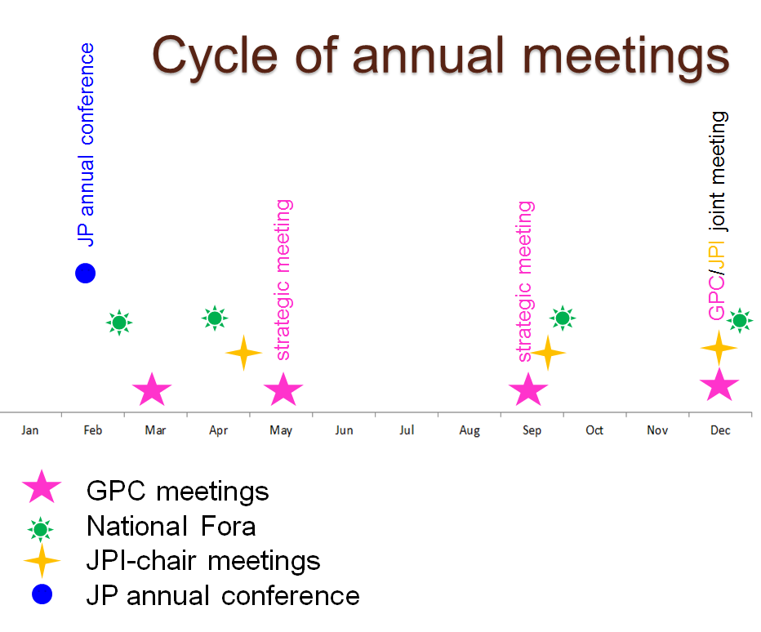

MAIN RECOMMENDATION II:

The JPIs should work closely with the GPC to address barriers to the implementation of their SRAs and alignment of national research and innovation strategies (and any other issues that arise).

II.1. JPIs’ focus on societal challenges
There is a perception that the JPIs’ attention has been taken up largely with operational matters and securing financial sustainability and that their main focus must now be on demonstrably addressing the societal challenges they were established to tackle. Demonstrating their ‘added value’ in tackling societal challenges will be the criterion by which their success or otherwise is judged. We recommend that the JPIs ensure their main focus is on delivering results and being in a position to demonstrate their achievements and the added value they contribute.

II.2. JPI reporting to GPC
At least once a year all JPI leaders, upon invitation from the GPC chair, should report on achievements, progress, barriers etc., to facilitate discussion of these reports by the GPC. These meetings should take place regularly at the same time each year to fit the cycle of annual meetings of GPC and related meetings (cf. I.8. above).
JPIs should consider the GPC as the political forum for addressing their difficulties, achievements, successes taking into account all information needs expressed by the key stakeholders.

II.3. JPI reporting to EC
JPIs should report to the Commission services on a voluntary basis, but more frequently on progress including reasons for lack of progress, potential difficulties, reservations from MS, improved cooperation, alignment, and ongoing/planned activities. They should demonstrate their ability to deliver added value and accelerate advances in their field, procedures developed, lessons learned, best practices etc. Furthermore, they should inform regularly on issues in JPI management, participation, commitment/lack of commitment etc. A structured reporting scheme should be developed for his purpose.

II.4. Commission services’ participation in JPI Meetings
JPIs should invite Commission officials in charge of JPIs to relevant meetings of the JPIs, to facilitate greater understanding of, and feedback on, expectations by the Commission services and the GPC.

II.5. JPIs’ outreach and promotion activities

JPIs should involve GPC in their outreach activities, either by inviting their country’s GPC representative or their contact point as recommended under I.4. here above. This will serve a double aim, namely informing the GPC more in detail on communication issues related to a JPI, but also allowing the MS to stand up for a JPI and demonstrate political commitment and support.

MAIN RECOMMENDATION III:

The Commission services should streamline their internal coordination and information process/communication channels relating to JP; harmonise the official status of the Commission in the different JPIs and proactively promote JP and the JPIs.

III.1. Establish an EC Joint Programming ‘Task Force’
Given the complex and diverse landscape in DG Research and Innovation in the area of Joint Programming, the WG recommends the establishment of a ‘Task Force’ composed of Commission officials in charge of following the JPIs in the Thematic Directorates (similar to the Inter Service Group that was running in the past) and their colleagues from the coordinating entity (sector Joint Programming). A detailed description of the proposed Task Force can be found in Chapter 5 Implementation.

The members of this task force should (amongst others) be tasked with actively seeking contacts with high-level representatives of less active countries to discuss issues related to JP and encourage the countries’ participation in the JPIs.

The members should also ensure that the appropriate level of representation (HoU or higher) of Commission officials is sent to the relevant meetings of the GPC (cf. annual cycle of meetings) to facilitate policy discussions and decisions.

III.2. Harmonise Commission representation on JPIs
The official status of the Commission services in the Management Boards of the different JPIs (non-voting member, observer…) should be harmonised and a clear practice on participation (who, when …) in the JPIs’ Management board/scientific advisory board etc. should be established and followed by the Commission services.

III.3. Ensure articulation with Horizon 2020
The Commission services should ensure articulation of JPIs with Horizon 2020 in accordance with Article 5(5) of the Specific Programme for Horizon 2020. (‘The work programmes for Horizon 2020 shall take account of the state of science, technology and, innovation at national, Community and international level and of relevant policy, market and societal developments. They shall contain information on coordination with research and innovation activities carried out by Member States, including in areas where there are Joint Programming Initiatives. They shall be updated where appropriate’.)

Furthermore, Strategic planning for the 2016-2018 Horizon 2020 Work Programmes should include early consultation with the JPIs.

III.4. Commission services should actively promote JP
The Commission, as the guardian of the EU Treaty, should become more proactively involved in the process of Joint Programming and should play a proactive role in discussion with the JPIs, GPC and also in-house to ensure thorough information flow and exchange of information at all levels. It should promote JP and the JPIs whereby the services should act as the secretariat for the organisation of all events related to coordination of JP and the JPIs.

To ensure an enhanced information flow between GPC-JPIs-Commission services, adequate human and financial resources should be put in place.

The Commission’s communication services should ensure that the ‘JP Annual conference’ under the auspices of the Council Presidency include appropriate press/diffusion activities.

Regular meetings of the JPI Chairs should be organised centrally in Brussels to allow exchange of best practices between JPIs (GPC and Commission services to be invited); Workshops on issues determined by the GPC, or upon request of the JPIs via the GPC, should also be organised.

Consideration should be given to the preparation of a regular internal (electronic) newsletter (4 times/year) with input from the JPIs, including contributions on achievements of the JPIs and news on JP, for the information of the GPC (delivery in advance to the GPC meetings). This newsletter could contribute to the ERA (external) newsletter to enhance visibility of JP and its JPIs.

A collection of success stories and achievements of JPIs should be prepared in view of its use for future policy actions in Council or at National and Community level.

III.5. EC portal/database
The independent EC secure portal established in 2012 should be used for all issues relevant to JP and JPIs, and also with open information for the public. The AT portal could be used on an ad hoc basis. This is elaborated on in Chapter 5 Implementation.

The graphic representation hereafter shows the ways of communication of the stakeholders and the link of the EC database with other JPI sites.

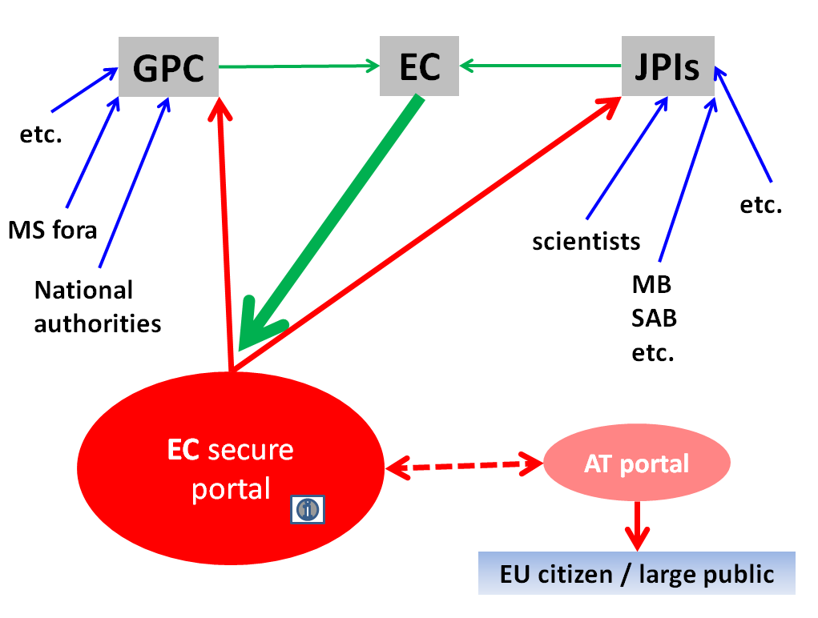

5. Implementation

5.1. Endorsement Required

The recommendations in this report are subject to endorsement by the GPC, which mandated the establishment of the Working Group. The recommendations are based on views expressed by GPC members, JPIs and Commission officials and the Working Group would like to express its appreciation of the time taken by all concerned to provide their valuable input to this report. In particular, the Working Group thanks Dr. Irmela Brach, Senior Policy Officer, DG Research and Innovation, for her unstinting support and expert advice.

Recommendations addressed to the GPC:
The recommendations approved by the GPC should be prioritised and implementation tracked through the GPC running list of decisions and actions proposed by the Working Group. MS are to report to GPC meetings on progress to implement the GPC’s recommendations at national level.

Recommendations addressed to the JPIs:
These recommendations take into account views expressed by JPIs in the course of the consultation undertaken by the Working Group. The WG, therefore, counts on the understanding of the JPIs to the soundness of the recommendations and hopes for full acceptance and implementation. JPIs should nevertheless report on the implementation of the GPC’s recommendations by written communication to the GPC or when attending GPC meetings as proposed above.

Recommendations addressed to the Commission:
It is proposed that recommendations addressed to the Commission be implemented by the Task Force recommended by the Working Group (see description below). The WG counts on the Commission services to endorse the recommendations at the highest level for the benefit of the JP process and the JPIs, in line with the Commission’s obligation to ensure the EU Treaty is properly applied. GPC would appreciate feed-back on implementation by the Commission services in early 2015.

5.2. Timeline for implementation

All recommendations of the WG should ideally be implemented as soon as possible after endorsement by the GPC. Nevertheless, the WG is aware of the fact that such recommendations are sometimes difficult to implement in the diverse landscape such as JPIs or the Commission services wherein the JPIs are spread over different Directorates.

The WG would like to draw the attention of all key actors in the field to the fact that the JP process is currently in a critical situation, requiring a new impetus and orientation and that the JPIs are more than ever in the need of political commitment to ensure sustainability.

5.3. Human and financial resources needed

The WG has tried to check its recommendations against feasibility as well with the Commission officials in charge of JPIs, several GPC members and some JPI-leaders. Human resources should therefore not be a major problem even if several recommendations request some early substantial need for human resource (i.e. update of the EC portal, the establishment of the Task Force etc.).

The WG is convinced that all actors will be able to find sufficient human and financial resources to satisfy the recommendations.

5.4. Description of the recommended EC ‘Task Force’ on Joint Programming

In follow-up of the recommendation by the Working Group and the proposed issues the Commission services should deal with, the WG proposes the establishment of a Commission internal ‘Task Force’.

The proposed task force should ideally be composed of the responsible Commission officials in charge of following JP and the JPIs in the Coordination unit (Joint Programming sector), in the different Thematic Directorates and their hierarchy.

It is proposed that the officially nominated representative of the Commission in the GPC (Deputy Director General) nominates the members of the task force ensuring a certain degree of stability in composition. Though all members are Commission officials, they should have, in our opinion, a certain degree of autonomy to meet their mandate in accordance with the mission of their respective Directorates’ policy.

The task force should for evident reasons be led by the DDG and have regular meetings on issues relevant to the GPC and the JPIs; the frequency of these meetings should be flexible, but determined by the DDG. The members of the task force being the most experienced Commission officials in the field of their respective JPIs could lead as such the coordination efforts across the Commission’s strategy and policy with respect to Joint Programming.

The task force should substantially contribute to the preparation of the agenda of the GPC meetings, WPs/calls for proposals and should take care of the up-taking of issues relevant for JPIs. Their involvement in foresight activities should serve the GPC and JPIs, ensuring timely information exchange and involvement.

Given the focus of Joint Programming addressing societal challenges, the task force should ideally stimulate a certain degree of cross-fertilisation as well as successfully deliver on achievements and successes of JPIs.

Furthermore and in follow-up of certain important issues brought up during the consultation process of the key stakeholders, this task force should, while mainly supporting the coordination team in all tasks, be contributing to:

- the development of a vision/strategy on JP
- a sound strategy for funding from the Commission services to be commonly agreed by the task force internally and then discussed with the JPIs and GPC
- the harmonisation of the common status of the Commission in the Management Boards of the JPIs.

With reference to the coordination unit acting as the secretariat/chef de file for the handling of communication issues (such as awareness raising actions, conference organisation, impact analysis etc.), the taskforce should, in this respect contribute to:

- the organisation of conferences, dedicated workshops, press activities, etc.
- the support of efficient awareness raising activities of the MS.

Furthermore, it should take full responsibility for:

- sustained operation of the JPIs
- voicing concerns and striving for discussing problems/issues related to JP/JPIs in view of finding solutions, if needed with the help of the GPC
- encouraging entities and bodies at national level to participate in JP/JPIs and striving towards more internationalisation of JP/JPIs
- informing on progress, interesting news/highlights/achievements from their respective JPIs
- communicating the Directorate’s policy priorities in task force meetings
- clarifying articulation, coordination and synergies between JPIs and Horizon 2020 in a timely manner
- implementing a sound and efficient routine mechanism for exchange of information at all levels
- ensuring proactive, context specific participation at relevant level in meetings of the GPC and the JPIs.

Such a task force, as a common forum for exchange of information internally, could be seen as an easy tool to furthermore ensure spreading a sound, coherent and commonly agreed message towards the external key stakeholders and via political channels.

The members of this task force are the right forum to take care of putting more prominently Joint Programming and its initiatives in Commission publications, briefings, notes, speeches and on the political agenda whenever possible/necessary.
They could be considered as the Commission’s ambassadors for Joint Programming.

5.5. EC database for JP/JPIs

Since the end of 2011, the Commission’s coordination unit had created a sound and well-structured database for JP/JPIs. Although this database has shown to be fully operational during its test phase, it has never been used in a systematic way.

In follow-up of its recommendation, the WG would encourage the Commission services to complete the information in this database with all relevant information for JP and JPIs since it offers a reliable, secure and efficient service to a wide-spread community of users while fully meeting the requirements of administrations, businesses and associations. This database enables users to work on a same subject and achieve common goals in a swift and cost-effective manner.

We would recommend extending the ‘closed/confidential section’s reserved space’ to the work of the proposed EC Task Force on Joint Programming with special access restriction.

The database had been created with open-source software for collaborative workspaces where communities of users can work together over the web and share information and resources, CIRCABC (Communication and Information Resource Centre for Administrations, Businesses and Citizens). For the 10 on-going Joint Programming initiatives this database could be a useful tool to exchange information (confidential, restricted or public) and learn from each other. As such, this common space presents an added value for everybody involved in JP and/or JPIs, be it internally or externally.

Being even more than just a platform for mutual learning and exchange of best practices, CIRCABC is a major opportunity for JPIs to enhance implementation based upon experience from others.

Access to this powerful tool as it has now been set-up, is to be granted by the Commission services to the predefined user groups as a function of their status and with regard to confidentiality of the information made available as well as with respect to the potential embedding of the database in the ERA website (public access to certain areas). The CIRCABC database as it stands is ready for embedding into the ERA website.

As the database is set up, JPI leaders can also upload their documentation to complete the information on their JPI and/or exchange information with relevant users about their on-going work, best practices and major achievements.

The concept of the site structure is presented in the graphic hereafter.

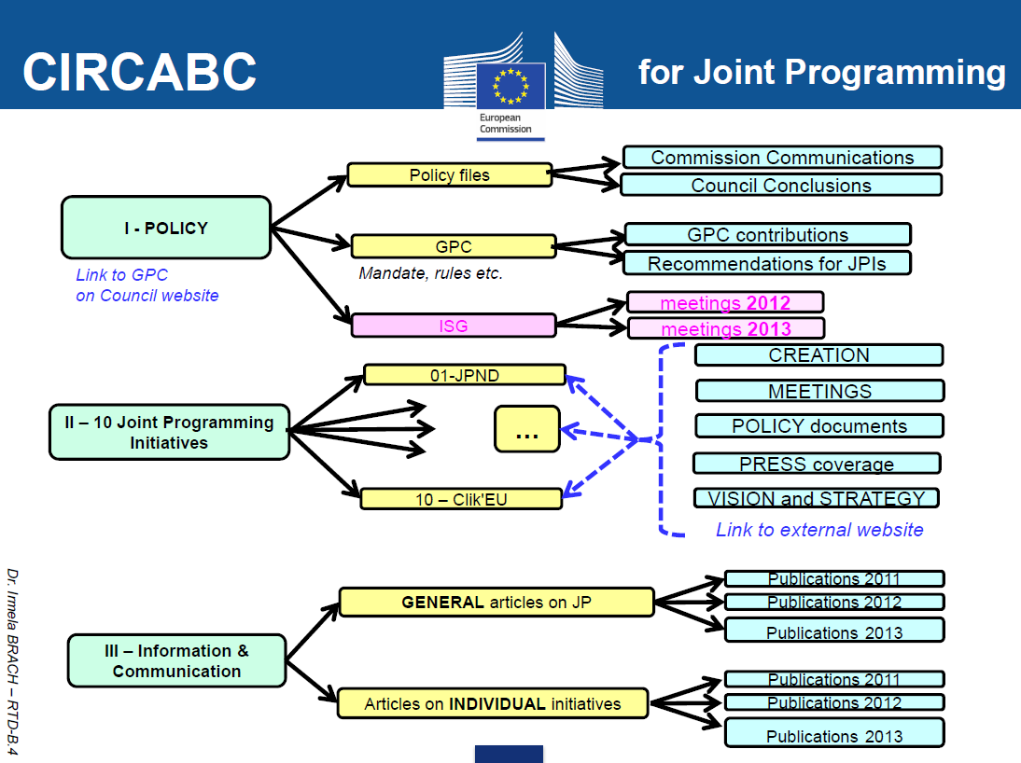

Until now, only a few documents have been uploaded into the predefined folders. Members with different access rights have tested successfully the system as currently set up. Upload of all relevant documents should subsequently be undertaken and the member list should be completed / extended.

An information session for the various users should be scheduled and a large awareness campaign should then be conducted towards all members of the GPC and the participants of the JPIs.

At this stage, it is critical to complete the archiving/uploading of the existing documentation/information etc. with respect to Joint Programming and its 10 initiatives as a first step to mutual learning and exchange of information for an enhanced and more efficient implementation of Joint Programming in Europe while contributing to the achievement of the ERA by 2014. CIRCABC is a major step in this direction.

6. Methodology

This Chapter outlines the approach taken by the WG in the preparation of its report. For the purposes of this exercise, data was collected from three main groups (namely GPC representatives, JPIs and Commission Officials) as well as information from the coordinator of the CSA JPIs to Co-Work.

Information was gathered in the following manner:

In most of the cases, questionnaires [cf. annex a. to this report], elaborated by the WG, were sent to the key stakeholders (JPI leaders and GPC members/observers) between October and November 2013.

It was decided by the WG to also send a questionnaire to the coordinator of the JPI-To-Cowork to have the benefit of his experience in the issues addressed.

During an extended interview in early December with the officially nominated Commission representative in the GPC, speaking on behalf of the coordination unit, it was suggested to also consult the Commission officials in charge of following the different JPIs in the thematic Directorates in DG Research and Innovation. Consultation with those officials in general underpinned the findings from the GPC and JPIs.
Further face-to-face interviews have been conducted with certain JPI-leaders by the chair of the WG or its individual members. In particular during the JPI-chair meeting in early December 2013, helpful information and support was given to the WG by representatives of the JPIs or their leaders.

The group organised its discussions around 5 meetings (between September 2013 and May 2014).

In particular, WG discussions and questionnaires focused on how the roles of the GPC, JPIs and Commission services as individual entities and collectively could be enhanced in order to improve and consolidate their communication structures (such as its relationships i.e. in the way these entities communicate with one another, communication ways and means, etc.) in order to facilitate the circulation of complete and timely information between the entities and to third parties in order to become more efficient. Themes discussed in meetings and in questionnaires addressed a variety of subjects from the promotion of Joint Programming to the frequency of exchange of information to communication ways and means.

The Working Group’s report, which makes specific recommendations to address the various issues raised, will be presented to the GPC in September 2014 in order to contribute to the preparation of the 2014 GPC Biennial Report.

It is envisaged that the GPC will follow-up on implementation of recommendations, once endorsed, at each of its meetings from December 2014 onwards.

ANNEXES

- Questionnaires

QUESTIONS addressed to the JPI leaders
(October 2013)

- ways by which timely communication between the GPC and the JPIs can be enhanced in order to facilitate the implementation of the JPIs, follow their advances and be aware of their needs
- the issues on which information should be exchanged between the GPC, JPIs and Commission services responsible for Joint Programming.

QUESTIONS addressed to the GPC (members and observers) and to the coordinator of JPIs-To-Cowork
(November 2013)

- What are the key elements you consider to be necessary to be communicated by the GPC and by which communication channels/tools? To the JPIs ? - To the EC ?
- Which elements, and by which means, should be communicated from the JPIs? To the GPC ? - To the EC ?
- Which elements, besides the input from the Commission services during the GPC meetings, should be communicated to the GPC by the Commission and by which means?
- Which are the key issues the Commission services should communicate to the JPIs and by which means taking into account the service structure of the Commission services responsible for JP & JPIs?
- How do you see the JPIs involved in or associated to the strategic planning / preparation of the work programmes (Horizon 2020)?
- Do you see an added value of Commission support (not funding) to raise awareness on Joint Programming as a political initiative for the future of European research?
- Do you consider the Commission should support (not fund) dedicated communication on the Joint Programming Initiatives upon request from the MS/JPI-leaders (i.e. valorisation actions on results/outcomes, etc.)?
- In your opinion, how can the relations between the Commission services and the JPIs be deepened (organisation of accompanying measures, i.e. workshops, specific events, press activities…)?
- How would you suggest measuring the impact of new ways of communication?
- How can the GPC and its members help the JPIs in reaching their goals?

QUESTIONS addressed to the Commission Officials following the JPIs in the Thematic Directorates
(February 2014)

- What are the key elements the YOU consider to be necessary to be communicated and by which communication channels/tools? To the JPIs ? - To the GPC ?
- Which elements and by which means should be communicated from the JPIs? To the GPC ? - To the EC ?
- Which elements, besides the input from the Commission services during the GPC meetings, should be communicated from the JPIs and by which means? To the GPC ? - To the EC ?
- Which are the key issues the Commission services should communicate to the JPIs and the GPC and at by which means taking into account the service structure of the Commission services responsible for JP & JPIs?
- How do you see the JPIs involved in or associated to the strategic planning / preparation of the work programmes (Horizon 2020)?
- Do you see an added value of EC support (not funding) to raise awareness on Joint Programming as a political initiative for the future of European research?
- Do you consider the EC should support (not fund) dedicated communication on the Joint Programming Initiatives upon request from the MS/JPI-leaders (i.e. valorisation actions on results/outcomes, etc.)?
- In your opinion, how can the relations between the GPC and the JPIs be deepened (organisation of accompanying measures, i.e. workshops, specific events, press activities…)?
- Should the Commission services play a pivotal role in such a process and if yes, which service?
- In your opinion, what would be the adequate frequency of these exchanges of information? GPC <-> JPIs ? - JPIs <-> EC ?
- How would you suggest measuring the impact of new ways of communication?

- synthesis tables on outcome of the consultations

SYNTHESIS TABLE 1:
Responses from the JPI leaders

1. Please indicate ways by which timely communication between the GPC and the JPIs can be enhanced in order to facilitate the implementation of the JPIs, follow their advances and be aware of their needs.
The GPC has been created initially to identify the topics that should be identified as “grand challenges” by the European Commission. Then he was in charge of several matters related to the JPI organisation and management, including an appraisal of their actions. Now the JPI have grown up and most of them have integrated the role and function of JPI, to reduce fragmentation and to increase collaboration within member states, associated countries and third countries on European Grand Challenges that are indeed global challenges.
More bilateral exchanges and updates are necessary to develop synergistic actions in order to solve as efficiently as possible these grand challenges. Due to the fact that JPI are primarily member states initiative, the GPC could be the body that could receive information from JPI, receive information of the European Commission and act as a “place” of exchange along with its strategic action.
- So regular exchanges could begin by mutual information of the agendas of the JPI and of the GPC
- A section could be created in the GPC meeting to address questions submitted by the JPI
- GPC could ask each JPI to give a yearly state of play of its action
- GPC could synthesize the points of view of its members regarding the roles and framework conditions of JPIs within ERA and to communicate to JPIs
- GPC should be informed of the progress in the implementation of the SRA of the JPI
- GPC should be informed of the alignment of the SRA of the JPI with MS research agenda
- GPC should collect from its members their perception and their action plan for the JPI. For instance all members are not interested in all JPI. A clear picture of these areas of interest should be elaborated by the GPC and information could be transmitted to the JPI.
- A common information sheet should be elaborated between GPC and JPIs to be presented during the management board of the JPIs and during the plenary session of the GPC
- The GPC have created working groups. JPIs members should be proposed to participate in each of them to insure a constant link between GPC and JPI and offer a realistic vision.
The GPC can be informed of JPI progress and needs through:
- Occasional GPC participation in Governing Board (GB) meetings as FACCE has already done
- JPI websites
- JPI newsletters
- Periodic telephone interviews with coordinators, GB Chair
- JPI participation in meetings organised by the GPC
- Given the importance placed by the European Commission on ‘alignment ‘of national research programmes with JPI SRA and Action Programmes , local MS dialogue with GPC representative Members is critical. National forum of JPI participants with their GPC representatives are necessary.
- Send GPC communication to JPIs’ coordinators in order to be up dated on the relevant information which regard JPI implementation within the frame of the national and EC research programming.
- Annual meeting with all JPIs in the presence of GPC and EC in order to facilitate successful monitoring, state of implementation, exchange of knowledge, identification/tackling of common problems.
- Regular reports on the milestones reached by the JPIs including new activities and actions required by the JPIs (i.e. Heritage plus, CSA etc.)
- Use of the Heritage Portal (in a secure dedicated areas) to communicate with the GPC.
The GPC plays a critical role in ensuring the political recognition and support for the JPI’s. The JPIs are all evolving at different rates which are dependent on the base from which they started. The JPI HDHL is working hard to develop strong relationships between health; physical activity and food researchers – a group of researchers that did not work together in the past. The research programmes at MS level are not all fully co-ordinated or integrated to undertake the type of research required to deliver on the vision of this JPI. Therefore, much effort has been made and will continue to be made to develop the appropriate ecosystem in which many of the research groups across Europe and beyond can come together and establish a critical mass that will result in the expected impact.
The GPC can ensure that the political environment within the MS is supportive of the work of the JPI HDHL; can facilitate the required activities within the MS research programming policies and activities; and can ensure that adequate resources (human and financial) are in place to support the MS actively participating in the JPI HDHL. To ensure implementation of the JPI HDHL’s SRA, the GPC should encourage the MS representatives on the GPC to support the joint activities required for implementation. Appropriate and timely communication between the JPI and the GPC will enable implementation. Currently, the communication activity between the GPC and JPI is low. Below are some issues / activities to enhance communication:

Specific Activities:
- The Commission has been responsible for developing the policy for JPI’s – the GPC could ensure that the JPI’s are involved in that policy development and should be consulted a key time points in that process.
- The GPC should ensure that the JPIs are consulted in the development of actions and activities related to Horizon 2020 such as the strategic programming and development of the WP’s;
- The GPC should support the JPI’s to promote their achievements and success stories;
- The GPC should support the JPI HDHL to work on aligning the SRA with the national research programmes and policies;
- The GPC could consider their role in facilitating international co-operation between JPI’s and other countries.
- Electronic communication to JPIs (Chairs, Administrative Structure) about major results and discussions in GPC meetings after the meeting
- Yearly reporting of JPIs to GPC about major achievements and progress and (potential) barriers/problems in the development of JPIs
- Yearly meetings between GPC and JPI representatives, Participation of JPIs in GPC meetings
- Once a year JPIs should report to the GPC in an ordered manner, including status quo, achievements, plans for next year, etc. (all JPIs should report a 3-5 page document with predefined headings)
- Once a year JPI Chairs should meet back-to-back with the GPC in order to exchange views and agree on common issues to be reported to the GPC
- If desired, cross JPI thematic working groups (e.g. concerning evaluation) could be established by the JPIs, results could also be presented to the GPC
- Timely communication needs to be increased substantially between the GPC and the JPIs by developing activities such as:
  - Annual meetings to be established with the presence of the JPI representatives/coordinators in order to enhance information exchange, set goals and evaluate progress.
  - Meetings/workshops where JPI progress and impact; as well as barriers to JPI implementation can be discussed.
  - Meetings/workshops where synergies in the implementation of JPIs and H2020 and the sustainability of JPIs can be discussed.
- The GPC should visit daily activities of the JPIs. As national delegates of JPI partner countries, GPC representatives can be invited to attend JPI meetings and to experience by themselves both progress and problems. Additionally, a number of GCP representatives from different countries are very close to JPI partners. In the case of the Water JPI, two partner countries are very close to their GPC representatives and can contribute to this liaison.
- Water JPI shows its availability to participate to the ad-hoc groups created at GPC, and congratulates the GPC for their creation.
- A GPC member could be appointed to take part as observer in JPI Oceans Management Board / or a single GPC contact point could be appointed for each of the JPI in order to facilitate exchange of information
- GPC could invite JPI representatives occasionally or regularly to their meetings. According to the type of meeting (plenary meeting, working groups), JPI could appoint the most relevant representative at the proper level.
- JPI Oceans has put in place some communication tools aiming at stakeholders, institutions and national bodies: these can also benefit GPC (newsletter, tweeter, and website).
Distribute agenda and minutes of GPC meetings to JPIs. (Agenda before the meeting to allow for input.)

2. Please indicate the issues on which information should be exchanged between the GPC, JPIs and Commission services responsible for Joint Programming.
The GPC could continuously keep high level of information regarding the positions of EC on JPIs as an instrument in the fulfilment of ERA-between the Commission and GPC-and between individual JPIs and GPC.
The GPC on the specific topic of each JPI could be the place where the coordination between the progress in the implementation of Horizon 2020 and the progress of the implementation of the JPI SRA could be presented
At the very beginning, the question of the framework conditions of JPI has been a major issue for GPC. A regular update should be made to allow a more practical implementation of these framework conditions
The GPC could be the common place where JPIs coordinators could exchange on their daily practice. GPC could gather JPI coordinator, European commission representative and GPC members to have brain storming and experience exchanges.
The GPC and JPI could build out the role and inform about JPIs as the “Knowledge Hub “ for the Program Area of the JPI for the particular issue of each of the JPIs
GPC could be the place where JPI could progress, improve and develop in order to fulfil their defragmentation role as efficiently as possible.

Among the different topics that could be addressed
- Harmonization of their terms of reference
- Harmonization of their dissemination strategies
- Facilitation of international relationships
- Discussions about the sustainability options for JPI
- Facilitation of information about JPI to country government represented in the GPC
- Facilitation of the relationships between the different European Commission services
- Lobbying places for alignment of national plans and identification of milestones and indicators to reach (to be defined : for instance % of national funds earmarked to JPI program each year…)
Respective roles of GPC, JPIs and Commission services
- Different way of communication and consultation between EC and JPIs: Being JPIs built on thematic areas and planning different instruments for common research programming, JPIs need transversal interactions with the EC on Horizon 2020, not limited on specific Societal Challenges.
- Greater flow of communication from EC on issues like CSA, Horizon 2020 (including Specific Programme and Work programme), Innovation Plan, relation between Horizon2020 and Innovation Plan (including the discussion on the instruments to correlate the two Programmes).
- Greater communication between EC and JPIs on expectation.
- Best practice in calls, in developing the Action Programme, in ‘in kind’ driven activities, networking /information.
Information exchange between the GPC, JPI’s and Commission on the following issues are important to facilitate progress in delivering the ERA:
- EC Policy on JPI and on other policies that can facilitate JP i.e. Regional Policies; Smart Specialisation; Industrial Policy (especially when JPI’s can support research on development of standards; Sectoral policies (especially where JPI’s can support activities that can underpin public health policy or regulatory policy);
- Horizon 2020 –strategic programming; funding instruments;
- Activities in the ERA – how JPIs are contributing to building the ERA and how that can do more to achieve the ERA;
- Information on other JPI’s – sharing of best practice
- Amendments / discussions on the Framework Conditions.
- Relations and Interaction between JPIs and Horizon2020 (in terms of research priority-setting and funding mechanisms and public-public-partnerships) – especially mechanisms and outcomes of interexchange.
- Expectations/Evaluations from GPC members towards the JPI instrument
- Voluntary Guidelines for Framework Conditions and their adaption/modification to the on-going developments of JPIs
- Funding strategy of JPIs (CSA, ERA-NETS)
- Role for JPIs for international cooperation
- Evaluation of JPIs
- Framework Conditions
- Issues related to the difficulties to address alignment of national research and innovation agendas.
- Issues related to the mobilisation of the Research and Innovation programmes in partner countries. Very often mobilisation of the resources in partner countries is only partial. The GPC can help in gaining access to all potentially interested agencies and programmes within a partner country.
- Issues related to the cooperation between JPIs and Horizon 2020. It is very important that communication and discussion reaches the GPC delegates. Their closeness to the Council will ensure that issues are debated and focused towards solution.
- Issues related to establishing a dialogue with prospective additional JPI partners. National representatives before the GPC can ease these contacts.
- current activities of JPIs including:
- development and implementation of SRIA
- mapping and foresight activities
- pilot actions or other common activities
- synergies and cooperation within Horizon 2020
- Development of questionnaires in order to secure relevance regarding progress (a single questionnaire does not fit all as JPIs are all at different stage of implementation)
- Collaboration between JPIs and Commission services responsible for JP.
- Role and Use of Framework Conditions.
SYNTHESIS TABLE 2:
Responses from the GPC (members and observers) and to the coordinator of JPI-To-Cowork

- What are the key elements you consider to be necessary to be communicated by the GPC and by which communication channels/tools?
To the JPIs ? | Willingness/ability of member states to support JPIs, requests for information needed by JPIs, ways how according to GPC the implementation could be improved (as a way to support the JPIs, not trying to patronize them)
To the JPIs ? | First of all GPC needs to communicate that it is there to facilitate the JPIs work. The GPC needs to establish itself as a board for the improvement of framework conditions for Joint Programming in a broader sense. It can then serve as link from the JPIs to MS/AS and EC. We need to create a mutual understanding of each other’s roles. I do have the impression that JPIs do not perceive GPC as important or even helpful for them. A communication can only successfully be established, if there is a mutual interest in that communication. We need to cater for that first.  I think we should decide at each meeting of the GPC what we want to communicate to the JPIs. We could make a kind of newsletter to be sent to all JPIs containing information we consider relevant for them. A member of the GPC could take over the role to prepare this. Furthermore, if need be, we could address some or a certain JPI with specific information or address questions to them. For this kind of communication all JPIs should name us an e-mail address.
To the JPIs ? | Simplification and standardisation of common procedures across the different JPI´s
To the JPIs ? | Full focus should be given to the obstacles that MSs face during either joining or implementing JPIs in their respective countries
To the JPIs ? | We believe the GPC and the JPIs need to have a common ground of work, with sustained communication flow. This communication should be instrumented in two ways: 1) JPIs attend specific GPC strategic meetings; and 2) GPC representatives attend relevant JPI meetings. Please note that a number of country delegates at the JPIs are at the same time GPC delegates. Regarding key elements to be communicated:  - GPC Vision on general JPI goals and time frame;  - GPC vision on the procedures and ambition in the alignment of National Research and Innovation Agendas.
To the JPIs ? | What: a) important decisions taken at GPC meetings and recommendations adopted b) Work programme in order to get their inputs  How: each JPI should nominate a contact person to be the link to GPC chair by mail
To the JPIs ? | - Updated list of GPC members and contact details;  - A single point of contact on the GPC for each JPI;  - Member States national JP strategies and governance structures  - Minutes of GPC meetings;  - GPC work plan  - The GPC Secretariat should be able to email this information to JPIs
To the JPIs ? | The main decisions, the work programme, the agenda and minutes of the meetings. In case, specific indications as e.g. the output of the WGs
To the JPIs ? | Key elements:  In spite of the fact that the JPI tackle different thematic areas, most of them have very similar problems related to:  - Means for sustainability  - Methodologies to create the Strategic research agenda  - Organization of the calls  - Outreach and interaction with the stakeholders  - Outreach and interaction with industry  - Communication with general public  Each JPI is at present time addressing these themes individually: this is excellent because the creativity of each JPI is challenged: however it would be useful to be able to compare the different approaches and facilitate cross-dissemination.  In addition, each JPI is facing different difficulties which should be defined and clearly presented to the GPC with the aim of finding a solution.  The main decisions, the work programme, the agenda and minutes of the meetings. In case, specific indications as e.g. the output of the WGs should be communicated as well.
To the JPIs ? | - Long term support – sustainable commitment and forward looking planning  - Coordination support on an international level  - Supporting JPI initiatives - Building sustainability through forward looking plans (targets to be achieved as well as funding available) communicated to JPIs in order for JPIs to plan calls  - Alignment of national funding to SRAs
To the JPIs ? | - On-going GPC work to create better enabling and facilitating conditions for the JPI’s  - GPC work programme, progress and meeting dates
To the JPIs ? | decisions on outcomes of GPC meetings i.e. priorities, best practice, relevant developments elsewhere in transnational co-operation e.g. COST, ERA-Nets
To the JPIs ? | GPC should communicate its priorities related to:  - Thematic areas to be tackled by JPIs  - Preferred options on how to address framework conditions (and closely related issues such as governance) and increase consistency across all JPIs  - Identification of potential spaces for collaborations among JPIs including the implementation of framework conditions: foresight, peer review, evaluation, dissemination, IPR
To the JPIs ? | - Reporting from key discussion topics  - Any updates regarding framework conditions  - Any updates that could have an impact on the JPIs  - Could be send the meeting dates in case the JPIs would like to submit any specific item  - Means: email communication and a yearly joint meeting
To the EC ? | National policies in supporting the alignment of RTDI, willingness/ability to support JPIs, need for support by the EC (CSA’s for the JPIs…)
To the EC ? | I do not see the need to improve the communication from GPC to EC
To the EC ? | Plans and progress reports for the individual JPI´s  The need for top up financing and/or financing of CSA
To the EC ? | Full focus should be given to the obstacles that MSs face during either joining or implementing JPIs in their respective countries
To the EC ? | We believe it can be useful the EC can participate in the GPC as a member, such as it is now. It can be useful that a wider, context specific representation of the EC attends specific meetings. Regarding key elements to be communicated:  - Difficulties found at the JPI level in progressing towards their goals.  - Specific needs of the JPIs to sustain their operation, particularly relating to Horizon 2020  - Need to optimize the coordination and synergy with H2020  - Needs for coordination with other EU initiatives, such as the European Innovation Partnerships, where relevant
To the EC ? | What: preparations of meetings, exchange of opinions  How: within the GPC meetings; the minimum EC level contact should be Head of Unit.
To the EC ? | As above if not in receipt through participation on GPC
To the EC ? | The EC participates to the meetings. Unless there are issues which should be dealt according to a very ‘formal’ procedure, I do not see the need for a specific communication
To the EC ? | An Annual meeting with all JPIs in the presence of GPC and EC would facilitate monitoring, state of implementation, exchange of knowledge, identification/tackling of common problems; however, the EC participates to the meetings. Unless there are issues which should be dealt according to a very ‘formal’ procedure, we do not see the need for a specific communication
To the EC ? | - Assist and support JPIs in their CSAs (continuation of)  - Provision of CSA support in H2020 (continuation of)  - Visibility and promotion of JPIs and their activities  - Coordination support on an international level  Means:  - Single contact person in GPC, JPIs and EC to consolidate communication channels  - Electronic mail  - Mail  - Special Communications  - Events and periodic meetings
To the EC ? | - On-going GPC work to create better enabling and facilitating conditions for the JPI’s  - GPC work programme, progress and meeting dates
To the EC ? | As the Commission are represented by DG RTD at GPC meetings and at working groups I am not clear what the communication issue is. If there are other DGs that need to be communicated with e.g. DG CNECT then should this be done by GPC secretariat?
To the EC ? | - Thematic areas to be tackled by JPIs  - H2020 activities:  - To complement JPIs, e.g. with Marie Curies, specific scientific topics in work plans, support to less active countries (regional and cohesion policy)  - Exploratory activities to enhance consistency of framework conditions across JPIs and collaboration across JPIs  - Activities needed to build European science information systems and data bases to identify gaps, overlaps and unnecessary duplications, including data from national programmes, and to facilitate smart specialization in one hand and European coordination in the other
To the EC ? | - This should be replied by GPC members

- Which elements, and by which means, should be communicated from the JPIs?
To the GPC ? | Brief information in a structured way on the progress of the JPI every year or twice a year (GPC to develop a template for this), Suggestions, how GPC could support the JPIs
To the GPC ? | The JPIs should communicate to the GPC the problems they are facing and the things/resources/support they need  And of course they should communicate the steps in implementation they make. A (the same) GPC member could take over the task to collect this information.
To the GPC ? | Short annual presentation at the meetings and/or short written reports on main activities and plans
To the GPC ? | For instance financing schemes should be communicated by EC. Initially the process was led and research activities were financed solely by Member States, now Commission has promised to strengthen its support in Horizon 2020 (e.g. what rules apply to using Structural Funds in financing JPI activities?).
To the GPC ? | - Issues related to the difficulties to address alignment of national research and innovation agendas.  - Issues related to the mobilisation of the Research and Innovation programmes in partner countries. Very often mobilisation of the resources in partner countries is only partial. The GPC can help in gaining access to all potentially interested agencies and programmes within a partner country.  - Issues related to establishing a dialogue with prospective additional JPI partners. National representatives before the GPC can ease these contacts.  It is very important that communication and discussion on these issues reaches GPC delegates. Their closeness to the Council will ensure that issues are debated and focused towards solution.
To the GPC ? | What: Strategy, milestones covered, 2 years planning, information on calls. Problems and best practices on implementation.  How: written report to chair and once a year presentation to the GPC committee. In every GPC meeting should be an information point by written that will include any interesting news. The GPC chair will collect and select the interest points to be included in the documentation to be sent to the delegates in advance
To the GPC ? | - A single point of contact for each JPI (by email to GPC Secretariat)  - Annual update of progress (by attendance at GPC meeting)  - Invitations to and reports of JPI annual meetings and conferences (by email to GPC Secretariat)  - Key decisions, policy documents (SRAs), proposed calls  - Issues which require GPC attention and recommendations
To the GPC ? | The main decisions, their SRA, the agenda and minutes of the meetings, underlining issues (if any) for which action by the GPC is required
To the GPC ? | Given the importance placed by the European Commission on ‘alignment ‘of national research programmes with JPI SRA and Action Programmes, local Member States dialogue with GPC representative Members is critical. National forum of JPI participants with their GPC representatives are necessary.  Regular reports on the milestones reached by the JPIs including new activities and actions required by the JPIs (i.e. Heritage plus, CSA etc.) have to be provided.  For example, in JPICH the use of the Heritage Portal (in a secure dedicated areas) is a good means to communicate with the GPC.  Through the GPC Members of the Coordinator and Participating Countries.  In addition, the main decisions, their SRA, the agenda and minutes of the meetings, underlining issues (if any) for which action by the GPC is required.
To the GPC ? | - Periodical progress  - Calls to be published  - Amendments occurring within the JPI  - Foresight planning  - Strategies towards third counties and industry  - International relations activities  - Other activities  - JPIs needs in terms of support from the GPC  - Detailed information regarding JPIs and their activities  - Details regarding relations of JPIs with third parties  - Provide advice to MS, GPC and Commission (advisory role)  Means:  - Periodic reports  - Electronic mail  - Mail  - Special communications  - Web portal  - Single contact person in GPC, JPIs and EC to consolidate communication channels  - Events and periodic meetings
To the GPC ? | - barriers for cooperation  - experiences with connecting multilateral programmes (e.g. JPI) and national programmes  - points to be included in the GPC agenda  - brief progress reports once a year
To the GPC ? | Outcomes and actions from their meetings. Progress on the JPI itself
To the GPC ? | - Lessons learned in JPIs useful to be adopted by national programmes in relation to foresight, peer review, evaluation, dissemination, IPR  - Recommended improvements on national programmes for better implementation of JPIs  - Problematic inconsistencies in national positions in different JPIs  - Needs related to infrastructures
To the GPC ? | - GPC should be updated with latest information on the JPIs: a yearly brief report on key activities and achievements could be sent.  - Specific communication could be done when the JPIs need specific political support
To the EC ? | Brief information in a structured way on the progress of the JPI every year or twice a year (GPC to develop a template for this), Suggestions, how GPC could support the JPIs.
To the EC ? | See point 4
To the EC ? | Short annual progress report on main activities and plans for the coming year
To the EC ? | For instance financing schemes should be communicated by EC. Initially the process was led and research activities were financed solely by Member States, now Commission has promised to strengthen its support in Horizon 2020 (e.g. what rules apply to using Structural Funds in financing JPI activities?).
To the EC ? | - Issues related to the cooperation between JPIs and Horizon 2020.  - Coordination of cooperation approaches JPI - Horizon 2020.  - Need for support to reach out to all areas of Horizon 2020, not just the Societal Challenges, specially mobility programmes  - Need to moderate the time overhead required to manage the financial support from the European Commission: from proposal preparation to the last report.
To the EC ? | What: Strategy, milestones covered, 2 years planning, information on calls.  How: Directly to the EC liaison officer and with copy to the GPC Board for the important issues  NEW: To the participants and national / regional managers?  How: annual open Conference on Joint Programming presenting the status of every JPI and discussing future plans
To the EC ? | - A single point of contact for each JPI (by email to GPC Secretariat)  - Annual update of progress (by attendance at GPC meeting)  - Invitations to and reports of JPI annual meetings and conferences (by email to GPC Secretariat)  - Key decisions, policy documents (SRAs), proposed calls  - Issues which require EC attention and recommendations
To the EC ? | Same as above, plus administrative issues
To the EC ? | JPIs need transversal interactions with the EC on Horizon 2020, not limited to specific societal challenges.  Administrative issues should be also part of the communication.
To the EC ? | - Periodical progress  - Detailed information regarding JPI activities  - Details regarding relations of JPI with third parties  Means:  - Single contact person in GPC, JPIs and EC to consolidate communication channels  - Electronic mail  - Mail  - Periodical reports  - Special Communications  - Web portal  - Events and periodic meetings
To the EC ? | - brief progress reports once a year
To the EC ? | - Scope of thematic areas of JPIs and points to be coordinated with H2020  - Complementary activities needed related to infrastructures and human resources  - Supporting activities for less active countries and promoting smart specialization
To the EC ? | - To the EC JPIs coordinating unit: a yearly brief report  - To the EC thematic unit: constant regular information in all aspects as a key partner within the JPI
- Which elements, besides the input from the Commission services during the GPC meetings, should be communicated to the GPC by the Commission and by which means?
Overview on elements in H2020 where the JPIs can find corresponding topics, More information on support to the JPIs coming from H2020 (CSA’s…)
There should be a constant dialogue between GPC and EC. Joint Programming needs to be implemented in a true partnership between MS/AS and EC. Therefore I do not see the need to define specific elements or channels.
The Commissions comment to the annual reports from the JPIs and how the input (e.g. the strategic plans) can be useful for the Commission in relation to Horizon2020 in general.
For instance financing schemes should be communicated by EC. Initially the process was led and research activities were financed solely by Member States, now Commission has promised to strengthen its support in Horizon 2020 (e.g. what rules apply to using Structural Funds in financing JPI activities?).
We believe that communication between the GPC and the Commission is very important, due to the closeness of the GPC to both the Council and the JPIs. The commission should discuss with the GPC developments in JPIs and expectations, given a previous good coordination between GPC and JPIs. The critical view of the GPC on these issues stands good chances of resulting useful to steer the JPIs.
What: the experience till now is very poor. EC should early present -and debate at GPC- theirs plans in order to support JPI. GPC should know in advance their ideas on future H2020 work programs. They should share within GPC their feeling on how are going forward the 10 JPI. Also should be included an analysis and possible connections of JPI with ongoing and future ERA-Nets. At GPC should be a debate (including EC) on the relation of JPI and their corresponding research at the normal calls.
Should every delegate read the 20 work programmes of Horizon in order to discover how EC is trying to support every JPI?
How: information points and debates at GPC meetings
EC’s strategic plan for joint programming (by presentation to GPC)
See answer to question 1
The European Commission position arising from monitoring activities, towards JPIs should be communicated also in view of Horizon 20202 through specific items and written procedure.
Consultation procedures should be implemented to favour synergies between Horizon2020 and JPIs, which are for their nature transversal to the three pillars.
In addition, see also answers to question 1.
- Briefing on all developments that could affect the structure and function of JPIs and developments on H2020 in general
- Highlighting any existing barriers or challenges that may be hindering the work of the JPIs so that these can be addressed
- Any other information involving JPIs
- The items above should be included in the GPC agenda
Commission communication related to GPC meetings should be sufficient.
  - Overview of ERA developments relevant for joint programming
  - related multilateral initiatives
The GPC should be kept informed of any significant developments that are likely to have an impact on joint programming in a timely fashion. This might mean that there will be communication via email between GPC meetings via the GPC secretariat.
Updated generic policy priorities such as Smart Specialization, Responsible Research and Innovation, Human Resources Strategy for Researchers, Innovation scoreboards, I3S
- Which are the key issues the Commission services should communicate to the JPIs and by which means taking into account the service structure of the Commission services responsible for JP & JPIs?
Overview on elements in H2020 where the JPIs can find corresponding topics, More information on support to the JPIs coming from H2020 (CSA’s…)
The JPIs should establish a constant communication channel with the officer(s) in charge of the corresponding part(s) of H2020. Those EC officials should actively participate in the JPI’s work.
It could be useful with information to the JPI´s about timing and plans relevant for the research activities in the JPI´s - e.g. activities and plans related to Horizon2020 calls
Not only information exchange between JPIs and corresponding FW projects is necessary, but also broader planning of research infrastructures as well as research cooperation with third countries should be communicated to JPIs. Also, JPI should be informed about political issues/setting of regulations, etc. that is ongoing on the same field.
The structure we now see is a liaison officer from the thematic unit plus an officer from the Joint Programming Unit. The liaison officer seems to be the single entry point to the Commission.
We understand that as an initiative we can have a fluid communication with different services of the EC, depending on the subject/instrument of communication. We believe on an enhanced communication on issues of mobility and completion of ERA. We are counting on the Liaison officer for these contacts. Interaction within the Commission seems to be quite important, since officers in other areas of DG R&I are not current with JPI developments.
What: future plans on related fields of research in order to inform and if possible complementing actions for covering the value chain.
It depends from the governance structure, whether the EC is a member of the governing boards or not
A member of the Commission is already present in the Management Board of most of the JPIs as observer, in order to ensure a continuous flux of information between the Commission and each JPI: this same figure should be responsible for the flux of info between Commission-GPC and JPI; in any case it should be present in those in which it is still not.
- Briefing on all developments that could affect the structure and function of JPIs and developments on H2020 in general
- Highlighting any existing barriers or challenges that may be hindering the work of the JPIs so that these can be addressed
- Any other information involving JPIs
- Commission services to propose how improvements can be made within JPIs by using examples from other networks and best practices
- The items above should be included in the GPC agenda
I don’t have enough experience of JPIs to comment on this. Presumably anything that affects JPIs should be communicated to them via the GPC secretariat
- The same as for the GPC
- updating of activities such as JTIs in related thematic fields
- Should inform about the possible instruments that could support the JPIs
- Should communicate regarding any events relevant for JPIs
- Should communicate on any information relevant to JPIs
- It would be good to communicate on any political initiative in general that could affect JPIs
- Ideally they could gather some information among JPIs and facilitate exchanges of good practices or key information
- From JPIAMR we have in 2013 received any information from them
- How do you see the JPIs involved in or associated to the strategic planning / preparation of the work programmes (Horizon 2020)?
Give an overview on elements in H2020, in the Work Programmes and call document where the JPIs can find corresponding topics, information on possible support to the JPIs coming from H2020 (CSA’s…). It is a big task for Member States to make Joint programming possible and support by the EC can have a huge impact.
To be involved in the strategic planning (including WPs) of H2020 is from my point of view one of the main tasks of JPIs. H2020 has to be one of the means to implement the SRA’s.
Important with active involvement of JPI´s strategic planning in the preparation of the work programmes (Horizon2020).
JPIs should give a common vision of where we are moving in scientific field and the content of H2020 should match with this vision, as H2020 is one tool to implement them. While H2020 and JPIs should be directly connected, it is not clear yet in some cases.
It should also be reflected in funding schemes – at the moment direct links between H2020 and JPIs are not clearly pointed out in this sense
In our view, JPIs need to be more involved in the strategic planning of the EC initiatives for Horizon 2020, the Innovation Union (in case of Water through its EIP on Water) and the ERA. In Work Programmes where there is an established JPI, the role of the JPI is ‘key’ to share and complement priorities (through the JPI SRIA) at a pan-European level. Communication with Horizon 2020 is at this time informal through the liaison officer. A more structured communication would be more effective and practical. There is no formal link between the JPIs and the Programme Committees. Some JPIs are represented at the Advisory Groups of the Societal Challenges.
What & How: JPI are a members and associates states driven initiatives; as the members and associates states are already represented at the Horizon 2020 committees, the natural way to channel their ideas should be through their national representatives at the committees. There is no need to complicate even more the representation structures.
Many Member State representatives on the Horizon 2020 Programme Committees have little or no involvement in joint programming/JPIs. It is vital that the objectives and plans of the JPIs are taken into account and facilitated by the Programme Committees when preparing the work programmes. JPIs should be invited to make written submissions, supported by presentations, to the relevant Programme Committees on each occasion when a work programme is being prepared.
I think the relationship between the JPIs and the so-called “configurations” of the H2020 Programme Committee should be the same as with the GPC, i.e. they can be invited (and they can ask to be invited) in specific circumstances. Routinely, a mechanism for exchange of information between the individual JPI and the relevant configuration(s) should be in place
Through the identification of common research thematic, on which the work programme should be created.
Most JPIs have been very active in the generation of the SRA: this knowledge should be the basis for the preparation of the Horizon 2020 programming: thus each JPI should represent a major source for the consultation in each respective thematic group and should be highly responsible for the development of the European Agenda in the field of their respective competence.
However, this responsibility necessitates that the procedure for the generation of the SRA in each JPI meets a certain set of requirements which should be set and assessed by the GPC.
Common research areas have already been identified among JPI Urban Europe, JPI Cultural Heritage, JPI Seas and Oceans and JPI Climate.
In addition, the relationship between the JPIs and the so-called “configurations” of the H2020 Programme Committee should be the same as with the GPC, i.e. they can be invited (and they can ask to be invited) in specific circumstances, during H2020 Programme Committee meetings. Routinely, a mechanism for exchange of information between the individual JPI and the relevant configuration(s) should be in place.
- Proposing initiatives to GPC which in turn can approve the proposals and define a plan of action for implementation
- Step up efforts to implement SRAs
- Ensure SRAs are developed and aligned with both the priorities addressed in H2020 and also aligned to national strategies of MS in order to facilitate coordination. JPIs should aim to create synergies with H2020 work programmes and design calls for proposals that complement the rest of the work under H2020.
- JPIs are still encouraged to have their own strategy when approaching industry at national, regional and international levels
- JPIs need to be proactive and take initiative so that they involve themselves in on-going consultations
- FACCE developed a model for addressing research issues. New issues: workshops to explore, upcoming issues in H2020 and ongoing issues by Joint programming. This idea could be explored further
- JPI’s should not develop towards another lobbying group for topics in H2020
I think that both the GPC and JPIs should be involved in the wider strategic planning for Horizon 2020 and other instruments for European research collaboration such as COST.
JPIs should be formally consulted and officially included in the process
We currently hold several synergies meetings with the EC during the year regarding funding programmes coordination and they are also using our SRA for H2020 funding. This model currently works very well in our side
- Do you see an added value of Commission support (not funding) to raise awareness on Joint Programming as a political initiative for the future of European research?
JPIs to be consulted, strategic planning of JPIs to be taken into account if possible. Joint Programming is a joint effort of Member States and the Commission
Yes, I am convinced that a determined political support by the EC for Joint Programming is essential. The EC rightly keeps saying that MS shall be in the lead. But the EC is a core player in the ERA and therefore needs to involve itself in the JP process also through promoting it and considering it as an important element of the ERA in its policy.
Increasing volume (funding from member states) is essential for raising awareness of the JPI. In addition the Commission can inform about the progress at relevant meetings
Certainly. MSs make considerable effort to raise awareness on JPIs and it would be helpful if EC could support these actions
We believe the EC support to raise awareness on Joint Programming as a pan European socio-economic-political initiative can be of a clear added value for Europeans, the European research and can certainly be useful for the completion of the European Research Area.
Before going any further, the Commission should concentrate on awareness to the existing JPI and ERA-Nets in the following issues:
- Pushing as much as possible the knowledge generated on those initiatives closer to the market.
- Fostering on adding coherence to all EU initiatives in related fields in such a way that the already existing ones (before inventing new ones) should complement each other and linking them: JPI & ERA-Net with EIP/ JTI-PPP/ Art. 185/ and related big projects as appropriate
The Commission can and should play a vital role in helping to promote awareness of joint programming given the Council’s decisions to approve the establishment of the JPIs. The political decisions by the Council should be fully supported / facilitated by the Commission which should use its resources not just to promote awareness of joint programming but to require Member States to demonstrate the actions they are taking to implement Council’s decisions.
Definitely YES; but I suggest additionally that there should be incentives for those who practice a Joint Programming process
Yes, seen as the connection for mutual exchange of information.
Indeed the Commission should be even more active and set a series of actions aimed at raising the awareness of the relevance of Joint programming and find means facilitating the process of joint programming.
The Commission could also facilitate the access of information of the JPI to the activities of SME and Industries funded by the EC and working in the field of interest of each JPI: often the information available is not sufficiently updated.
Definitely YES; but I suggest additionally that there should be incentives for those who practice a Joint Programming process
- There is added-value of Commission support to raise awareness on joint programming as a political initiative – Member States need to be made aware that incentives exist to coordinate their R&I efforts in certain fields and to reduce the fragmentation that exists across different countries.
- Support from the Commission will assist Member States and encourage them in participating in EU research and innovation fora
- Commission support can facilitate networking through the creation of hubs which may link JPIs especially in certain areas where there may be overlapping between the various JPIs. Such occasions may be excellent opportunities for JPIs to interact horizontally and hence deepen the networking also at horizontal level.
- Provide information about best practices and inform GPC and JPIs, it can also work the other way round where JPIs have best practices which can be used as an example in other fora.
yes: connecting national research strategies and programmes at European Level
I am not sure that I would call it a political initiative. I think it would be worth identifying what awareness of joint programming exists in the European research community and see how it can best be promoted through existing mechanisms at Commission and MS/AC level. If there is need for more support from Commission to raise awareness then the GPC could request that support from Commission.
Of course, but in joint venture with the GPC and / or national authorities
yes
- Do you consider the Commission should support (not fund) dedicated communication on the Joint Programming Initiatives upon request from the MS/JPI-leaders (i.e. valorisation actions on results/outcomes, etc.)?
Yes, it would be very helpful if Joint programming would be placed more prominently in Commission publications, communications, etc.
yes
Not important – it is a member state initiative
Yes, Commission should support the communication. As JPIs are interministerial by nature, the question of responsibility arises, but smooth cooperation between different ministries is a precondition for successful implementation – in this sense the involvement of EC could help considerably.
We believe that support on communication, dissemination and raising awareness from the EC is of special importance for the JPIs.
Yes. The Commission has a very good communication office that should help JPI, if properly advancing, on facilitating these tasks.
Yes, see answer to Question 6.
Definitely YES
Definitely YES
- The Commission should take a proactive approach with regards to dedicated communication on JPIs and if approval is required, the Commission should seek this approval from the MS/JPI-leaders so as to support dedicated communication on JPIs.
- The Commission needs to actively involve itself and foster stronger communication between it, the GPC and the JPIs.
- should be included in regular JPI initiatives and CSA’s, no special role for the Commission
- I don’t have enough experience of JPIs to comment on this. I don’t know what communication activities are currently undertaken.
Yes, but jointly with JPIs themselves
Yes
For example we are going to do a joint workshop with the EC show casting results /projects of both of our programmes
- In your opinion, how can the relations between the Commission services and the JPIs be deepened (organisation of accompanying measures, i.e. workshops, specific events, press activities…)?
Yes
See point 4
Perhaps workshops or seminars on case studies and examples of successful implementation would be helpful? As also pointed out already earlier by others, JPIs suffer from lack of routine – this is an untested field of operation in Europe
The EC and JPIs can foster their relations through different existing tools: participation in already existing committees of each other, consultation and frequent meetings (something already done by Water JPI). We need to structure a formal approach to interaction with Horizon 2020, and specifically consider areas other than the societal challenges.
See the previous answer plus organising the JP Annual Conference.
The Commission, rather than individual MS, is best placed to organise such accompanying measures given the service structure of the Commission services responsible for JP & JPIs.
By guaranteeing flow of information
Yes, through all the means listed, by guaranteeing flow of information
Several meetings and workshops are already organized and there is no need to add other meeting to those already on-going, as said before the Commission should participate to the meetings held in each JPI in order to convey the desires of the Commission to the JPI and vice-versa
- EC is doing an excellent job in supporting JPIs
- Visibility to JPIs is a key element in order to raise awareness and to strengthen the JPI networking at MS level.
- EC to actively seek MS participation into JPIs
- Workshops and press activities can improve relations between the Commission and JPIs
Joint activities GPC (members) Commission and JPI’s
I don’t have enough experience of JPIs to comment on this. If there is currently a lack of awareness if understanding of roles/activities between Commission and JPIs then a workshop would seem to be a good start. We would, of course, need clarity on what the objectives and desired outcomes for such an event were.
workshops
Specific events by topics that could benefit all the JPIs (e.g. research infrastructures or peer review issues)
Joint press activities regarding JPIs events or joint activities
- How would you suggest measuring the impact of new ways of communication?
EC organising mutual learning exercises, EC acting as a secretariat in organising meetings of the JPI chairs (like the meeting on 4.12. organised by Austria and the JPI Urban Europe)
Since well working communication is the basis of every successful system, improved overall performance of the JP process could be the simple indicator.
The involvement of different institutions in JPIs should rise as a consequence.
The Impact of the new ways of communication, including Communication 2.0 could be measured through activities realised online (e.g.: European Twitter Infoday of Water JPI on 13 November 2013 aiming to promote the open call for research and innovation proposals), through social media followers and interactions. However, we believe that there is still a lot to do in the arena of conventional communication.
The stakeholders’ views will be the best barometer of whether new ways of communication are having the desired impact. A review after a year might include GPC, JPIs and the EC being asked for their views as to what is working better and what is not.
Participation of JPIs in strategic planning of Horizon 2020 should be measured i.e. attendance at / submissions to programme committees.
Measurement of extent of ongoing engagement between GPC and JPIs – attendance at key meetings and events.
Population with relevant data and use of communications portal.
I know there are professional experts who can answer this question. I am not
As we know, there are professional experts who can answer to this question.
In any case, in my opinion, it can be done through questionnaires.
The trend of communication on line is spreading: there are easy ways to measure the impact of on line information through the social networks and by assessing the access on line to specific sites
- By measuring the popularity of the communications measure over a period of time, one can assess whether that particular means of communication was successful or not.
- Communication tools should be kept as uncomplicated as possible in order to maintain a pragmatic communications approach and to minimise misunderstandings between GPC and JPIs.
- increase in Joint programming activities
Consult with communication experts in the Commission (I assume they have marketing, digital communications and press people). In order to measure impact we will need to establish the current level of awareness, any issues with communications now. This might be done through a short survey perhaps using an online questionnaire service like Survey Monkey which would be repeated in 12 months. The chairs of JPIs meeting would seem the logical place to sound out JPIs on what the key issues are and what sort of communication they are looking for
Making surveys to involved actors on:
- Satisfaction
- Consistency of different programmes and framework conditions
You can ask on a yearly basis regarding satisfaction, impact is much more difficult to measure
- How can the GPC and its members help the JPIs in reaching their goals?
See replies to previous questions. Act as a partner for the JPIs
As said under point 1., the GPC needs to establish itself as a board for the improvement of framework conditions for Joint Programming in a broader sense. It can then serve as link from the JPIs to MS/AS and EC pushing the needed actions by MS/AS and Commission.
By encouraging coordination at national level – .sharing best practice – encouraging national participant to work together by facilitating national meetings or working at the same places or other activities according to national
The idea of JPIs as a tool to connect national research policy goals between different MSs is still not widely acknowledged. Knowledge about JPIs being one of the five initiatives of European Research Area does not help to fully grasp the range and extent of activities performed by JPIs or in connection with JPIs. Therefore it is important to communicate all relevant information to the stakeholders as soon as possible. Perhaps developing materials in local language would also help.
The GPC can help the JPIs with the following:
- Timely communication to be increased substantially between the GPC and the JPIs by developing activities such as:
- Annual meetings to be established with the presence of the JPI representatives/coordinators in order to enhance information exchange, set goals and evaluate progress.
- Meetings/workshops where JPI progress and impact; as well as barriers to JPI implementation can be discussed.
- Meetings/workshops where synergies in the implementation of JPIs and H2020 and the sustainability of JPIs can be discussed.
- The GPC should visit daily activities of the JPIs. As national delegates of JPI partner countries, GPC representatives can be invited to attend JPI meetings and to experience by themselves both progress and problems. Additionally, a number of GCP representatives from different countries are very close to JPI partners. In the case of the Water JPI, two partner countries are very close to their GPC representatives and can contribute to this liaison.
- Water JPI shows its availability to participate to the ad-hoc groups created at GPC, and congratulates the GPC for their creation.
Reinforcing the dialogue as described in questions 1&2
In addition to above, by enabling the JPIs objectives and needs to be a key factor in the work plan of, and decisions taken by, the GPC.
Actively pursuing decisions taken by the GPC on foot of requests/needs of the JPIs. GPC meetings should conclude with a list of actions to be taken and a running list of earlier decisions and the measures taken to implement them.
Representing key issues of the JPIs to the Council with recommendations for decisions to support the JPIs to reach their goals.
GPC/Member States should each map their own Country’s participation in the JPIs, detailing which JPIs they participate in or observe, who are the officials in Ministries and agencies at national level participating in each national JPI steering committee. Where feasible GPC members should attend meetings of the JPI national steering committees.
Member States should outline to GPC their national JP strategies and governance structures.
By a structured reciprocal consultation and ‘early warning’ mechanism. A periodical monitoring/measuring exercise (an example exists with the European Strategic Forum for Research Infrastructure ESFRI) could help. In a way, the Expert Group, although established to the evaluation of the ‘process’ and not of the individual JPIs, it provided some evidence about the ‘degree of maturity’ of almost each of them
It is of crucial importance that GPC communications are sent to JPIs’ coordinators in order to be up dated on the relevant information which regards JPI implementation within the frame of the national and EC research programming.
By a structured reciprocal consultation and ‘early warning’ mechanism. A periodical monitoring/measuring exercise (an example exists with the European Strategic Forum for Research Infrastructure ESFRI) could help. In a way, the Expert Group, although established for the evaluation of the ‘process’ and not of the individual JPIs, provided some evidence about the ‘degree of maturity’ of almost each of them.
- Encourage entities and bodies at MS level to participate in JPIs
- Provide coordination at MS level refunding for participation and other expenses
- Voice concerns of JPI participants during GPC meetings if these are not addressed by JPIs
- provide coordination of funding from national agencies
- Discuss and subsequently approve JPIs’ financial requirements on a long term basis
- Analyse annual and financial reports to be provided by JPIs and provide feedback to JPIs
At the risk at stating the obvious by providing effective governance for joint programming with effective communication of decisions, improved guidelines on framework conditions etc. (i.e. all the things that the GPC working groups are currently looking at)
  - Defining clear national positions regarding framework conditions
  - Working towards increasing coherence among these national positions
- GPC members could lobby at the national level to make that the JPIs national representatives have time allocated to work in JPI issues and can allocate the right level of resources
- GPC members could discuss cross issues among JPIs and help in facilitating the contacts among JPIs
- GPC could support JPIs when they need political support
- GPC could share strategic visions with JPIs
- How can the Commission help the JPIs in reaching their goals ?
See replies to previous questions. Act as a partner for the JPIs.
As said under point 6., the EC must involve itself in the JP process since H2020 is one of the means to implement JPIs and the Commission must support JP politically as well.
Topping up funding
Both the JPIs and the EC share the overarching goal of strengthening European competitiveness in research and innovation.
The established common ground for work between them has to be fostered. The JPIs need a wider gateway for interaction with the EC (different services/policies: i.e.: research & innovation, cohesion, education & culture, environment, energy, etc.), which by its well established mechanisms can be valuable to reach the JPIs goals in tackling pan-European societal challenges. Specifically:
- The Commission needs to continue supporting JPI activities with H2020 funds. This seems to be a critical point for JPIs take off.
- The Commission should consider ways to moderate the time required from the JPI to obtain and manage these funds; a simplification of procedures is required.
- The Commission should offer JPIs a clear and coordinated approach to the interaction with Horizon 2020.
Commission help should be selective depending on the advances and integrating steps taken by every JPI.
Ensuring JP and JPIs’ objectives are taken into account in all relevant policy areas e.g. Horizon 2020.
Keep JPIs and MS apprised of policy development
Maintain adequate staff resources to provide support to JPIs and GPC members
The major difficulties within the JPIs are to raise the awareness of the activities carried out within the JPIs in the different participating Countries: this is a major limitation for the alignment of the different Countries. Thus the Commission should further enhance the means of communication with the diplomatic and political channels within the EU Countries
- EC could provide best practices in other fora in order for challenges the JPIs are currently facing to be addressed at GPC level
- Provide continued support to JPIs via CSAs in H2020
The Commission should ensure that they consider joint programming as integral to H2020 and other EU wide initiatives and communicate effectively the opportunities to JPIs. (Apologies if they already have mechanisms in place for doing this)
- Supporting a European science information system
- Supporting less active countries
- Complementing JPIs with H2020
- Facilitate exchange of practices among JPIs
- Facilitate information on EC instruments to support JPIs
- Facilitate alignment between H2020 and JPIs SRAs
- Centralise information on JPIs activities and support on their dissemination

c. List of the 10 Joint Programming Initiatives

Alzheimer and other neurodegenerative diseases | 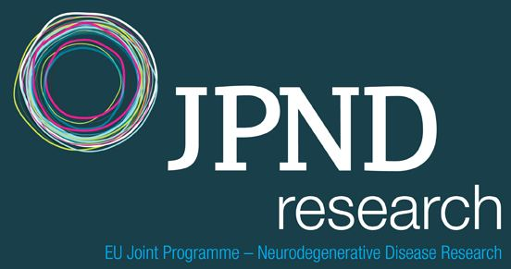
Agriculture, Food Security and Climate Change (FACCE) | 

Cultural Heritage and Global Change, A New Challenge for Europe
A Healthy Diet for a Healthy Life | 
More Years, Better Lives - The Potential and Challenges of Demographic Change | 
Urban Europe - Global Urban Challenges, Joint European Solutions | 
Water Challenges for a Changing World | 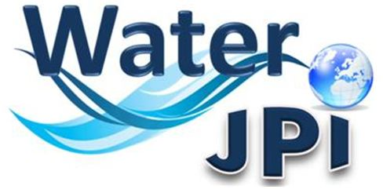
Healthy and Productive Seas and Oceans
The Microbial Challenge - An Emerging Threat to Human Health | 

Connecting Climate Knowledge for Europe

ANNEX 2
Alignment in the context of
Joint Programming Initiatives

REPORT

OF THE GPC WORKING GROUP ALIGNMENT

Chaired by Mogens Hørder

July 2014
Table of Content
Executive Summary
Members of the GPC Working Group Alignment
1. Introduction
1.1. Mandate of the GPC Working Group Alignment
1.2. Understanding alignment: the role of Joint Programming in the context of ERA
2. Key Stakeholders involved in alignment for Joint Programming
3. Information gained and collected by the Working Group Alignment
4. The Recommendations of the Working Group Alignment
5. Recommendations
5.1. A proposal for a Definition of alignment in the context of Joint Programming
5.2. Recommendations for actions to enhance alignment for the JPIs, for the Member States and for ERA
5.2.1 Recommendations for the role and engagement of Member States in the alignment of national research programmes and JPIs
5.2.2. Recommendations for actions of JPIs to enhance alignment
5.2.3 Recommendations for alignment in the perspective of ERA and the role of alignment in the coherence of Horizon 2020 and JPIs
5.3 Recommendations for monitoring the progress of alignment
Annex I: Key Documents on the concept of alignment in the context of Joint Programming
Annex II: The group internal analysis by the Working Group Alignment
Annex III: Outcome of a Questionnaire to the 10 JPI Chairs on JPI implementation strategies of alignment, February 2014
Annex IV: Summary Workshop Alignment, 12 March 2014, hosted by the GPC and the European Commission
Annex V: List of JPIs and their contact points
Executive Summary
The mandate of the GPC Working Group on Alignment
A crucial element of the Joint Programming Process is the alignment of national and European strategies and research programmes with Strategic Research Agendas (SRAs) of Joint Programming Initiatives (JPI). The Working Group was tasked with drafting a report to the GPC with the objective of exploring the concept of alignment in order to develop a common understanding of the ways alignment is undertaken in the context of Joint Programming; producing practical recommendations to implement actions that lead to alignment and making proposals for establishing measurable targets to help monitor the progress of alignment.
A common definition of Alignment for Joint Programming
The state of alignment for a particular JPI is changing and developing over time. Alignment is the strategic approach taken by Member States’ to modify their national programmes, priorities or activities as a consequence of the adoption of joint research priorities in the context of Joint Programming with a view to implement changes to improve efficiency of investment in research at the level of Member States and ERA.
Recommendations for the Member States
- Stronger interministerial coordination is needed, involving commitment and funding from several ministries (and their related funding agencies).
- New ways of engaging institutions should be addressed by policy makers, by developing a coordinated approach for institutional and project-based funding.
- Alignment is catalysed when there is a national top-down (i.e. strategic) programme/strategy in the domain. Member States do not necessarily need thematic programmes that exactly mirror a JPI’s SRA but they do need a national strategic approach towards the respective challenge. It is essential that this engagement is visible and long-standing.
Recommendations for the JPIs
- JPIs should look into aligning all actions spanning the programming cycle: from joint foresight, development of SRAs to joint processes of research practices, funding, implementation and ex-post evaluation and mobilization of in-kind resources.
- JPIs should use different actions and tools based on their type of challenge, on the kind of existing national programmes and on the available economic, human and technical resources and based on the phase of development they are in at a given point in time.

- Different actions that enable alignment within participating Member and Associated States are brought together in a JPI. Good practices should be further developed and eventually become best practices, shared among JPIs and promoted throughout Member States.
Recommendations for Alignment in the perspective of ERA and the role of Alignment in the coherence of Horizon 2020 and JPIs
- The alignment of national policies/programmes towards JPIs is pivotal for the role of JPIs in ERA.
- JPIs should become platforms for strategic programming and foresight for Member States working jointly together according to the identified good practices for alignment.
- The European Commission should facilitate the process of alignment by mapping, monitoring and evaluating the synergetic actions taken in the domains of societal challenges between Member States and between Member States and the EU-level.
Recommendations for monitoring of the progress of Alignment
- The JPI should continuously define which good practices for alignment it will apply and then monitor the implementation of these.
- The Member State should identify how much its own “programmes, priorities and activities” have changed since its commitment to the JPI and/or the adoption of the SRA.
Recommendations for the role of the GPC in the context of Alignment
- Monitoring of alignment activities should be undertaken by both JPIs and Member States by developing a strategy for monitoring their alignment activities.
- The role of the GPC would not be to monitor alignment accomplished in different JPIs or different Member States, but to develop a common approach for monitoring alignment. This can be done either by a dedicated GPC working group on this issue or by delegating some tasks to the new ERA-Learn 2020 project.
- The GPC should regularly review the progress of alignment as achieved by the individual JPIs and Member States.

Additional information on Alignment of the Report
Important additional information on the material collected and analysed by the Working Group can be found in the annexes of the report.
Members of the GPC Working Group Alignment
First name | Name | Nationality
Ingunn Borlaug | Lid | Norway
Dariusz | Drewniak | Poland
Fulvio | Esposito | Italy
Lutz | Gros | Germany
Leila | Hakkinen | Finland
Francien | Heijs | Netherlands
Mogens | Horder (Chair) | Denmark
Kristine | Naterstad | Norway
Rami | Nissila | Finland
Sirpa | Nuotio | Finland
Sergiu | Porcescu | Moldova
Jaana | Roos | Finland
Eva | Stensköld | Sweden
Josef | Stuefer | Netherlands
Laszlo | Szilagyi | Hungary
Arnolds | Ubelis | Latvia
Mats | Ulfendahl | Sweden
Selda | Ulutas | Turkey
Fabrizio | Vecchi | Italy
Birte | Wollenhaupt | Germany
The Secretariat of the Working Group was ensured by the European Commission (Julia Prikoszovits).
1. Introduction
Alignment is the key to successful Joint Programming.
The first phase of Joint Programming included identifying societal challenges to be addressed by JPIs and was guided by the GPC and approved by the EU Council. The current second phase is involving the process of alignment of national research programmes and activities around a common focus or societal challenge.
By aligning and coordinating the institutional and competitive funding committed nationally, which accounts for 88% of GBOARD in Europe, we can better exploit our resources for maximal societal impact and thereby improve efficiency of resources for research in Europe.
Member States need to engage fully in the alignment of national research programmes and activities in order to unlock the potential of Joint Programming and move from the current second to a third phase of Joint Programming.
A future third phase sees Member States working together in a systematic and strategic way to identify societal challenge (or core research question) and then implementing the full policy cycle -including developing roadmaps, funding research, undertaking ex-post and ex-ante evaluations- leading to alignment.

1.1. Mandate of the GPC Working Group Alignment
The Working Group was established as a follow up by the GPC in response to the outcome of the conference on Joint Programming by the Irish Presidency and the European Commission in February 2013.
The Working Group agreed on a mandate for the group in its first meeting in September 2013:

“A crucial element of Joint Programming is the alignment of national and European strategies and research programmes with Strategic Research Agendas of Joint Programming Initiatives (JPIs). Much emphasis has been put on the need for alignment, however little has been indicated on how to achieve it. The Working Group recognizes that alignment is a concept that is open to many interpretations.
The objectives of the group are:
- to explore the concept of alignment and to develop a common understanding of the ways alignment is undertaken in the context of Joint Programming
- to produce practical recommendations to implement actions that lead to alignment
- to make proposals for establishing measurable targets to help monitor the progress of alignment
- to identify the possibilities for implementing alignment in parallel with Horizon 2020
Working methods of the group:
The Working Group will explore the ways alignment is perceived by the existing JPIs and will investigate how the differences in the scope of the various JPIs might influence the way alignment with national research programmes might be turned into practice.
The Working Group will look into the potential for alignment given that at the national level research funding systems include many different actions.
The Working Group will put emphasis on developing practical recommendations for achieving alignment within the European Research Area considering the barriers mentioned above.
The Working Group will present its report to the GPC June 2014.”

1.2. Understanding alignment: the role of Joint Programming in the context of ERA
ERA policy is a shared competence between Member States and the EU. Even though legally speaking, the Treaty of Lisbon (TFEU) would give the power (Art. 182.5) to the European Union to establish the necessary measures for the implementation of ERA, so far a partnership approach with Member States has been chosen to make ERA a reality. The responsibility to develop ERA rests with the Member States because research policy is mainly handled at the national level. With the creation of ERA in Lisbon in March 2000 the European Council formulated the ambitious aim for Europe to become the most competitive and dynamic knowledge-based economy in the world by 2010. With that vision in mind, Member States agreed in Barcelona in March 2002 to raise R&D expenditure levels to 3% of GDP by 2010. So since 2000, the Union has started to coordinate national research policies.
The EU Framework Programmes (FPs) have always had structuring effects on the national research systems but it was with the introduction of “ERA instruments” as of FP 6 (ERA-NETs, Art. 185 initiatives) that this structuring influence became more evident and moved from the project level (involving researcher and/or research unit level) to the Member State/funding bodies – the programme - level. With the FP, the European Commission disposes of a tool that can incentivise this coordination financially. Only 1,47% of GBOARD is transnationally coordinated funding, financed by Member States. Broadly speaking, about on average 8% of the overall available European GBOARD is funded by the FP. Around 88% of GBOARD is confined to Member States (2010 figures for EU-27).
Joint Programming Initiatives (JPIs) are country to country collaborations involving the full policy cycle as well as the different layers of the national research systems (from the policy-making level to the level of the individual researcher). An ERA-NET is a program to program collaboration based on joint calls. There are several favourable gains from the move from collaboration within a project to cooperation and coordination of programmes. Most importantly a programming approach provides for joint vision development and strategic agenda setting. It also ensures a longer-term period of available funding and is more likely to build critical mass.
Whilst programme cooperation remained to be done ex-post for ERA-NETs and Art. 185 initiatives (existing programmes joining up), a more ex-ante approach was introduced with Joint Programming, where new programmes addressing societal challenges were jointly created by Member States at the EU-level and where no EU funding was involved a priori. Joint Programming is a process designed to ensure the optimisation of existing and future research efforts at the level of the Member States and by doing this, contributes to the structuring of research efforts in the ERA. Amongst many other positive effects, a coordinated approach in public research policy making can enhance national and overall European efficiency and effectiveness, avoid unnecessary duplication in research funding, create critical mass by pooling funds and enhance the level of scientific excellence by streamlining and standardising research evaluation practices and by generating a greater pool of scientists that compete with each other.
Grand societal challenges have been introduced as a vehicle and catalyst to capture political and public imagination for larger efforts that also engage Member States resources. The idea was to bring together national programmes to tackle grand societal challenges, as defined in the Strategic Research Agenda (SRA) of the JPI.
In order to embrace fully this double nature of Joint Programming(structuring ERA and addressing societal challenges), alignment of national policies towards a defined SRA of a JPI is the prerequisite to realise Joint Programming.

2. Key Stakeholders involved in alignment for Joint Programming

The aim of this report is that the key stakeholders involved in Joint Programming observe and implement the recommendations made for alignment.

The key stakeholders identified are the GPC, the Member States (as well as Associated States), the JPIs, the European Commission, the research institutions and the researchers.

- From a political perspective, the GPC plays a critical role in ensuring political recognition and support for the JPIs. The GPC is considered as the forum where exchange of information about developments at national level in priority areas takes place in order to align national research strategies with the JPIs’ SRAs agreed priority areas.

- Member States have been invited to step up efforts to implement joint research agendas addressing grand societal challenges, to share information about activities in agreed priority areas, to ensure that adequate national funding is committed and to strategically align programmes and activities at European level in these areas.

- JPIs were entitled to make use of the variable geometry principle and were tasked with setting up their own management and scientific boards and develop their SRA. They are expected to recognize that alignment plays a crucial role in the implementation of the SRA.

- The European Commission plays a pivotal role in the development of coherence between Horizon 2020 - the current most important instrument for ERA - and the JPIs, recognizing them as important actors in ERA.

- The research institutions and the individual researcher in Member States that participate in JPIs are very important stakeholders. Research institutions may develop institutional strategies towards the JPI domain. Many of the actions towards alignment are well known to researchers. Becoming a stakeholder for alignment is adapting the way research is planned and conducted in the context of a specific JPI.

- Ultimately, JPIs being in place to address societal challenges through joint European research, European citizens are key stakeholders for Joint Programming as well. Citizens are involved in JPIs usually via Stakeholder Advisory Boards. Civil Society Associations' concerns are taken into account by JPIs either directly or through the government (ministries) acting as transmitter.

3. Information gained and collected by the Working Group Alignment
The members of the Working Group recognized that alignment is a concept that has been open to many interpretations - by e.g. individual JPIs, by Member States, the GPC and by the European Commission. To get closer to a common understanding of the concept of alignment the Working Group decided on a methodology based on four types of information sources:
- The Working Group researched key documents published within the latest 2-3 years by the European Commission and the GPC (see Annex I).
- The members of the Working Group representing mainly Member States had different experiences and expectations as to what the role of JPIs is - and in particular how alignment should be interpreted. The group therefore did a “group internal analysis“ of the concept of alignment (see Annex ).
- The 10 JPIs were asked to report their experiences in implementing Alignment through a structured questionnaire (see Annex II)
- Finally a workshop on alignment was organized by the Working Group together with the European Commission in which representatives of all JPIs, of the Member States, the GPC and the European Commission participated (see Annex IV).
Several physical meetings as well as teleconferences were organized, assisted by the European Commission who acted as Secretariat of the Working Group.
4. The Recommendations of the GPC Working Group Alignment
According to the objectives stated in the mandate the Working Group has drafted:
- A proposal for a definition of alignment in the context of Joint Programming
- Recommendations for actions to enhance alignment for the JPIs, for the Member States and for ERA (ie for the GPC and the European Commission)
- Recommendations for monitoring the progress of the implementation of alignment.
The Working Group hopes that with this report a contribution is made to a common understanding of the concept of alignment in the context of Joint Programming Initiatives within ERA. Hope is that the report adds to a gradually commonly accepted standard as to how alignment can take place.

5. Recommendations
5.1. A proposal for a definition of alignment in the context of Joint Programming
The approach of the Working Group has been to explore different pathways towards alignment and thus to come closer to a definition that will be achievable by Member States for current and future Joint Programming Initiatives.
Alignment concerns Member States and JPIs alike and the form it takes will depend on the individual JPI and the individual Member State. There is no unified approach to alignment towards the 10 JPIs even within the same Member State because of the interdisciplinary nature of Joint Programming addressing societal challenges that involves multiple actors (stakeholders in society, research funders/ministries, researchers etc.).
The state of alignment for a particular JPI is changing and developing over time. This rolling process of alignment is in line with the three phases of the Joint Programming process as described in the Expert group review from 2012. However, the aim of alignment of the SRAs of national programmes with the SRA of a JPI, in order to best possibly address the societal challenge, is the same of all JPIs.
The definition that will cover the above approach is:
‘Alignment is the strategic approach taken by Member States’ ^{[1]} to modify their national programmes, priorities or activities as a consequence of the adoption of joint research priorities in the context of Joint Programming with a view to implement changes to improve efficiency of investment in research at the level of Member States and ERA.’
The practical steps to undertake for achieving alignment are to decide on and implement practices towards alignment by JPIs as well as Member States.
A list of good practice for alignment activities combined with a suitable exchange and learning platform should be kept up to date by an adequate forum in close cooperation with the GPC and the JPIs.
In this report, a first listing of good practice for alignment can be found in Section 5.2.). Annex III and IV includes further examples of good practice and experiences of JPIs and Member States in implementing such practices are described. The Workshop on Alignment as described in Annex IV is an example of a platform for exchange of good practice.

5.2. Recommendations for actions to enhance alignment for the JPIs, for the Member States and for ERA
5.2.1 Recommendations for the role and engagement of Member States in the alignment of national research programmes and JPIs
Member States’ internal research governance structures
The Working Group’s findings support the notion that there are different ways of how Member States can organize themselves for enhancing alignment (see Annex IV, case studies Member States as presented in the GPC Workshop on Alignment on 12 March). There is no need for a unified European approach to internal research governance of Member States in order to participate in JPIs and diversity in this respect is not an obstacle.
However there are two points that deserve careful consideration and possible mitigation:
- Because of the cross-cutting nature of societal challenges, stronger interministerial coordination is needed, involving commitment and funding from several ministries (and their related funding agencies).
- Because of extensive amounts of untapped potential of research performing organizations (institutional funding), new ways of engaging institutions should be addressed by policy makers, by developing a coordinated approach for institutional and project-based funding.
Member States and their authorities should be aware of the importance of good administrative practice to enhance alignment and decrease barriers towards it. They should invest in the build-up and continuous training of sufficient human resources in ministries and agencies in order to create and ensure awareness about the benefits of alignment in Joint Programming (including the adaption of operational funding rules).
National engagement in the JPI domain
The need for national and regional policy frameworks in the research fields of the JPIs, has led many Member States to develop national action plans, roadmaps and strategies in the domain of the JPIs they participate in with a view to underpin their commitment to the SRA of JPIs. Indeed alignment is catalysed when there is a national top-down (i.e. strategic) programme/strategy in the domain.
However Member States do not necessarily need thematic programmes that exactly mirror or mimic a JPI’s SRA but they do need a national strategic approach towards the respective challenge. It is essential that this engagement is visible and long-standing.
National research programme/national strategies in the JPI domain developed with the input of national researchers will catalyse, develop and create identity and ownership for the JPI nationally.
Special awareness is necessary within a Member State for JPIs that are funded entirely bottom-up, ie national programmes do not exist in that domain. If at the same time, the amount of funding in that domain is small, it becomes nearly impossible for a Member State to participate in a meaningful way. A bottom-up approach to research funding makes it difficult to identify areas for alignment. In these cases, the engagement of institutional funding for the SRA of a JPI is a good approach but ideally a mixed top-down and bottom-up approach is to be preferred.
Decision makers at different levels in the key stakeholders need to be aware of the JPIs SRAs and their long-term visions and they should be involved in the definition, validation and final approval of the adopted SRAs.
Externally demonstrated national political commitment for the JPIs
Political commitment and will is best expressed by the nomination of national high-level senior representatives to the GPC and in the Governing Boards of the JPIs. Nominations should be for a longer period to support the understanding of the nature of Joint Programming

For a better understanding of how alignment action can bring value to the national context, communication at all levels (EU, GPC and JPI and individual Member State level) has to be improved and be more political and strategic.
For an integrative communication at national level, those responsible for the national research policy and funding in the respective area should ideally also be in charge of the JP involvement of the respective Member State. It would be optimal if they are at the same time the national representatives in the JPI Governing Board.

5.2.2. Recommendations for actions of JPIs to enhance alignment
The spectrum of alignment
JPIs will benefit from the alignment of national research programmes of participating Member States because it will increase the basis of their available means to implement the commonly defined SRA for addressing the societal challenge of the JPI. Therefore it is in the interest of JPIs to look into aligning all actions spanning the programming cycle: from joint foresight, development of strategic research agenda to joint processes of research practices, funding, implementation and ex-post evaluation. Mobilization of in kind resources (e.g. joining up research infrastructures) are also important joint actions of Joint Programming.
Alignment is a long term development
JPIs are not funding instruments, but intergovernmental transnational coordination bodies, all long term and in the midst of development. Whereas joint calls have been a first joint activity for some of the ten JPIs, JPIs’ activities should go far beyond joint calls. JPIs should use different actions and tools based on their type of challenge, on the kind of existing national programmes and on the available economic, human and technical resources and based on the phase of development they are in at a given point in time.
Good practices of alignment
Different actions that enable alignment within participating Member and Associated States are brought together in a JPI. In addition to a systems oriented definition and profiling of the term „Alignment“ –as already discussed in the section on definitions of this report- good practices for alignment in JPIs (like the knowledge hub or the thematic programming or others) are as important. Good practices should be further developed and eventually become best practices, shared among JPIs and promoted throughout Member States.
Networking approaches (e.g. Knowledge Hubs, Thematic Programmes, Centres of Excellence) are well suited to themes where most Member States have priorities. They also allow Member States to identify gaps in their research strategies and practices. They easily allow combining in-kind and institutional funding with in cash support, and smart specialisation.
However, also other important actions have been applied by current JPIs. All together these constitute a number of actions that should be considered “Good Practices for Alignment”. It is important to stress that actual good practices will change over time depending on the three phases of the JPI.
“Good Practices for alignment in the Context of JPIs”- as of 2014
1. Explore and prepare for alignment
- Mapping of current research and gaps among participating Member States
- Differentiation of tools for exploration and assessment (mapping, workshops, syntheses, white papers) suited for the needs of the different topics
- Evolutionary vision from 3 to 10 years for the development from weak to stronger alignment.
2. Actions for JPIs to achieve alignment of national policies/programmes
- Networking and capacity building among research groups and stakeholders - eg Knowledge Hubs and Thematic groups
- Calibration and standardization of methodologies
- Identifying capacity building approaches to facilitate better networking across and between disciplines and researchers
- Any activity heavily building on large infrastructures or large institutionally funded players
- Most appropriate areas should be selected carefully taking into account the cost for mid-term adaptation versus the long-term reward
- Definition of approaches that may facilitate wider access to national technology platforms or infrastructure, and promote the sharing of data and resources
- Institutional Alliances: Institutional cooperation, complementarity, sharing of infrastructure and staff
- Standardize – where possible - internal procedures in Member States where relevant for joint actions
- Focus on research areas where nationally funded research is existing aiming at building joint critical mass – eg centres of excellence
- Alignment leads to joint transnational calls (eg funded by ERA-NET Cofund) and joint transnational calls lead to alignment
- Development of transnational procedures for prioritizing, evaluation and decisions on funding
- Consider that excellence as an ultimate priority for funding does not always constitute the most efficient way to enhance alignment
- Coordinated funding decisions in each country (time, amount and topic).
- Catalyzing development of national strategies
- Identifying capacity-building approaches to facilitate better networking across and between disciplines and researchers
- Linking, harmonizing and sharing information between investments under national programmes in the JPI research field
- Smart specialization/labor sharing

5.2.3 Recommendations for alignment in the perspective of ERA and the role of alignment in the coherence of Horizon 2020 and JPIs
The role of JPIs in ERA
It is essential to be aware that JPIs do not only address societal challenges but also play a structuring role in the ERA landscape. The alignment of national policies/programmes towards JPIs is pivotal for this role of JPIs in ERA. In fact, Joint Programming is the most strategic and all encompassing process developed within the ERA so far, and has the potential to be the vehicle for the other, more operational elements of ERA.
JPIs are Mini-ERAs in that they in themselves address all the important ERA actions (from effectiveness of national research systems to knowledge transfer and dissemination). Thus JPIs should be made more visible at all levels of ERA.
The advantage of JPIs as Member States’ cooperations at the public research programme level in the complex ERA landscape is the long-term focus of its activities. Alignment introduces changes in approaches for research policy from the political level to the level of the individual researcher.

JPIs should become platforms for strategic programming and foresight for Member States working jointly together according to the identified good practices for alignment. This would be comparable to how the European Commission is proceeding with internal strategic programming of the Horizon 2020 Work Programmes.
The role of the European Commission is important in facilitating the process of alignment in Joint Programming and within the individual JPIs. It could do so by mapping, monitoring and evaluating the synergetic actions taken in the domains of societal challenges between Member States and between Member States and the EU-level. It could assist in defining current or new common societal challenges, eg by providing forward looking activities to feed priority setting for societal challenges. Furthermore, the European Commission should envisage continuing to support the individual JPIs in their endeavour of alignment. Finally, the European Commission could explore the potential of JPIs - bringing together the right people from Member States – to discuss the content, funding and implementation of new Art. 185 initiatives.
The way forward with alignment for Joint Programming in ERA
It is essential that the work started by the GPC Working Group Alignment continues (at the appropriate level), in collaboration with the GPC, and that best practises are “logged” for future use.
The Working Group welcomes the efforts undertaken by the EC to support the assessment and exploration of current and possibly new approaches to alignment in the context of the follow-up project of ERA-Learn, JPI to Co-work and Netwatch. The Working Group considers such arenas to be the right place to build further on this exploratory GPC report on alignment. However, the Working Group wants to emphasise that involvement of the GPC should be ensured in activities that an eventual successor project will undertake in its quest to push alignment further ahead.
Such involvement will ensure a continuum that will benefit the alignment by Member States and JPIs, meaning that a log of good practice for alignment is updated steadily and its use assessed. Ideally this is done through workshops and further analysis on the topic. In the future, it will also be important to concentrate more strongly on alignment using a broader spectre of means, ie institutional funding or smart specialisation. With scarce Member States’ resources as regards cash funds channelled via national programmes to the JPI, the alignment of institutional strategies will inevitably come more into the picture.

5.3. Recommendations for monitoring the progress of alignment
Monitoring of alignment activities should be undertaken by both JPIs and Member States. The role of the GPC would not be to monitor alignment accomplished in different JPIs or in the different Member States, but to develop a common approach for monitoring alignment.
1. The JPIs individually should develop a strategy for monitoring their alignment activities:
The JPI should continuously define which good practices for alignment it will apply and then monitor the implementation of these. With time it can test different alignment activities. Overall JPIs will gain experience and a growing number of good practices will be applied and implemented.
2. The Member States should individually develop a strategy for monitoring their own alignment activities based on their situation:
The participating country of a JPI should identify how much its own “programmes, priorities and activities” have changed since its commitment to the JPI and/or the adoption of the SRA.
A change could be
- a change in the content of research (e.g. degree of similarity in objectives or themes),
- a change in the volume of research,
- a change in the way the programme/activity is executed (e.g. degree of collaboration),
- a change in research output.
In case of volume, one can consider e.g. number of programmes/activities, number of joint programmes/activities, number of researchers or institutes involved (the size of JPI community), or the amount of funding allocated to these, either in real terms or relative to other research.
The overall alignment of each of the participating countries should provide an indicator to how much a JPI is aligned to its own priorities.
The GPC should regularly review the progress of alignment as achieved by the individual JPIs and MS.
Annexes
Annex I: Key Documents on the concept of alignment in the context of Joint Programming
The Working Group has reviewed 4 key documents on Joint Programming published since 2012. In the following references are made to those sections of the four documents where the concept and roles of alignment are highlighted in the documents.
1. Review of the Joint Programming Process
Final Report of the Expert Group (October 2012)
“The overall conclusion reached by the Expert Group is that the Joint Programming process has got off to a good start, although the process can only reach its full potential if commitment and financial support from national level administrations continues. In some cases participating public authorities are already working to orientate and align their programmes and their funding in order to contribute to the overall implementation of JPIs in a coherent manner. However, the full delivery of “joint programming” as originally envisaged, that is going beyond programme alignment and joint calls, remains uncertain.” (Executive Summary (page 5))
“MS need to move away from the idea that Joint Programming is about bringing new funds to address specific research ideas in single joint calls, to a realisation that it is about aligning existing national programmes to tackle major societal challenges and ultimately to engage in a full policy cycle together in order to arrive at true “joint programming”. (page 6)
“MS should increasingly inform and align national strategies and research programmes with the JPI SRAs.” (Recommendation 9 (page 8))
“Joint Programming is a process designed to ensure the optimisation of existing and future research efforts at the level of the Member States. Optimisation means reinforced cross-border cooperation, improved coordination and better alignment of publicly funded research programmes in Member States in a limited number of fields and, overall, contributing to the structuring of research efforts in the ERA.” (JP in brief (page 9))
“The Expert Group sees this new concept of Joint Programming as having three distinct phases. There is the current suite of JPIs identified and guided by the GPC and approved by the EU Council; a second phase involves the alignment of national research programmes around a common focus or societal challenge. The final phase which involves “true” Joint Programming involves Member States (MS) working together in a systematic and strategic way to identify the next societal challenge (or core research question) and then implementing the full policy cycle (including developing roadmaps, funding research, undertaking ex-post and ex-ante evaluations).” (JP-policy vision (page 12))
“The majority of responding countries identified limited budgets for R&D as a major obstacle to their participation in joint programming. Despite the fact that aligning research programmes was one of the drivers for establishing the process, and through this achieving efficiencies, it seems to the Group that thus far convincing most programme owners about such efficiencies has not been successful.“ (Challenges/difficulties (page 17))
“MS have yet to fully experience the benefits that can arise. There is still some misconception about what Joint Programming entails – some perceive it as an extended ERA-NET, rather than a process that could eventually lead to the alignment of national programmes. The Expert Group considers that the research agendas of JPIs and the objective to align national programmes should remain the focus of the Joint Programming process and be the primary motivation for MS participation.” (Conclusions (page 23))
“The concept of Joint Programming as a means of aligning existing national programmes is not yet fully understood.” (page 24)
“Joint Programming is primarily about the alignment of existing and planned national research programmes in order to tackle grand challenges more effectively and efficiently. However this concept has yet to be fully adopted and acted on by national programme owners and policy makers.” (Political challenge (page 36))
“MS need to move away from the idea that Joint Programming is about bringing new funds to address specific research ideas in single joint calls, and is more about aligning existing national programmes to tackle major societal challenges.” (Conclusions (page 44))

2. Communication from the Commission: A Reinforced European Research Area Partnership for Excellence and Growth
17.7. 2012 (COM(2012) 392 final)
“Joint Programming also has the potential for better anchoring co-operation with international partners. But implementation to date falls short. The crux is to enable transnational research and innovation by exploiting synergies between national and international programmes, strategically aligning different sources of national and other funds at EU level rather than cross-border funding per se. The level of alignment is presently too low to make a serious impression on big and complex challenges.”(Optimal transnational co-operation and competition (page 7))
“Member States are invited to step up efforts to implement joint research agendas addressing grand challenges, sharing information about activities in agreed priority areas, ensuring that adequate national funding is committed and strategically aligned at European level in these areas and that common ex post evaluation is conducted.” (page 8)
3. 2012 Biennial Report of the High Level Group for Joint Programming (GPC)
ERAC –GPC 1301/13
“GPC wishes to call on JPIs to step up efforts to implement SRAs, ensure that JPIs build upon national programmes, that adequate national resources are committed and strategically aligned at European level in these areas.” (Recommendation (page 21))
“GPC calls for complementarity, coherence and alignment between Horizon 2020 and JPIs and their SRAs.”(Recommendation (page 27))

4. Report on the Joint Programming Conference; February 2013, Dublin
“Politically, the message was clear: Member States need to renew their commitment to Joint Programming and need to engage fully in the alignment of national research programmes in order to unlock the potential of Joint Programming and move from planning to implementation.” (Executive Summary (page 2))
“It became clear that joint calls may be an excellent testing ground for joint activities but only the alignment of research programmes will ultimately make a change in using research resources more efficiently and in building the ERA.” (Executive Summary (page 2))
“Similarly, Commissioner Geoghegan-Quinn regards Joint Programming as being at a critical juncture where agenda setting has to be moved forward to implementation, which she believes will be “achieved first and foremost through the alignment and coordination of national research programmes and activities.” (Introduction (page 6))
“Increasingly inform and align national strategies and research programmes with SRAs.” (The way ahead (page 17))
“Since its start in 2008, the Joint Programming process and the Joint Programming initiatives have gained considerable momentum and have led to the development of strategic research agendas, visions ahead and first joint activities, which in general have taken the form of common calls. Even if these have been the major criteria to prove that the JPIs are functioning, it became evident during the Dublin conference that these steps do not suffice. The way ahead in Joint Programming has to lead to alignment of national research programmes and implementation. These are the two cornerstones of success.” (Main conclusion (page 20))
Annex II: The group internal analysis by the Working Group Alignment
In a first brainstorming by the GPC Working Group (September 2013) alignment was characterised by the members in a number of statements. They are part of the this report because they represent views on alignment that is found broadly among members of JPIs and among representatives of member states
- Alignment should lead to coordination and will reduce fragmentation
- The existence of a Strategic Agenda for the research area is a prerequisite for Alignment
- Alignment will lead to synergy and to complementarity
- Alignment is bi-directional: Common (JPI) SRA vs the SRA of member states
- Alignment is about identifying best practices
- Alignment is not about theory but must be practical and lead to changes
- Active alignment will disclose barriers to collaboration
- Alignment occurs at different levels in the JPIs –some not even introduced
- Alignment is not (only) joint calls
- Alignment is not ERA-Net
- There are many actors in the process of alignment: Ministries (principles), Research Councils(Funding), JPI Secretariats, Research Institutions
- Alignment is about to change the mind of science-administrators, scientists, funders
- Member states have decided to join the JPI and thus the wish and needs of the scientists are in accordance with alignment
- Alignment must show added value to existing research activities
- Alignment is an arrangement of groups and forces in relation to each other-
- Alignment is to reach more critical mass in an area.
- Alignment is important for small countries to increase the scientific quality and research capacity
Further considerations of the GPC Working Group Alignment (May 2014)
- Alignment in itself is also a product of coordination, coordination should precede alignment
- Coordination and alignment can only be achieved through active collaboration also on the work floor of scientists and research institutions; if research institutions want to collaborate and to align, their ministries will follow (in many cases it’s not the other way around)
- In-kind contributions to common activities and programmes are key to the success of alignment; every in-kind contribution is a direct sign of alignment, much more so than cash-contributions, as people, infrastructure and other capacity linked to national institutions are linked to national agenda’s while money is not (or not always); assessments of the success of a JPI's alignment should always include in-kind contributions
Annex III: Outcome of a Questionnaire to the 10 JPI Chairs on JPI implementation strategies of alignment, February 2014
In 2012, an Expert group put in place by the European Commission made a review of the progress of Joint Programming within the Joint Programming Initiatives.
In February 2014 the Chair of the Working Group sent a questionnaire to the 10 JPI Chairs on the state of implementation of alignment in the context of their JPI.
All 10 JPIs have reported back on three areas in the development of alignment:
Questions and Answers on the Strategic Research Agenda
-Has the JPI developed a Strategic Research Agenda (SRA)?
-Has the SRA been introduced to member states participating in the JPI?
-Has the SRA been introduced to EU member states outside the JPI?
- Eight out of ten have a final SRA- two are in the process-and expect to have the final SRA before end of 2014
- All ten JPIs have introduced the SRA/SRA in process to MS that participate in the JPI -some at a ”Launch Event”
- Six JPIs have introduced the SRA to MS outside the JPI –and some have introduced the SRA globally-to nations or organizations
Questions and Answers on the principles of alignment
Has the JPI discussed, defined, searched for a definition of alignment within the context of JPI?
Has the JPI developed a policy, roadmap or strategy for alignment of the SRA and national or regional research strategies?
Has the JPI developed a policy, strategy for the alignment of activities (incl. infrastructure) within the JPI and similar activities within national or regional research activities (incl. infrastructure)?
- 3-5 JPIs have developed a strategy for alignment of the SRA and national strategies –although not always successful
- 3-5 JPIs –not the same as above-have a strategy for alignment of national activities and infrastructure eg through JPI actions and calls
Questions and Answers on the practice of alignment
Where does the JPI see the most appropriate area for implementing alignment?
- Linking and harmonizing between investments under national programs
- Already funded research
- Identifying capacity building and networking across and between disciplines
- Simultaneous ,open calls in different countries with a mutual alignment of themes
- Activities based on heavy infrastructure
- Defining priorities transnationally
Has the JPI in particular been successful in implementation of alignment?
Successful practice of alignment by JPIs
- Knowledge Hubs
- Mapping of current research and gaps
- Joint transnational calls – Joint transnational and coordinated calls (ERA-NET Cofund as a first step)
- Catalyzing development of national strategies
- Calibration and standardization of methodologies
- Development of transnational procedures for prioritizing, evaluation and decisions on funding
- Differentiation of tools for exploration and assessment (mapping, workshops, syntheses, white papers) suited for the needs of the different topics (JPI Climate). Evolutionary vision from 3 to 10 years from very weak alignment to stronger alignment.
- Identifying capacity building approaches to facilitate better networking across and between disciplines and researchers
- Any activity heavily building on large infrastructures or large institutionally funded players should be a good candidate for a strong alignment. Most appropriate areas should be selected carefully taking into account the cost for mid-term adaptation versus the long-term reward.

- Additionally, the alignment of internal procedures would greatly help the development of joint activities.
- In research areas where there is already nationally funding research. Through alignment, critical mass can be met and duplications avoided. Institutional Alliances - See the last page of JPI Climates questionnaire
- Coordinated funding decisions in each country (time, amount and topic).
- Institutional cooperation, complementarity, sharing of infrastructure and staff, for example
- Define approaches that may facilitate wider access to national technology platforms or infrastructure, and promote the sharing of data and resources (infrastructure).
- Collect positive experiences from past alignment efforts and made available to new activities – a strong role for GPC to promote success story that could be transferable from one JPI to another one.
- Dialog between all stakeholders, ministries, funding agencies, scientific community related to JPI-agenda and participation.
- Dialog between JPIs (a role for GPC?)

Has the JPI experienced failures-barriers to the development of alignment?
- The lack of national priorities of research within the field of the SRA of the JPI
- Bottom-up approach to research funding makes it difficult to identify areas for alignment
- More than one funding agency in one MS and non-synchronized timing of funding transnational – Lack of coordination at national level on strategic research agenda and funding
- Lack of capacity building on JP/Alignment in MS- leads to lack of trust and confidence –and building of experience
- Excellence as THE ultimate priority does not always lead to alignment
- Awareness of the added value of cross-border collaboration is low
Annex IV: Summary Workshop Alignment, 12 March 2014, hosted by the GPC and the European Commission
The main objective of the workshop was to gather input for the forthcoming report of the GPC Working Group “Alignment with JPI Strategic Research Agendas” (due by mid-June 2014). The workshop outcomes met the expectations of the Working Group:
- The workshop focused on relations between JPIs and national programmes (i.e. did not go into relations between JPIs and Horizon 2020);
- The Working Group obtained an overview on how JPIs develop and apply different types of alignment;
- Various proposals for the roles and engagement of Member States in aligning national programmes to JPIs were discussed;
- Visions for the contribution of alignment of national programmes to JPIs and to their role in ERA were proposed.
The workshop gathered around 80 participants who were invited on the following basis by the GPC incoming and outgoing Chairs (Rolf Annerberg and Fulvio Esposito):
JPI Chairs were asked to additionally nominate one more representative from the JPI with insight into alignment, i.e. from the governing board or from the scientific advisory board.
GPC members and observers were asked to additionally nominate one person at strategy and policy level involved in national programming (other ministries, funding agencies) and involved in the Joint Programming process.
The morning session was chaired by the GPC Chair Fulvio Esposito, the afternoon session by the Chair of the GPC Working Group Alignment Mogens Horder (Denmark, Member Executive Board of JPND). The workshop was structured according to the three different levels involved in the Joint Programming process: the Member States level, the JPI level and the EU-level (including both ERA and H2020).
The questions in the afternoon world café groups were based on these 3 levels:
Q1: JPI-level: Where do you see JPIs fit as of today and in which directions should they evolve in the future? Can you give examples of how JPIs have applied the identified types of alignment or different ones?
Q2: MS-level: How do you see the role and engagement of Member States in aligning national programmes to JPIs, currently and for the future?
Q3: ERA-level: How do you see alignment of national programmes to JPIs contribute to the position and role of JPIs in the European Research Area as of today and in the future?
2. All JPIs are now at the stage where alignment (bi-directional: from national level to JPI and vice versa) becomes an issue for them: Eight of them have an SRA and launched joint calls (this was identified as not being alignment and usually based on fresh money). Now comes the time where alignment means going deeper:
- into the national institutions (by aligning institutional funding);
- into the national interministerial governance (by coordinating the scattered responsibilities for addressing societal challenges);
- into the cooperation of national funding agencies participating in a JPI;
- into the synchronisation of processes by the research funding agencies to coordinate the funding streams;
- and into the role of JPIs in ERA and vis à vis the FP as a whole.

Country Case Studies presented at the Workshop to illustrate bi-directional alignment between MS and JPIs
The selection of the 3 countries that were presented at the workshop was done based on their very different internal governance structures. The sample contained a small associated Country in northern Europe (Norway), a large country in Southern Europe (Italy) and another Northern European Country (Finland) from a sectorial ministry point of view. All three countries are research intensive.
It became evident that all three countries have responded differently to ERA and Joint Programming. Each has developed its own approach but at closer look there are many similarities and both JPIs and MS share a number of general patterns and common challenges.
Norway
Norway is organised according to the sector principle, whereby each ministry is responsible for research funding and research institutions within its remit. There is one single research council, the Research Council of Norway (RCN), which cooperates with and manages funding for all ministries. Within RCN, most research funding is organised in research programmes with programme boards of experts and programme administrators. Norway has joined all 10 JPIs and the SET plan. For each JPI, one ministry is appointed as the responsible ministry.
The responsible ministry (1) appoints the delegate and the expert to the governing board of the JPI and (2) defines the role of RCN, in dialogue with other ministries and RCN.
Each JPI is a “programme” within the RCN who dedicates a committed JPI coordinator for each JPI. An advisory group (people from other programme boards, networks, research institutes, industry, etc), may give advice to the representatives in the governing board. The advisory group is linked with H2020 reference groups/networks. The JPI coordinator is often the Norwegian expert in the JPI’s governing board. The JPI coordinators in RCN meet regularly to discuss management of the JPIs, and are closely connected to relevant national research programmes.
Essentially, the JPI is not a separate programme in Norway: No difference is made between national calls and transnational calls. In fact, national calls are even being cut down to the benefit of the transnational call because it has been proven easier for researchers to cooperate in a joint call.
The impact that JPIs have on the national landscape in Norway are manifold.
• JPI Climate, JPI Oceans, JPI FACCE, JPI HDHL and JPI Urban Europe: Areas of national importance with recently developed governmental research agenda / white paper
• JPI Oceans, JPI FACCE, JPI HDHL, JPI AMR and JPI Urban Europe has inter-ministerial groups coordinating activity
• JPI Climate, JPI FACCE, JPND, JPI Water Challenges, JPI Urban Europe and JPI CH, JPI HDHL: Norway has participated in several calls– leading to high activity, shared forces nationally and internationally
• JPI CH, JPI Water challenges and JPI AMR: stronger focus on topics after joining JPIs– might see a slight turn of SRA, coordinated activity in Norway and with JPI partners
• JPI Urban Europe and JPI Oceans: relates to several research programmes in RCN
• JPI Oceans: Institutional funding has been mobilised

Italy
Despite being a big, research intensive country, Italy has decided to "mirror" Horizon 2020 by adopting a national "Italian Horizon 2020 Research Strategy”. On the basis of these EU drivers and foresights, a national research framework programme has been defined. Italy used an addition/subtraction process to define the Italian specific objectives (= priorities) within the larger societal challenges, based on the EU objectives. No parallel, but a
complementary structure to the FP has been established that way, inspired by national and EU needs and by national excellences and interests.
Programme committees (PCs) will be composed of the representatives of the main funding agencies and institutions of the national research and innovation programmes. A PC can manage one or more programmes. One agency will assess the impact of all funded projects and of the work programmes. The chairs of the PCs compose the informal coordination committee.
The success of the implementation of this new approach based on programmes in Italy still needs to be seen and also, if the new government will fully take up the developed design by the old government.

Finland
A Research and Innovation Council is advising the Finnish government. The ministries that mainly responsible for research policy are the Ministry of Education, Science and Culture which is funding the Academy of Finland as well as the Ministry of Employment and the Economy which in turn is responsible for funding TEKES (the Finnish Funding Agency for Technology and Innovation). Universities and government research institutes are funded by the different ministries.
For Finland, alignment for RPOs will be driven by the available funding. This means that because of the increased dependence on external funding sources, universities and public research institutes will need to align their strategies, research agendas, programs as well as research infrastructures.
A recent example for this is the creation of the Natural Resources Institute Finland and with it its Strategy for 2015 – 2030 that is very strongly directed towards societal challenges.
The Finnish strategy of alignment for RFOs is to mirror broadly the H2020 outline nationally.
The Academy of Finland works along the lines of the Excellent Science strand of H2020. Tekes mirrors the H2020 strand of industrial leadership and “Strategic Research” will be the companion of the part of H2020 that is addressing societal challenges. “Strategic Research” is a new funding instrument for policy relevant scientific research. Funding will be available from 2015. The volume will increase gradually from 22 M € to 70 M € per year during 2015 – 2017. The funding can be used as national contribution in EU joint calls.
The challenges for Finland regarding alignment is the need to keep up national commitment at all system levels to common EU goals in research policy. Because Finland is a member in 9 of the 10 JPIs, allocation of limited resources (people and money) as well as strategic planning and prioritisation of research topics is not always easy. Sometimes there is also a gap between the flexibility of public funding instruments and strategic planning processes.
Main points collected from the 5 world café groups
Q1: JPI-level
There can be at least four types of Alignment for JPIs:
1. The joint call (e.g.MS-funded and or ERA-NET) – funding streams in national programs are aligned to the joint call;
2. Sharing of work (smart specialisation) – some countries stop activities in certain areas, which are only carried out by others. Results are shared amongst JPI members;
3. Establish areas where no one country can do the work alone – all will work in common with little purely national activities in that area;
4. Sharing of resources (e.g. research infrastructures as in Oceans JPI) or common prioritisation of institutional funding (without common calls) as in the European Energy Research Alliance.
→ Where do you see JPIs fit as of today and in which directions should they evolve in the future? Can you give examples of how JPIs have applied the above 4 types of alignment or different ones?
1. Types of alignment
JPIs are not a funding instrument, but intergovernmental coordination bodies, all long term, under development. They use different instruments and tools based on national programmes and resources/institutional funding.
Therefore all examples for types of alignment are valid.
Alignment Type 1: the joint call: most JPIs are doing this now, albeit with small call volumes compared to national calls. It was the first step and started as of 2009. However, the group agreed that a joint call is not alignment. Alignment leads to a joint call and alignment can result from a joint call, but per se, a joint call is not alignment.
Joint Calls are a first way of “aligning” national programmes by forcing MS Research Funding Organisations (RFOs) and Agencies to (i) choose similar priorities, (ii) Synchronize the timing of calls, (iii) Develop coherent peer review processes – compatible with all national regulations, (iv) Synchronize contracting and funding cycles…
Type 2 and 3 are developing at the moment. The future should focus more on aligning and exploring than on investment (type 1).
Sharing of work (smart specialisation) may be an option, especially at the regional level, even if there are not many examples in the JPIs yet. However, some scepticism also exists, due to big country-level differences and bad experiences from the Networks of Excellences of FP6. There is a need to involve regions not only because they play a key role in several Member States, but also because they have experience in Smart Specialisation.
Type 4 is not equally important for all JPIs.
Sharing resources is the main way to go in JPIs. The good examples are: Knowledge Hubs (DEDIPAC in JPI-HDHL; FACCE-JPI), Infrastructures (research vessels in JPI Oceans, observation centres of JPI Climate), Research Alliances (JPI Urban Europe) and sharing the costs of coordination activities (FACCE-JPI; JPND; JPI Oceans).
Alignment covers much more activities spanning all the programming cycle: from joint foresight (a powerful aligner for future activities) to joint processes and ex-post evaluation. Mobilization of in kind resources (e.g. joining up the usage of infrastructures – especially common ones such as ERICs) is the “next frontier” of Joint Programming.
Collaboration between JPIs on both scientific and societal level is needed since there are substantial overlaps between them.
2. Granularity of JPI SRA
There is a lack of identity for JPIs to the policy as well as researcher community. The identity is easier to achieve if the JPI is very focused (like AMR or JPND) but harder to achieve if the JPI theme is very broad (Ageing, A Healthy Diet for a Healthy Life, Urban Europe). For Alignment to work effectively the appropriate governance in a JPI needs to be in place. The JPI must be able to work on a strategic level and have the appropriate stakeholder involvement.
3. Alignment tools
Alignment is an enabling environment for JPIs and different types of alignment are brought together in a JPI. However, instead of looking for definitions of the term „Alignment“, we should identify good practices in JPIs (like the knowledge hub or the thematic programming or others) and support and promote their use. Networking approaches (e.g. FACCE’s Knowledge Hubs, FACCE’s Thematic Programmes, JPND Centres of Excellence…) are well suited to themes were most MS have priorities. They also allow other countries to identify “blind spots”. They easily allow to combine in-kind/‘institutional’ funding and in cash support of some researchers. Leverage is very high (50 k€ of management costs support > 1M€ projects in a typical Knowledge Hub)

Q2: MS-level
How do you see the role and engagement of Member States in aligning national programmes to JPIs, currently and for the future?
1. National strategies in the JPI domain
Internal Coordination/alignment in MS/AS is needed in order to enable an effective alignment at European level. MS/AS do not necessarily need thematic programmes that fit into a JPI’s SRA but they do need a national strategic approach towards the respective challenge. Member States should develop national action plans (JPND, AMR), Roadmaps (Cultural Heritage), Strategies (FACCE) to mirror their commitment to the SRA of JPIs. This would ensure alignment, provided that top players in Ministries and RFOs / Agencies have been involved in the definition and validation/approval of the adopted SRAs.
A systemic change is needed in MS. JPIs and GPC can facilitate the communication and interaction in MS. Decision makers at different levels in governments and administrations need to be aware of SRAs and their long-term visions. Even if many countries will do the similar things anyway, the challenge is to fit the different timelines and increase coordination.
Sometimes the best way to commit to Joint Programming is a national programme in the domain of the JPI. These are often missing. Indeed alignment is easier when there is a national top-down (i.e. strategic) programme in the field. However, in some cases, an SRA can only be truly transnational, structuring the ERA and ‘imposing’ priorities to national activities where programmes do not exist, even if it is more challenging to design and maintain one in an environment where there is little or no strategic programming.
The fact that national research programme/national strategies in the JPI domain are developed with the input of national researchers is helping to develop and create identity and ownership for the JPI nationally.
In Norway, in the JPI Climate, no difference is made between national calls and transnational calls. In fact, national calls are even being cut down to the benefit of the transnational call because it has been proven easier for researchers to cooperate in a joint call.
The fact that a JPI has to be organised entirely bottom-up (national programmes don’t exist in that domain) is difficult. If at the same time, the amount of FP funding in that domain is small, it becomes nearly impossible. Awareness has to be created in order to create the JPI. The question is if you can you have alignment without top-down programmes at all. Then, coordination of institutional funding should come in. Lessons learnt by EERA show that structuring research organisations at the EU level can give them a European vision.
Ideally, it should be a mixed top-down and bottom-up approach. It is a challenge for MSs to involve research organisations much more closely in the JPIs. However, it really depends on the JPI – sometimes a national programme is not needed and the international programme is the national programme.
At MS level, Joint Programming and alignment occur ‘naturally’ at the bottom of the programming pyramid (with Ministries at the top, RFO/Agencies under, then RPOs/Universities and individual researchers at the bottom) whilst difficulties occur at the top. ERA-NETs and P2P more in general have helped develop alignment at the top but there are still more barriers/challenges than successes in Joint Programming between Member States due to different programming structures, logics, processes, timing…. across Member States.
Good practices and experiences with alignment from other JPIs and other countries are needed to push alignment further. Finally: How far does alignment go – where does it start and end?
2. Political commitment for the JPIs
It was suggested that in the GPC and in the Governing Boards of the JPIs, high-level senior members should be reinvigorated so to have also the political commitment (but high-level people will need assistance). It is essential to understand that JPI Governing Board Members are not representing only their agency or ministry but the whole Member State.
To understand better how alignment action can bring value to the national context, communication from all levels (EU, GPC and JPI level) has to be improved and more political.
Political will and commitment of MS/AS to support JPIs and the Joint Programming process is needed. MS/AS need to engage themselves actively in the alignment process. That way, MSs will also not get the impression that national programmes are influenced externally.
MS/AS need to be represented in the JPIs at the appropriate level. Those persons who are responsible for national research policy and funding in the respective area need also to be in charge of the JP involvement of the respective MS/AS. This is a prerequisite for alignment.
Political will and decisions at very high political level are needed to make the changes happen in all levels (including various agencies, institutes and organisations that fall in area of several ministries). More inter-ministerial coordination is often needed. Governments need to make decisions – even if the governments change, their decision remains.
3. Different countries have specific rationales / see different advantages in joining a JPI:
MS1 saw the opportunity to learn from other MSs to define quality national strategies
MS2 saw an opportunity for the research ministry to learn and coordinate ‘operational ministries’ that control most of the resources through ‘mirror groups’ for each JPI
MS3 (on the contrary) had difficulties in participating to JPIs due to the lack of a mechanism/structure to express a national point of view
MS4 was spurred to participate by its science and research base, who wanted to have the opportunity to participate in Joint Calls
The alignment may be faster in smaller countries that don’t have resources to do everything and therefore need the other countries more than, in comparison, the big countries.
Q3: ERA-level
How do you see alignment of national programmes to JPIs contribute to the position and role of JPIs in the European Research Area as of today and in the future?
1. JPIs and ERA
JPIs are Mini-ERAs because in themselves they address many ERA actions (from effectiveness of national research systems to knowledge transfer and dissemination) and are therefore key for ERA.
JPIs can contribute to widening active participation (involving other countries) by focusing less on cash calls, but sharing other things, like infrastructure, human capacity and data.
The advantage of JPIs in the complicated ERA landscape (with numerous initiatives and therefore missing the big picture) is the long-term focus of its activities. It is easier to align, when there is plenty of time. And accordingly, the changes take their time and one cannot expect real changes very quickly.
In the future, JPIs may hopefully become platforms for strategic programming and foresight for MSs, similar to how the European Commission is proceeding with internal strategic programming of the H2020 WPs.
We need to recognize the role of JPIs to underpin policy development. JPIs have the final goal to deliver the basis for (societal and/or technological innovation) and the evidence base for political decisions or policy development. This role needs to be recognized better in order to underline the political significance of JPIs.
2. JPIs and the FP
The European Research and Innovation Area (ERIA) can be represented by a ‘Landscape’ of rather fixed national - and European - structures and programmes. Recently, P2Ps and PPPs have appeared on this landscape creating an evolving ‘Eco-system’.
This ‘Eco-system’ adapts/reacts to changes in the ‘ERIA Landscape’ with synergies and competition developing between the partnerships. The launch of Horizon 2020 EU level is a major change in the Landscape which will influence the ‘Eco-System’, e.g. by Art.13 of the H2020 regulation calling for synergies with national programmes and Joint Programming "in particular in areas where coordination efforts are made through the JPIs”.
Whilst they occupy different positions in the knowledge triangle, JPIs, European Innovation Partnership (EIPs) and Knowledge and Innovation Communities (KICs) of the European Institute of Technology (EIT) are interacting for several Societal Challenges without a clear rationale or overall strategy for many areas.
The Standing Committee on Agricultural Research (SCAR) is playing an important role for possibly ‘Aligning’ the EIP, the two JPIs, the new KIC and the several ERA-NETs active in Agricultural Research.
But SCAR is unique in its legitimacy (the Common Agricultural Policy) its mandate (Overseeing and coordinating national research programmes, Partnerships and Contributing to prioritisation in Horizon 2020) and bodies to play a similar role have not been identified in other areas.
We need to avoid „fragmentation at a higher level“ and therefore need not only to make sure that JPIs interact with each other but also that all initiatives at European level (H2020, PPPs, P2Ps, KICs, COST, etc.) are taken into account when engaging into alignment
JPIs should address complementarities to the FP. Some JPIs have good collaboration with the EC and there is a coherent approach in order to avoid duplication with the FP. In the case AMR and the health challenge of H2020, a division of labour seems to be in place: some parts are better placed with FP instruments (e.g. new research fields rather H2020 in order to build up capacity), some parts are better for industry (PPP-IMI) and in some parts the JPI can make a difference. For some parts, duplication is even good.
If there are strong national research groups, this should rather be a domain for a JPI. FP has over the years built up strong research networks – the JPI can pick up from that.
The role of the European Commission is important in facilitating the process: The support through Coordination and Support Actions for coordination and networking activities is important since all MS have money and instruments for research, but they may not have instruments for coordination activities.
Future vision is that there is a better link between national programmes and European programmes. JPIs are paving the way to this direction by building the trust and providing evidence how to get better return for the investments.

3. JPIs combining ERA and the Innovation Union
JPIs would rather focus on the generation of research/knowledge, whilst EIPs would rather focus on Market Pull/Development. This is the accepted Rationale for the area of Demographic Change/Ageing, where the Active and Healthy Ageing EIP cohabitates with two JPIs and a new KIC.
In line with Art.13, a global ‘strategy’ for the interaction between different partnerships should be developed by Member State and the European Commission for each Societal Challenge (possible Joint Strategic Programming between Member States, Partnerships and Horizon 2020).
JPIs have a strong legitimacy to possibly develop such a coordinating role for public research:
- Their Management boards – if they represent well key players in Ministries/RFO can be effective in allocating public funds from national research programmes (which represent 88% on average of public funding for Research and Innovation in the ERA);
- Their Scientific Advisory Board – if they adequately represent the scientific community, can identify the key research challenges;
- Their Stakeholder Advisory Boards – if they represent the stakeholders, give JPIs its legitimacy for addressing Societal Challenges via public Research and Innovation actions/programmes.
JPIs should not only ‘map’ national programmes, but also other Partnerships active in their research area or addressing the same challenge, including other JPIs. This will allow them to optimise their reciprocal activities at an ERIA ‘meta-level’.
The fact that JPI coordinators are members of EIP Steering Bodies is seen as positive for this possible role of being aware of and influencing the generation of public knowledge in an areas/for a Societal Challenges and possibly fostering its flow towards markets and innovation.
Strong Partnerships (and by extension areas in which Partnerships interact proficiently) are strong attractors for international, non-EU, partners. Several JPIs have developed partnerships and actions beyond Europe, either attracting non-EU members (Canada in JPND and AMR) or acting as the EU strand of international partnerships (FACCE and AMR).
An effective ERIA where Partnerships interact effectively should not focus only on joint actions and calls, but also nurture the flow of researchers and programme managers in the ERA.

Workshop on Alignment – Brussels, 12 March 2014 – List of Participants
First Name | Last Name | Email | Country | Participating as a member of
Maarja | Adojaan | maarja.adojaan@hm.ee | Estonia | GPC
Isabelle | ALBOUY | isabelle.albouy@paris.inra.fr | FRANCE | JPI
Lisa | Almesjö | lisa.almesjo@formas.se | Sweden | GPC
Philippe | AMOUYEL | philippe.amouyel@pasteur-lille.fr | France | JPI
Annette | Angermann | annette.angermann@vdivde-it.de | Germany | JPI
Lourdes | Armesto | lourdes.armesto@mineco.es | Spain | JPI
Edvard | Beem | beem@zonmw.nl | Netherland | JPI
Beata | Bibrowska | bbibrowska@innoviris.irisnet.be | Belgium | JPI
Joe | Borg Camilleri | joe.d.borg@gov.mt | Malta | GPC
MASSIMO | BUSUOLI | massimo.busuoli@enea.it | BELGIUM | SET PLAN
Pamela | Byrne | pamela.byrne@abbott.com | Ireland | JPI
MILAGROS | CANDELA CASTILLA | milagros.candela@reper.maec.es | SPAIN
Giorgio | Clarotti | giorgio.clarotti@ec.europa.eu | Belgium | EC
Paola | Clerici | paola.clericimaestosi@enea.it | Italy | JPI
François | Constantin Severini | Francois.Constantin@ec.europa.eu | Belgium | EC
Rosita | Cottone | rosita.cottone@bmbf.bund.de | Germany | JPI
Amanda | Crowfoot | amanda.crowfoot@scienceeurope.org | UK
Ciara | Daly | ciara.daly@ec.europa.eu | Belgium | EC
Birgit | de Boissezon | Birgit.De-Boissezon@ec.europa.eu | Belgium | JPI
Dariusz | Drewniak | dariusz.drewniak@nauka.gov.pl | Poland | GPC
Liina | Eek | liina.eek@envir.ee | Estonia | GPC;JPI
Virginia | Enache | virginia.enache@rosteu.net | Romania
Fulvio | Esposito | fulvio.esposito@miur.it | Italy | GPC
Anna | Fogiel | anna.fogiel@consilium.europa.eu | Council | GPC
Yngve | Foss | Yngve.foss@rcn.no | Austria
Fabienne | Gautier | fabienne.gautier@ec.europa.eu | Belgium | EC
Petra | Goyens | Petra.GOYENS@ec.europa.eu | Belgium | EC
Jarmo | Heinonen | jarmo.heinonen@rym.fi | FINLAND | JPI
Mogens | Horder | MHorder@health.sdu.dk | Denmark | GPC
Peter | Keet | p.keet@minez.nl | Netherland
Patrick | Kelly | pat.kelly@djei.ie | Ireland | GPC
Neringa | Kranauskiene | neringa.kranauskiene@smm.lt | Lithuania | GPC
Graham | Leeks | gjll@ceh.ac.uk | United Kingdom | JPI
Julia | Lewis | Julia.Lewis@bis.gsi.gov.uk | UK | GPC
Gaëlle | Le Bouler | Gaelle.LE-BOULER@ec.europa.eu | Belgium | EC
Ingunn Borlaug | Lid | il@rcn.no | Norway | GPC
Huub | Löffler | huub.loffler@wur.nl | Netherland | JPI
Alemka | Marcotic | alemka.markotic@gmail.com | Zagreb | GPC
Laura | Marin | laura.marin@vr.se | Sweden | JPI
Severina | Markova | Severina.MARKOVA@ec.europa.eu | Belgium | EC
Dominique | MAZIERE | dominique.maziere@cea.fr | FRANCE | JPI
Heather | McKHANN | heather.mckhann@paris.inra.fr | France | JPI
Laure | Michelet | laure.michelet@recherche.gouv.fr | France | GPC
Derick | Mitchell | dmitchell@hrb.ie | Ireland | JPI
Patrick | MONFRAY | patrick.monfray@agencerecherche.fr | FRANCE | JPI
Pier Francesco | Moretti | pierfrancesco.moretti@cnr.it | ITALY | JPI
Kristine | Naterstad | kristine.naterstad@kd.dep.no | Norway | GPC
Jörg | Niehoff | joerg.niehoff@ec.europa.eu | Belgium | EC
Lucie | Nunez Tayupanta | lucie.nunez@msmt.cz | Czech Republic | GPC
Sirpa | Nuotio | sirpa.nuotio@aka.fi | Finland | GPC
Breda | O'Brien | breda.obrien@djei.ie | Ireland | GPC
Eric-Olivier | Pallu | eric-olivier.pallu@ec.europa.eu | Belgium | EC
Mikko | Peltonen | mikko.peltonen@mmm.fi | Finland | JPI
Julia | Prikoszovits | julia.prikoszovits@ec.europa.eu | Belgium | EC
Neville | Reeve | neville.reeve@ec.europa.eu | Belgium | EC
Agnes | Reiter | agnes.reiter@mfa.gov.hu | Hungary | GPC
Rosa | Rodríguez Bernabé | rosar.bernabe@mineco.es | Spain | JPI
Cristina | Sabbioni | direzione@isac.cnr.it | ITALY | JPI
Tiago | Saborida | tiago.saborida@fct.pt | Portugal | GPC
Martin | Schmid | martin.schmid@bmwf.gv.at | Austria | GPC
Keith | Sequeira | keith.sequeira@ec.europa.eu | Belgium | EC
Joaquín | Serrano | joaquin.serrano@mineco.es | España | GPC
Pal | Sorgaard | Pal.Sorgaard@kd.dep.no | Norway
Josef F. | Stuefer | j.stuefer@nwo.nl | Netherlands | JPI
Laszlo | Szilagyi | laszlo.szilagyi@mfa.gov.hu | Hungary | GPC
Maria | Uccellatore | maria.uccellatore@miur.it | Italy
Lieve | VAN DAELE | lieve.vandaele@belspo.be | BELGIUM | GPC
Arjon | Van Hengel | arjon.vanhengel@ec.europa.eu | BELGIUM | EC
Jan | van 't Hof | j.van.t.hof@cultureelerfgoed.nl | Netherland | JPI
Marina | Villegas | marina.villegas@mineco.es | España | GPC
Fabrizio | Vecchi | fvecchi69@gmail.com | Italy | GPC
Desmond | Walsh | Desmond.Walsh@headoffice.mrc.ac.uk | United Kingdom | JPI
Manus | Ward | manus.ward@sfi.ie | Ireland | JPI
Brigitte | WEISS | brigitte.weiss@bmvit.gv.at | Austria | GPC
Jolien | Wenink | wenink@zonmw.nl | The Netherlands | JPI
Thomas | Zergoi | thomas.zergoi@ffg.at | Austria | GPC
Christiane | Wehle | christiane.wehle@dlr.de | Germany
Sigrid | Weiland | Sigrid.WEILAND@ec.europa.eu | Belgium | EC
Annamaria | Zonno | annamaria.zonno@ec.europa.eu | Belgium | EC

Annex V: List of JPIs and their contact points
JPI | Participating Countries and Observers Countries  (25/06/2014) | JPI SECRETARIAT CONTACT
Neurodegenerative Diseases (Alzheimer)  Chair : P. Amouyel  philippe.amouyel@pasteur-lille.fr  http://www.neurodegenerationresearch.eu/ | 28 countries: Albania, Austria, Belgium, Canada, Croatia, Czech-Republic, Denmark, Finland, France, Germany, Greece, Hungary, Ireland, Israel, Italy, Luxemburg, Netherlands, Norway, Poland, Portugal, Romania, Slovakia, Slovenia, Spain, Sweden, Switzerland, Turkey, United Kingdom | secretariat@jpnd.eu
Agriculture, Food Security and Climate Change (FACCE)  Chair: Niels Gottke, nigoe@fi.dk  http://www.faccejpi.com/ | 21 countries: Austria, Belgium, Cyprus, Czech Republic, Denmark, Estonia, Finland, France, Germany, Ireland, Israel, Italy, The Netherlands, Norway, Poland, Romania, Spain, Sweden, Switzerland, Turkey, United Kingdom | 1. Isabelle Albouy  albouy@paris.inra.fr  2. Tim Willis  tim.willis@bbsrc.ac.uk
A Healthy Diet for a Healthy Life  Chair: Pamela Byrne  pamela.byrne@abbott.com  http://www.healthydietforhealthylife.eu/ | 18 countries: Austria, Belgium, Canada, Denmark, Finland, France, Germany, Ireland, Italy, Norway, Poland, Romania, Slovenia, Spain, Switzerland, The Netherlands, Turkey, United Kingdom  Observers: Cyprus, Czech Republic, Estonia, Latvia, Malta, New Zealand, Slovakia, Sweden | Jolien Wenink  wenink@zonmw.nl

Cultural Heritage and Global Change - A new challenge for Europe  Chair: A. P. Recchia  recchia@beniculturali.it  jpi_ch@beniculturali.it  http://www.jpi-culturalheritage.eu/ | 17 countries: Italy, Belgium, Cyprus, Czech Republic, Denmark, France, Ireland, The Netherlands, Lithuania, Moldova, Norway, Poland, Romania, Slovakia, Spain, Sweden, United Kingdom  Observers: Austria, Bulgaria, Estonia, Germany, Greece, Israel, Latvia, Portugal | Cristina Sabbioni  c.sabbioni@isac.cnr.it  jpi_ch@beniculturali.it
European Energy Research Alliance  part of SET Plan  Chair: Hervé Bernard (CEA, France)  Herve.Bernard@cea.fr  http://www.eera-set.eu/  http://setis.ec.europa.eu/ | 24 countries: Iceland, Ireland, United Kingdom, Norway, Finland, Sweden, Denmark, Latvia, Netherlands, Germany, Poland, Belgium, France, Spain, Portugal, Switzerland, Czech Republic, Slovakia, Austria, Romania, Slovenia, Italy, Greece, Turkey | Dominique Maziere  Dominique.MAZIERE@cea.fr  Deputy :  massimo.busuoli@enea.it
More Years, Better Lives - The potential and challenges of demographic change  Chair: Prof. Paolo Maria Rossini  paolomaria.rossini@afar.it  paolomaria.rossini@rm.unicatt.it  http://www.jp-demographic.eu/ | 15 countries: Austria, Belgium, Canada, Denmark, Finland, France, Germany, Italy, Netherlands, Norway, Poland, Spain, Sweden, Switzerland, United Kingdom  Observers: Turkey | C. Wehrmann  Christian.Wehrmann@bmbf.bund.de  demographic@vdivde-it.de  Annette Angermann

Antimicrobial Resistance - An emerging threat to human health  Chair: M. Ulfendahl  mats.ulfendahl@vr.se  http://www.jpiamr.eu/ | 19 countries: Belgium, Canada, Czech Republic, Denmark, Finland, France, Germany, Greece, Israel, Italy, Netherlands, Norway, Poland, Romania, Spain, Sweden, Switzerland, Turkey, United Kingdom | Dr pontus.holm@vr.se  secretariat.jpiamr@vr.se
Healthy and Productive Seas and Oceans  Chair: Dirk Van Melkebeke  dirk.vanmelkebeke@ewi.vlaanderen.be  http://www.jpi-oceans.eu | 20 countries: Belgium, Denmark, Estonia, Finland, France, Germany, Greece, Iceland, Ireland, Italy, Lithuania, The Netherlands, Norway, Poland, Portugal, Romania, Spain, Sweden, Turkey, the United Kingdom  Observers: Malta | Kathrine Angell-Hansen  ka@rcn.no
Connecting Climate Knowledge for Europe (Clik'EU)  Chair: Heikki Mannila  Heikki.Mannila@aka.fi  http://www.jpi-climate.eu/ | 14 countries: Austria, Belgium, Denmark, Estonia, Finland, France, Germany, Ireland, Italy, Norway, Spain, Sweden, The Netherlands, United Kingdom  Observers: Slovenia, Turkey | Dr. Armin Mathes  Armin.Mathes@dlr.de  Centralsecretariat@jpi-climate.eu
Water Challenges for a Changing World  Chair: Marina Villegas  marina.villegas@mineco.es  http://www.waterjpi.eu/ | 19 countries: Austria, Cyprus, Denmark, Estonia, Finland, France, Germany, Ireland, Israel, Italy, The Netherlands, Norway, Poland, Portugal, Romania, Spain, Turkey, United Kingdom, Moldavia  Observers: Belgium, Greece, Hungary, Latvia, Sweden | Waterjpi.secretariat@mineco.es

Urban Europe - Global Challenges, Local Solutions  Chair: Ingolf Schädler  ingolf.schaedler@bmvit.gv.at  http://www.jpi-urbaneurope.eu/ | 13 countries: Austria, Belgium, Cyprus, Denmark, Finland, France, Ireland, Italy, Malta, the Netherlands, Norway, Sweden, Turkey  Observers: Portugal, Spain, United Kingdom | H.G. Schwartz  hans-guenther.schwarz@bmvit.gv.at  info@jpi-urbaneuropa.eu

ANNEX 3
GPC Working Group
on Framework Conditions for Joint Programming

Final Report, 8 July 2014

The Working Group:

Chair/Rapporteur: Martin Schmid, AT
Members: Maarja Adojaan, EE
Liina Eek, EE
Yngve Foss, NOR
Peter Keet, NL
Julia Lewis, UK
Lucie Nunez, CZ
Joaquin Serrano, ES
Thomas Zergoi, AT
Observer: Karel Haegeman, JRC/IPTS

Table of Contents
Executive Summary 3
I. Introduction 5
- The History of Framework Conditions for Joint Programming 5
- Our Approach to Framework Conditions 6
- The Work of the FC Working Group 8

II. General Observations 8
III. Joint Programming Functions (Framework Condition Areas) 9
- Joint Programming Function 1: “Governance” 9
- Joint Programming Function 2: “The Strategic Process (Foresight)” 13
- Joint Programming Function 4: “Joint Activities” 16
- Joint Programming Function 5: “Dissemination and Use of Research 20
Findings, Innovation and IPR Issues”
IV. Enabling Environment for Joint Programming 23
Glossary 28
Annex: JPIs ToCoWork “Technical Annex” 29

Executive Summary
The Council of the EU, in its Conclusions of 29 November 2010, welcomed the Voluntary Guidelines (VG) for Framework Conditions on Joint Programming and encouraged “their regular review in the light of new experience of the JPIs in applying them”. On the basis of this mandate by the Council, the GPC set up a Working Group to carry out such a review. With this report, the Working Group presents the results of its findings. The report attempts to point out issues with regard to the Framework Conditions which are important for the further development of JP and JPIs, with a view to significantly contributing to the enhancement of the European Research Area.
The recommendations in this report are put forward to the GPC for consideration and approval. It is of utmost importance that the recommendations are supported by the GPC since they do not constitute the end of the work towards better Framework Conditions for Joint Programming, but a first step. A joint effort will be required to translate the recommendations into effective actions for the benefit of both the JPIs and the ERA.
The Working Group acknowledges the impressive progress JPIs have made since the publication of the VG. All possible shortcomings addressed in this report do not diminish the Working Groups’ overall appreciation of the JPIs’ efforts and achievements in any way.
The guiding principle of this report is that we wish to elaborate clearly that the term “Framework Conditions” has two aspects, both of which are already covered by the VG to varying degrees. We have named these two aspects “Joint Programming Functions” and “Enabling Environment”. Whereas the former addresses the aspects of the “joint programming cycle” which have to be implemented by the JPIs, the latter addresses the conditions for this implementation which exist in the ERA. Both aspects are naturally closely interdependent, and we have neither managed, nor intended to, avoid a certain overlap between them throughout the report. However, we believe that outlining and differentiating between these two aspects is vital for the work that should follow this report.
Key Messages and Recommendations:
- Joint Programming is a learning process. Its ambition is to substantively change the way we cooperate in the ERA. We believe that JPIs are, or should be, strategic hubs or platforms for research and innovation in their respective challenge. Such an undertaking cannot be designed on the drawing board, but needs to be developed over time. Trust must be built, new forms of collaboration must to be created. We therefore call for both patience and continued and determined commitment by all actors and stakeholders in the process.
- The degree of divergence of rules and procedures for funding R&I throughout Member States and Associated Countries is such that it considerably impedes transnational collaboration in the ERA. We therefore call for steps towards simplification of these rules and procedures and for developing common guidelines on terminology, rules and procedures for R&I funding, to be applied throughout the ERA on all levels on a voluntary basis
- A well-balanced governance system which provides effective leadership is a prerequisite for success in achieving the objectives of a JPI. We call for continuous evaluation of the effectiveness of the governance system of each JPI, taking into account developments or change of priorities over
time. Furthermore we call for an open, transparent and inclusive approach in the JPI, while maintaining the principle of variable geometry for joint activities.
- The strategic process of translating an identified grand challenge into joint activities is the core task of every JPI. Its main elements are: defining strategic objectives, defining a vision, developing a Strategic Research (and innovation) Agenda, developing an implementation plan. The core elements of the strategic process need to be implemented by every JPI. The strategic process has to be understood as a continuous cycle. All steps need to be revised in the light of new developments and experience gained through implementation.
- Though the focus with regard to implementation of the SRAs or SRIAs has primarily been on the implementation of joint calls, JPIs have already carried out a large variety of joint activities. All these activities aim at the alignment of (national and European) resources. We therefore call for a refined perspective of, and new indicators for, JPIs’ activities. The impact of JPIs should be measured by the amount of resources invested according to the strategic alignment activities of a JPI.
- The ultimate objective of JPIs is to contribute to overcoming societal challenges. JPIs can contribute to this objective by inducing (technological and/or societal) innovation, or by providing evidence (research findings, data) for political decision making. We therefore call for design and implementation of strategies in each JPI with regard to the dissemination and use of research findings, and to innovation.

- Introduction

- The History of Framework Conditions for Joint Programming
How it all began
When in 2008 the Council started the Joint Programming Process with its “Conclusions Concerning Joint Programming of Research in Europe in Response to Major Societal Challenges”, it outlined some basic issues for transnational collaboration in the ERA to be tackled during the development and implementation of Joint Programming. The Conclusions (paragraph 8) read as follows:
The Council of the European Union
…
8. ENCOURAGES Member States, with the support of the Commission, to consider how best to address the following issues during the development and implementation of joint programming:
– a coherent approach on the peer review procedures;
– a coherent approach for foresight activities and for evaluation of joint programmes;
– a coherent approach to funding of cross-border research by national or regional authorities;
– effective measures to ensure the optimum dissemination and use of research findings, inter alia via common practices for the protection, management and sharing of intellectual property rights;
– involvement of the various scientific and, where appropriate, industry communities;
The mandate of the GPC was an Annex to the above-mentioned Council Conclusions. With this mandate, the Council gave the GPC the task to initiate the consideration of issues referred to in paragraph 8. These issues were subsequently referred to as “Framework Conditions”.
The Voluntary Guidelines
Supported by the Commission and a “High Level Working Group”, the GPC started to develop Guidelines for Framework Conditions in 2009. This task was completed when the “Voluntary Guidelines for Framework Conditions” were adopted by the GPC on 4 November 2010. The Voluntary Guidelines were subsequently submitted to Council. In its Conclusions of 29 Nov. 2010, the Council stated as follows:
The Council of the European Union
…
WELCOMES the 2010 voluntary guidelines for Framework Conditions on Joint Programming, set out in the Annex, as a living document that will facilitate and simplify implementation of JPIs, and RECOMMENDS Member States participating in JPIs to use these guidelines, as appropriate, and ENCOURAGES their regular review in the light of new experience of the JPIs in applying them
The key elements in these Council Conclusions are:
- the ‘coherent approach’ the Council asked for,
- the aim to ‘facilitate and simplify implementation of JPI’

- the Member States being the addressees to use the guidelines, and
- the ‘regular review’

JPIs TO COWORK
In 2012, the “JPIs TO COWORK” project was launched with the objective to support JPIs in applying the Framework Conditions. The project was funded under the 7th Framework Programme and was carried out by a multinational consortium. With its several workshops and accompanying analytical work, the ToCoWork project contributed substantially to rationalising the Joint Programming Process, and to initiating a mutual learning process among JPIs.
The Framework Conditions Working Group
In September 2013, a GPC working group on Framework Conditions was set up with the mandate to examine ways of developing the Framework Conditions Guidelines so as to make them more useful and more widely used, as well as to collect experiences and identify the most important issues for common action.
- Our Approach to Framework Conditions
The Voluntary Guidelines of 2010 are a comprehensive guide to the six framework condition areas which still applies today. The FC-WG decided to use the VG as a starting point, to address those issues which need additional clarification, as well as those issues which have emerged in the course of the development of the JP process to date. We regard the Framework Conditions as set out in the Council Conclusions of December 2008 as being primarily directed towards the Member States and Associated Countries, with a view to improving the conditions for transnational research cooperation in the ERA. This becomes very clear from the wording of the first three of the originally five framework condition areas, all of which begin with “a coherent approach …”. The Council obviously wanted a joint effort to be started for more structured transnational collaboration in the ERA.
We therefore believe that a broader concept of Framework Conditions is required, a concept which more clearly addresses the environment in which JPIs operate. It is evident that JPIs depend on the way national funding organisations cooperate with each other and on the extent to which national systems, rules and programmes are interoperable.
We decided to clearly outline two main aspects of the “Framework Conditions”. We have called these two aspects “Joint Programming Functions” and “Enabling Environment”. Whereas the former addresses the aspects of the “joint programming cycle” which have to be implemented by the JPIs, the latter addresses the conditions for this implementation which exist in the ERA.
2.1. The Joint Programming Functions
In the light of the experience gained, we suggest regrouping the framework condition areas and calling them Joint Programming Functions. We have defined six Joint Programming Functions. The following table describes these JP Functions, what they entail, which of the 5 initial FC areas in the 2008 CC they correspond to, and which of the 6 FC areas in the VG they refer to:

Programming Function | Subject | 2008 CC | 2010 VG | Reasons
1. Governance | Governance systems; involvement of stakeholders, the scientific community and industry as appropriate; issues of openness and transparency | 5 | - | Inter alia, the Expert Group Report called for addressing governance issues in the FC. Experience shows that choosing the appropriate governance model is crucial for effective implementation.
2. Strategic Process | FLA as choosing and defining priority areas,  Stock-taking of ongoing and planned research, actors and infrastructures, defining a vision, elaborating an SRA, implementation plan, regular updating | 2 | FLA | Choosing and defining priorities, the programming process (SRA, implementation plan) and its continuous update are the core functions of a JPI. We have therefore renamed the FLA chapter “Strategic Process”.
3. Alignment | Alignment as defined and substantiated by the Alignment Working Group | - | - | Alignment has come up as a main issue for the implementation of the SRA. The Expert Group Report and the Dublin Conference clearly called for a focus on alignment. It is therefore only logical to take it up as a Programming Function.
4. Joint Activities | Including peer review and other issues related to various kinds of joint activities, funding issues | 1,3 | Peer Review, Funding | We believe that the focus on peer review is too narrow. To address the entire toolbox of joint activities altogether, including funding issues, seems more appropriate.
5. Dissemination and Use of Research Findings, Innovation and IPR issues | Dissemination, use of research findings, innovation, IPR issues | 4 | Dissemin. and use of research findings, IPR | As in the 2008 CC, we have grouped dissemination, use of knowledge, innovation and IPR issues together.
6. Evaluation of JPIs | Assessment and evaluation of JPIs | 2 | Evaluation | No changes to VG structure

In chapter III of this report, we will address, and make recommendations to, four out of these six Programming Functions. For Programming Functions 4 and 6, separate working groups have been established.

2.2. Enabling Environment
The second aspect of the “Framework Conditions” is improving the environment for Joint Programming and the JPIs throughout the ERA. We will deal with this aspect in chapter IV of this report. The issues we will address there are: (1) national strategic approaches and their alignment, (2) full commitment by all stakeholders (3) the problem of divergent national rules and procedures, and (4) the willingness to engage in joint and coordinated activities.
- The Work of the FC Working Group
The Working Group was initiated by the GPC and constituted on 13 September 2013. After an initial phase of generic discussions on the concept of the future of Framework Conditions for Joint Programming, we set up a list of areas for action, focussing mainly on how the Framework Conditions could contribute to the advancement of the Joint Programming process. This list of areas was presented to the GPC on 5 December 2013. The group then analysed the findings of the ToCoWork project and the participating JPIs and participated in the final ToCoWork conference. We updated the list of framework condition areas and incorporated our “list of areas of attention” in order to produce the final structure of our report. During the next phase, the members of the group drafted chapters of the report, and finally a draft report was prepared to be delivered to the GPC for discussion. A discussion of the draft report took place at the GPC meeting on 19 May 2014. Taking ideas of GPC members on board, the report was then updated substantially. The chapter on the enabling environment was completed, and an executive summary added.
In the meantime, the “Technical Annex” has been finalised by the ToCoWork project team. With the permission of the ToCoWork team the “Technical Annex” forms an Annex to this report. The Technical Annex is a summary of the findings by the ToCoWork project that may be used by JPIs with regard to the Joint Programming Functions.

- General observations
- The Joint Programming process is a learning process.
When it was launched back in 2009, there was no clear common understanding of either what could be the result of the Joint Programming process or what could happen and be developed during its implementation. The idea to spend large sums of national public research funds through joint calls proved to be only partly realistic. However, a closer look shows that the impact of the Joint Programming process on the European research landscape is remarkable. We have learned that the joint programming process as such is very important and requires substantial resources. We also believe that the intervention logic of JPIs cannot be determined at the beginning, but can only be developed over time and on the basis of the experience gained.
- Joint Programming needs time.

We have learned that to develop an exercise as complex as Joint Programming takes time. Mutual understanding and trust needs to be built. New forms of collaboration need to be developed. Governance systems need to be set up and tested, and maybe revised. Researchers, stakeholders, and not least Member States’ administrations, need to learn to play their part. As a consequence, we need to push for progress, while at the same time allowing sufficient time for achieving results. It is imperative that we do not lose patience and or reduce our commitment, if the results are not achieved as quickly or in the form we initially expected them to have.
- Joint Programming can sustainably change the way we cooperate in the ERA
New ways of collaboration developed in the JPIs can illustrate how far collaboration can go in the European Research Area. JP can be seen as a test case for deepening collaboration in a defined area strategically. As such, JPIs can be seen as mini-ERAs with a focus on a specific societal challenge.
- Joint Programming requires a balance between standard and tailored approaches
As each societal challenge is different and may involve different sub-systems and actors, JPIs need a considerable degree of flexibility. On the other hand, a certain degree of standardisation may also be required. We therefore believe that minimum conditions for JPIs should be established. Other ways to achieve coherence may include efforts to share good practices and foster mutual learning, or the use of common (adaptable) templates for certain programming functions. Another example concerns the evaluation of JPIs, where a mix of common and JPI-specific indicators is proposed.
- Interaction between JPIs
There is still room for increasing interaction between JPIs. The creation of JPIs has involved only limited exchanges among them (regarding the establishment of the JPI and the governance structure, the pilot phase, budgets, etc.). A platform for mutual interaction and joint learning, also with regard to governance questions, should be established.

- Joint Programming Functions (Framework Condition Areas)
JP Functions 3 “Alignment” and 6 “Evaluation of JPIs” are dealt with by separate working groups and are not part of this report. However, we could not exclude “alignment” from this report completely, since this is what Joint Programming essentially is about. We have tried to build on the work of the WG on Alignment.
In the following section, we will elaborate briefly, and make recommendations, on the Joint Programming Functions “Governance”, “Strategic Process”, “Joint Activities” and “Dissemination, Use of Research Findings, Innovation and IPR issues”:

- Joint Programming Function 1: “Governance”

1.1. Introduction

Appropriate governance is a crucial element for the functioning of Joint Programming Initiatives. Both the Expert Group which analysed the JP Process in 2012 and the JPIs To-Co-work project have recommended adding it to the list of Framework Conditions. This report uses the following description of “governance” as developed in the ToCoWork project:
“Governance is the function of selecting and involving the agents intervening in a Joint Programming Initiative (JPI), and setting up the rules and procedures and using them to make this involvement constructive for the purposes of the JPI.“

The WG decided to address three areas with regard to governance:
- Governance models and effectiveness of JPIs
- Openness and transparency of JPIs
- Involvement of stakeholders

Challenges in these areas are described separately, followed by recommendations.

1.2. Governance Models and Effectiveness of JPIs

Governance in JPIs usually involves three decision-making and advisory bodies: the management board (which may have different names), the scientific advisory board, and the stakeholders’ advisory board. Most JPIs use this basic structure of three bodies, with only very slight variations. JPI Oceans uses a different structure. Scientists/researchers and stakeholders (public authorities, industry, civil society) together form the “strategic advisory board”.
All JPIs have a secretariat for preparing and implementing the decisions of the governance bodies. Although formally, the secretariat has operational tasks, in practice it plays an important role with regard to the decisions taken by the governance bodies and the strategies to be developed. We therefore consider the secretariat to be part of the governance system of a JPI.
The effectiveness of a JPI and the likelihood of its being successful in the end depend to a large extent on whether the governance system functions well. In a nutshell, it must provide effective leadership for the JPI. We have identified the following crucial aspects/challenges in this respect:

Recommendations:
- All actors in the governance system must share a common understanding of the basic objectives of the Joint Programming process, especially the final goal of contributing to meeting the societal challenge concerned, and must act accordingly.
- All actors in the governance system must share a common vision and a common understanding of the basic objectives of the JPI. Pursuing particular interests is legitimate, but must not lead to losing sight of the common goals.

- Persisting conflicts must be solved sustainably, even if this entails substantive changes in the governance system.
- A balance should be found with regard to the representation of different interests in the system.
- Continuity over time should be sought as much as possible.
- The members of Governing Boards need to be closely linked to national strategic processes in the respective field.
- The secretariat is a crucial actor in every JPI. We therefore believe that the head of the secretariat should be chosen carefully and needs skills and experience in managing complex systems. The secretariat must be fully loyal to the objectives of the JPI and the decisions of the Governing Board.
- The effectiveness of the governance system should be monitored continuously, also taking into account the development or change of priorities over time. Adaptations should be made if necessary.

1.3. Openness and Transparency of JPIs
We believe that openness and transparency with regard to new participants and observers as well as stakeholders, researchers and society at large should be a basic principle for JPIs, in order to avoid closed shops and to make JPIs suitable tools for the entire ERA.
We further believe that including and integrating countries with less developed STI capacities or resources is indispensable to achieve the fundamental goal of Joint Programming which is to find and implement solutions to challenges that affect all nations in the world, regardless of their STI capacities. Indeed, these countries may even be those most affected by certain global challenges. Their integration can enable them to contribute their specific knowledge and expertise.
However, as pointed out in a 2012 OECD policy brief, the reality is different: “... International collaboration in STI mostly occurs among actors with equivalent capacities and seeks to avoid duplication. This means that actors with lower research capabilities may be excluded from the priority setting and collaboration process”.
Discussions also showed that non-balanced participation is a problem for JPIs, especially the implications of a lower level of participation of the EU13 MS. There are several reasons to be considered in this context:
- practical reasons (financial or human resources, language)
- relevance of a topic to a country (e.g. oceans are not relevant to land-locked countries, Urban Europe is not relevant to countries without a metropolis)
- strategic choice (sometimes expectations of return on investment influence countries’ decisions (not) to participate)
- Not (yet) connected to the relevant networks

- Different national research policy priorities
- Fear of losing control of national research money
- Bad communication regarding the “added value” of JPIs
- Lack of openness already on the level of JPI CSAs
- Difficulties to make long-term commitments
- Competing networks, scientists, institutes, companies

Recommendations:
- Notwithstanding the need for establishing effective and efficient governing structures and implementation methods, JPIs should aim to involve as many countries as possible. Therefore different and creative forms of participation should be developed.
- The work of JPIs should be as transparent as possible. The use of web-sites is already well established throughout the JPIs and should be further extended.
- Every JPI should, via its web-site, provide a contact person for countries, institutions or individuals who want to interact or co-operate with the JPI.
1.4. Involvement of Stakeholders
For relatively newly established initiatives such as JPIs, it is very important to connect to existing initiatives, organisations and networks. The challenge is to link diverse groups of stakeholders. Involving relevant stakeholders can help to transfer knowledge and experience, and to align activities to co-ordinate the use of resources and facilitate the dissemination of research results.
The fact that societal challenges address a great diversity of stakeholders establishes further challenges:
- Creating a clear concept of stakeholder involvement
- Identifying stakeholders, and determining which organisations and institutions to involve
- Finding out how to address the relevant target groups, and which communication channels to use
- Determining at which stages to involve stakeholders in the whole programming cycle.

The JPI “Agriculture, Food Security and Climate Change” FACCE provides a good practice example of stakeholder involvement. Essential stakeholders such as the Standing Committee on Agricultural Research (SCAR) or the EC are represented as observers on the Governing Board. ERA-NETs and European Technology Platforms have personal links, as some members of the Governing Board also participate there. Links to other institutions are established through members of the Scientific Advisory Board and their background organisations. FACCE JPI clearly addresses the need to connect and co-ordinate its activities with existing international programmes and envisages the establishment of a fourth governance body that would bring these stakeholders together. Other international or transnational stakeholders, including representatives of farmers, extension services, etc., will be involved in FACCE JPI more indirectly, e.g. through consultation via questionnaires or at national level.

Recommendations:

- Relevant stakeholders and decision-makers have to be engaged and involved in the forward-looking and agenda buildingprocess itself. This will increase the likelihood that results will be taken into account and the necessary decisions made. A participative and inclusive approach is needed.
- An analysis of key stakeholders should be undertaken to ensure their relevance.
- Alternative ways of stakeholder involvement like online surveys, online debate , stakeholder workshops, citizens’ jury , etc. should be considered.
- Policy involvement in the generation of the SRIA is essential to guarantee the strategic long-term vision of overcoming societal challenges and to involve national activities and resources.
- A timely graduated involvement of stakeholders should be considered, depending on the risk and benefits of their inclusion.
- The involvement of stakeholders should be part of the evaluation of JPIs.

- Joint Programming Function 2: “The Strategic Process (Foresight)”
2.1. Introduction
We decided to rename Chapter 2 of the Voluntary Guidelines for Framework Conditions “Forward-looking Activities” and call it “Strategic Process”. Thus we would like to express that FLA or foresight (we are using the two terms as synonyms) is not something that JPIs might use to support their activities, but that a major part of the activities of JPIs actually is foresight.
The definition for foresight given on the website of the European Foresight Platform reads as follows:
“Foresight is a systematic, participatory, future-intelligence-gathering and medium-to-long-term vision-building process aimed at enabling present-day decisions and mobilising joint actions. It can be envisaged as a triangle combining “Thinking the Future”, “Debating the Future” and “Shaping the Future.”

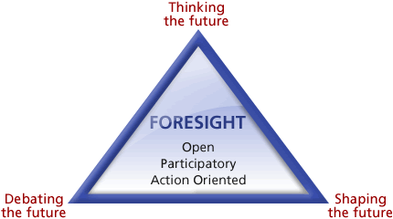

Figure 1: The foresight triangle (Source: JRC-IPTS)

In the Joint Programming Process, foresight is carried out in two phases: In the phase of identifying Grand Challenge Areas (Phase 1 of the Joint Programming Cycle), foresight is used for “early identification of existing and emerging grand societal challenges that could have far-reaching scientific and technological implications”. In Phase 2, which we call the “Strategic Process” of JPIs, foresight is carried out to “translate an already identified grand challenge into an operational reality”.

2.2. Identifying Grand Challenge Areas
While for the 10 existing JPIs, this phase is already in the past, a new “Phase 1” for identifying themes for new JPIs may well lie ahead of us, depending on an assessment of the Joint Programming Process and political decisions to be made in the future. The body responsible for governing this process would be the GPC.
While the selection process leading to the themes for the 10 existing JPIs has often been criticised for having been rushed, the process was nonetheless built on existing analyses on national, European and global level. It was a decentralised process, involving researchers and societal stakeholders in a flexible manner. However, we can certainly learn from this experience and benefit from it in a possible future identification exercise. The “Expert Group Report on the JP Process” recommended “preparing a systematic process that can be used for deciding on future Challenges including monitoring, evaluations and other forward looking activities”
Recommendation:
A possible future “challenge identification exercise” should be built on the experience gained and be properly planned in advance. Member States should be invited to provide input to the process, all
relevant stakeholders should be involved. Studies, workshops, stakeholder consultations and other foresight tools should be used. The GPC should eventually prepare proposals to the Council for discussion at the political level. This discussion at the political level should be used to build ownership of, and commitment to, the new initiatives and finally lead to the adoption of those initiatives which receive sufficient political support.

2.3. The Strategic Process of JPIs
We have decided to call the process of translating an identified grand challenge into an operational reality the “strategic process” of JPIs. In a slight variation of the Joint Programming Cycle as developed by ESF, and drawing on experience from the ongoing JPIs, the strategic process contains the following elements:
- Defining the strategic objectives of the JPI
- Identifying specific themes or aspects within the challenge area on which the JPI wants to focus its activities
- Developing a common evidence-based vision
- Developing a Strategic Research Agenda
- Developing/choosing tools for the implementation of the SRA
- Developing an implementation plan
While there is certain logic in the order of these six elements, especially during the orientation phase of a JPI, in practice these elements will often be carried out in parallel.
We are now in a position to look back on how the 10 JPIs tackled the challenge of carrying out a large part of the strategic process. All 10 JPIs have permanent governance systems in place. 7 out of 10 JPIs have adopted a Strategic Research Agenda. 3 JPIs have formally adopted an implementation plan. All JPIs have started to carry out joint activities. Drawing on the experience gained and taking into account what we consider to be desirable developments for the future, we would like to outline the following observations and make recommendations accordingly:

Observation 1:
While we agree that different challenges require different solutions, we believe that all elements of the strategic process need to be carried out by each JPI. As the skeletal structure of the Strategic Process, these elements are obligatory. JPIs are, however, largely autonomous with regard to choosing the methods they apply in their strategic process and the tools they use for implementation.

Observation 2:
The strategic process is, in fact, a cycle. All steps taken need to be constantly reviewed during implementation in the light of the experience gained and the changing environment. The strategic process of a JPI never ends. The issue of the overall duration of a JPI is closely related to its cyclic nature. We believe that all the societal challenges selected so far are long-term challenges. If a JPI proves to be successful, the established structures can be maintained as long as there is a need for research and innovation within the respective challenge.

Observation 3:
All seven elements of the strategic process represent steps in a complex foresight process. JPIs have used various foresight tools to carry out these steps. They have commissioned studies, held workshops, consulted stakeholders, carried out mapping exercises etc. Such a complex endeavour requires sound management and appropriate financial and human resources. It also requires specific knowledge of the area under consideration, national/regional priorities and capacities and of foresight activities, in order to get robust results within a tight timeframe.

Recommendations:
- JPIs should be aware of their strategic role in Europe with regard to their challenge area. In order to fulfil this role, they should aim at building up the necessary human resources in order to implement the strategic process effectively, and to play their strategic role convincingly.
- JPIs should seek external expertise where necessary to carry out the foresight processes effectively.
- JPIs should regularly revise their strategic documents in the light of new developments.
- JPI’s should be closely connected to relevant bodies and processes at national / regional level

- Joint Programming Function 4: “Joint Activities”
The Joint Programming Initiatives have developed a number of activities in order to ensure the implementation of their Strategic Research Agendas. In addition to these Strategic Research Agendas, several JPIs have set up Implementation Plans to ensure a follow-up of the Agendas.
Though varied in conception, design and follow-up, the activities developed by the different JPIs to implement their Strategic Research Agendas, including through Implementation Plans, generally fall into the following categories:
1. Mapping of research capacity and capability in order to identify opportunities for Joint activities
2. Identification of areas of national research for alignment at European level (co-investment with the European Commission)
3. Enhanced coordination, linking and alignment of national research funding, research programmes, national infrastructure and national strategies
4. Implementation of calls for proposals (funding)
5. Networking, cooperation and partnership activities – with researchers, industry, policy- makers and others
6. Capacity building initiatives with researchers
7. Outreach and communication activities

The different JPIs have chosen different modalities to implement their activities and actions. The emphasis here is on the specific activities of the different JPIs, and not on the modalities chosen to conduct the different activities.
From our point of view, of the activities listed above, activities 2 and 3 are key to the success of the Joint Programming Initiatives. Furthermore, of these two activities, activity 3 is the core activity of any JPI while activity 1 is vital in order to enable the development of activities 2 and 3. Individual JPIs have furthermore defined activity 4 (calls for proposals) as a key contributor to
activities 2 and 3.
We are aware of the fact that points 2 and 3 in particular have overlaps with the work of the Working Group on Alignment. However, in our report we address these issues from a more operational perspective and therefore believe that our findings will complement the report of the WG on Alignment rather than compete with it.
Below, the 7 identified activities are addressed in detail:
1. Mapping:
We assume that at this stage all JPIs have concluded mapping the research fields and capacities relating to the scope of the relevant JPI. Both the mapping exercises and the tentative operationalisation of the exercises have been conducted using very varied approaches. This makes it difficult to compare them across JPIs.
Additionally, the design of the mapping exercises has not always – at an early stage - taken into account the necessity of the later use to be made of the results of the exercises for purposes of coordination, linking and alignment of national research funding (programmes), national infrastructure and national strategies.
Recommendation:
Mapping exercises conducted to update or complete the baseline for coordination, linking and alignment of national research funding (programmes), national infrastructure and national strategies, should be conducted in accordance with guidelines to be developed under the auspices of the GPC.
The mapping guidelines should be developed in cooperation with national policymakers, ensuring that the mapping is of immediate practical use at the national level. This applies in particular to guidance on the alignment of national funding, national programmes, national infrastructure and national strategies.

2 and 3. Alignment at European level (co-investment with the European Commission) and enhanced coordination, linking and alignment of national research funding (programmes) and national infrastructure
Based on the existing Strategic Research Agendas - and Implementation Plans where they exist –
no JPIs at present would seem to have a complete set of detailed follow-up plans to ensure that activities 2 and 3 are accomplished.

FACCE-JPI could arguably be said to represent good practice with respect to activity 2, whereas JPND and JPI HDHL are good representatives of JPIs with fairly well-developed plans for activity 3 - national alignment.
A forward-looking integrated approach towards co-investment with the European Commission is, however, no guarantee for further alignment of national programmes, although it would lead to smarter use of national funds in specific instances. To ensure maximum impact of a programme of co-investment with the European Commission, the JPIs will also need to integrate long-term programme planning at national level with its co-investment activities.
It is still early days for national alignment at this stage, even with the most ambitious JPIs. The actions undertaken with respect to coordination of national funding programmes and strategies are light-touch, and could benefit considerably from better interaction with national priorities and plans in relation to the Strategic Research Agendas already in place.
There is also the impression that the interlocutors for the JPIs in most instances and for the most part still are the researchers at national and European level, and not the decision-makers at national level. In order to achieve substantive alignment, the JPIs, supported by GPC and other ERA groups, will need to enter into far-reaching dialogue with national policy-makers and decision-makers, on the basis of their respective Strategic Research Agendas. This dialogue should be facilitated through the fact that the different members (countries) are already represented at a high level on the Governing Boards.
A specific feature which makes the process of coordination, linking and alignment of national research funding (programmes), national infrastructure and national strategies particularly challenging, is the lack of common indicators for a definition of successful alignment.
Even though alignment by definition is an ongoing process, how can we measure it at set times in the process? In other words: how can we take snapshots of the ongoing alignment process? Specific indicators will have to be established to ensure that the alignment process takes place against an evidence-based background.
The indicators could be based on many different parameters. As a possible example, we could use the percentage of national funding (programmes) disbursed in accordance with the Strategic Research Agenda of the JPI in which the country in question takes part, as an indicator. The definition of indicators is not a simple matter, but is necessary in order to substantiate any progress made.
Defining indicators also requires determining the baseline on which the indicators are to be established. Such baselines should be developed on the basis of a common approach by GPC.
Recommendation:
Alignment at European level (co-investment with the European Commission) and enhanced coordination, linking and alignment of national research funding (programmes), national infrastructure and national strategies should be measured on the basis of Joint Programming indicators, developed by GPC.
The development of indicators entails the setting of a baseline for the individual JPI. The baseline is to be set in coordination with GPC, on the basis of a common approach for all JPIs.

4. Implementation of calls for proposals (funding)

Many JPIs have conducted calls for proposals, with the explicit intention that such calls contribute to alignment.
In several instances this has led to leveraging of national funds for the specific topics identified in Strategic Research Agendas. To what extent the calls have led to deeper dialogue with national funders and ensured a permanent change of national strategy is debatable, and evidence to back up such a claim may be difficult to access.
Calls for proposals by e.g. FACCE-JPI have been designed with a view to coordinating with ongoing and planned initiatives at European level, and as such have entailed smarter use of public funding in certain fields of research.
The use of calls for proposals as instruments of leverage of national funds will ultimately be successful if it leads to a permanent change of approach and funding at national level. At this stage, it is not possible to state that this change is taking place yet.
Using calls for proposals in JPIs also raises the question of which sources of funding are accessed nationally. For many JPI members (countries), institutional funding makes up the bulk of national funding. Accessing research agency funding for JPI calls will obviously still be of interest in such cases, but will not ensure the deeper impact achieved when accessing institutional funding. JPI HDHL is among the JPIs starting to look at including institutional funding in its joint activities.
The JPIs are still at an early stage in dealing with the question of how to leverage national funds, together with European and international funds. The development of the use of the place-based Structural Funds - together with other European, international and national funding – is of interest for the JPIs, not least in order to increase JPI membership in the newer Member States.
Recommendations:
- Implementation of calls for proposals (funding) as an instrument of alignment needs to be further explored and developed, based on existing best practices. Access to institutional funding as an instrument of alignment should also be developed.
- Furthermore, there is a need to explore and develop JPI mechanisms for the leveraging of national funds together with European and international funds.
- It is of specific interest to explore and develop the use and leverage of Structural Funds. This will be of specific benefit to newer member states, which are currently underrepresented in the Joint Programming Initiatives.
- The use and leverage of Structural Funds should be explored and developed in an effort organised by GPC, in cooperation with the member states which can access such funds. The use of the Structural Funds for JPI purposes may have positive consequences for the participation of these states in the Joint Programming Initiatives.
5. Networking, cooperation and partnership activities – with researchers, industry, policymakers and others

All JPIs have conducted extensive outreach activities with a range of stakeholders. These activities are ongoing.
As an example, JPND has developed a stakeholder database to "ensure that relevant stakeholders remain informed concerning the outputs, results and initiatives of JPND." JPND initiated a broad stakeholder process, organised as a combination of face-to-face meetings, workshops and on-line consultation, including an Industry Consultation. JPND has also set up Action Groups for engagement with industry, users and the general public. FACCE-JPI has set up a Stakeholder Advisory Board with 22 member organisations, as have other JPIs. JPIAMR has set up a Stakeholders Forum for which all interested parties can sign up through an online form.
Recommendation:
JPI networking activities need to be further focused and targeted towards policymakers and programme-level agencies at national level, as well as towards industry. As all JPIs are working towards the goal of ever closer alignment of national programmes, the outreach, networking, cooperation and partnership actions should be designed with this in mind.

6. Capacity building initiatives with researchers
All JPIs have developed capacity building initiatives with researchers in the research fields in question, both through their Scientific Advisory Boards and through wider outreach initiatives.
JPIAMR, for example, has conducted a series of Scientific Advisory Board Workshops with a view to identifying specific research priorities. JPIAMR is developing a Research Infrastructure strategy and establishing a number of Alignment Actions to "promote alignment of research activity across Europe."
Recommendation:
JPIs have given priority to engaging with the national research communities of JPI members, in order to develop their Strategic Research and Innovation Agendas. This has been a valuable investment in order to integrate these research communities in the work of the respective JPIs.
The challenge is now to turn the researcher-driven identification of research domains and topics into closer engagement with national funding agencies and national priorities. The establishment of alignment actions (cf JPIAMR) in order to overcome fragmentation and promote pooling of national research efforts is one promising development. These types of activities need to be promoted and strengthened.

7. Outreach and communication activities
All JPIs have developed communication plans and have set up websites to communicate their work.
The Water JPI Communication and Dissemination Strategy is one example. Much valuable work has been done in outreach and communication, also to the broader public. The different JPIs have chosen different approaches, also with respect to website design and overall communication strategy.
Recommendation:

All JPIs should be encouraged to continue and strengthen their outreach and communication strategies. Further efforts need to be made to communicate with the general public, including information on how alignment is progressing. Thus the general public will understand that alignment of national resources to reduce fragmentation is sensible from a research perspective.
Public support will also be enhanced when it is made clear that alignment contributes to sensible and smart use of public funding for research.

- Joint Programming Function 5: “Dissemination and Use of Research Findings, Innovation and IPR issues”

- Introduction
Learning from the findings of the ToCoWork project, we decided to group together the issues of “Dissemination and Use of Research Findings”, “IPR Issues” and “Innovation”, since they are all three related to the transfer of research results to final users or beneficiaries, or more directly to the use of research findings to induce innovation. Furthermore we decided that in the context of innovation, we need to address the role of JPIs for evidence-based policy making. Finally we added the issue of involvement of industry, since this can be of particular importance for the innovation capacity of JPIs.
The VG have already recommended to JPIs to set up strategies on dissemination, open access and IPR issues. We understand, however, that so far the resources of most JPIs have been put into other, more urgent issues. We also understand that JPIs are now entering a phase where these issues become important for the JPIs on a practical level and need to receive current attention.
- Dissemination, Open Access
Joint Programming is to a large degree about publicly funded research. Notwithstanding the importance of the protection and exploitation of IP that will play a role in some JPIs, the issue of dissemination of research findings needs to be high on the agenda of every JPI. It is the first step in making use of generated knowledge, and it is necessary to increase transparency and public awareness. Research results must not end up in a drawer somewhere – this is something that must be avoided at all costs.
As already recommended by the VG, open access should be applied to the research output of JPIs as much as possible. This claim is even more valid since open access to publications has been made obligatory in Horizon 2020. The question with regard to open access to publications is not so much if but rather how to implement it in JPIs. Furthermore open access to research data needs to be discussed within JPIs as well. Open access to research data can be a very effective mechanism to drive research in a given area without coordinating the research efforts.
The problems arising when addressing the issue of a common approach to dissemination and open access will be very much the same across the JPIs, therefore we think that a joint effort should be made
to develop dissemination and open access strategies. A process should be started, with support from the Commission, to organise the development of dissemination and open access strategies for each JPI. Additional support could be provided by experts, and best practices already used in the JPIs could be exchanged. Following the principle of “no one size fits all”, the JPIs will be free to make decisions for themselves according to their specific needs. However, certain principles should be followed by all JPIs, and JPIs should strive to make their strategies as coherent with each other as possible.
Recommendation:
JPIs should develop strategies for the dissemination of research findings and open access to publications as well research data. A process to support the development of such strategies should be drawn up with the support of the EC. Coherence between the strategies of the various JPIs should be sought as much as possible.
- Use of Research Findings, Innovation and Evidence-based Policy
JPIs serve the purpose of contributing to meeting societal challenges and increasing competitiveness. Therefore they should, at some stage, deliver input for innovation and/or political decision-making. In order to be able to meet these challenges, JPIs need to decide on strategies how to deal with research findings, as well as on how to implement these strategies. Relying on dissemination and open access will not be enough. A proactive strategy will be required to drive the change process.
Innovation is a key factor in JPIs for tackling societal challenges. Amongst other criteria, JPIs will also be evaluated regarding the level of innovation they have been able to contribute. Innovation should refer to industry, to policy-making as well as to societal innovation, and specific approaches should be developed.
Innovation should not be an abstract goal; it should address concrete and realistic issues. A focus on societal-driven innovation challenges, the transfer of results into innovations serving both the economy and society, and a clear impact on competitiveness and socio-economic issues are some of the aspects to be considered. Adequate timing and consultation of end-users are part of the innovation strategy process. In addition, collaboration with innovation-related initiatives (KICs, EIPs, …) is important for reducing fragmentation and increasing alignment between research and innovation efforts.
Recommendation:
JPIs should develop a strategy for the use of research findings and innovations, or incorporate these issues into their SRA. Such a strategy should address all forms of innovation, whether they are technological or societal. It should also provide input for evidence-based political decision making.
- Knowledge Transfer and Involvement of Industry
Concrete achievements in the field of innovation are rarely possible without the involvement of, and cooperation with, industry. Industry should, as appropriate, be considered both as a partner in joint research activities and as an end-user. Partnering with the business sector requires a solid and accomplished network that ensures good results. The restricted academic-industry consortium approach tends to be too narrow and not to be sufficiently flexible; concrete incentives and drivers to approach and engage industries are needed. Depending on the topics, the involvement of business should be considered in a wide range of areas from an early stage, e.g. in drawing up the SRA, shaping call topics, designing the peer review process, open access issues, IPR issues, innovation policy, and foresight. For this purpose, clear definitions of the role of the industrial partners and guidelines on industry involvement should be developed.
Among the reasons for involving business in the innovation cycle within JPIs and identifying common areas of concern is the necessity to understand user requirements early on, the possibility to pool resources and support the pull side of research, as well as faster dissemination of research results. On the other hand, involvement of the business and industry sector also implies competition and IPR issues, conflicts of interest, the applicability of national rules limiting funding of private research, or the exploitation of publicly funded research.
Recommendation:
JPIs should develop a strategy for knowledge transfer and the involvement of industry. Such a strategy may vary substantially from JPI to JPI, depending on the nature of the challenge addressed. A process to support the development of such strategies should be developed with the support of the EC.
- IPR Issues
Though the VG has already recommended that each JPI set up an IPR strategy, intellectual property rights (IPR) remain the “most unprocessed framework condition”. This may indicate that many JPIs are not yet aware of the importance of, or need for, IPR as they are still at an early stage of development.
As stated in OECD recommendations, well protected and appropriately enforced IPRs are prerequisite for successful innovation, and they can be arranged by several means so that they enable knowledge transfer and dissemination: “A variety of collaborative mechanisms, such as licensing markets or pools and clearing houses, can facilitate access to and use of knowledge. Patent systems need to be properly tailored to ensure a proper balance between incentives for innovation and the public benefit that flows from dissemination of the knowledge in the marketplace.”
Thanks to cross-border collaboration, JPIs have a strong potential to facilitate the rapid dissemination of research results. This may be useful in contributing to market predictability, due to the development of common, standardised solutions. Another aspect is that not only the result, but also the knowledge developed is valuable for industry. Therefore clear rules for IPR should be set up from the very beginning.
Recommendations:
JPIs should develop IPR strategies. A process to support the development of such strategies should be developed with the support of the EC. Coherence between the different IPR strategies should be sought as much as possible.
With the support of the Commission, differences in IPR regulations in Member States which interfere with common IPR strategies in JPIs should be identified with the aim to take measures to reduce such differences.

IV. Enabling Environment for Joint Programming
As pointed out in the introductory chapter of this report, the Framework Conditions are meant to have impact in two directions: the smooth functioning of the JPIs and the improvement of the environment in which they operate. All relevant issues have been mentioned already in the Voluntary Guidelines. This report attempts to carve out these two elements more clearly in order to clarify the responsibilities for action both on the side of the JPIs as well on the side of those who can improve the environment, which includes the GPC as the dedicated forum of MS and AC. The WG believes that more emphasis than in the past should be put on the latter, since it determines, to a large extent, the opportunities and success JPIs and the entire JP process can have at the end of the day. The issues which are at stake when we talk about an enabling environment for JPIs are the following:
- The existence of medium-to-long term national strategies towards a certain societal challenge and the readiness of MS and AC to align those strategies within the remit of a JPI;
- The level of medium-to-long-term commitment by Member States, Associated Countries, national Funding Agencies (including their European federations) and the European Commission to invest in, support, enable and facilitate Joint Programming Initiatives;
- The degree of divergence of rules for funding R&I throughout Member States and Associated Countries, and the readiness of MS and AC to take steps towards simplification and developing common standards;
- The readiness of Member States (and funding agencies) to participate in joint activities (joint or coordinated calls, co-ordinating facilities, opening up of national programmes, etc.) and to facilitate this participation by administrative and/or legal measures, including the development of new and innovative methods for funding.

- The existence of national strategies towards a certain societal challenge and the readiness of MS and AC to align those strategies within the remit of a JPI
The GPC Working Group on Alignment has focussed on these issues in more detail. In order to provide a complete picture, however, we will address these issues briefly.
MS, AC, and funding organisations should not only consider the JPIs’ activities when designing their national strategies and programmes, but should use the JPIs as a platform to involve the European level as well as other MS and AC in the planning process. The “thematic programming” exercise of the FACCE JPI provides an example of how JPIs could organise a process of distributing tasks or themes to MS/AC, thus directly aligning MS/AC funding activities in a given area.
Equally importantly, the EC, as the body responsible for drafting and implementing the Framework Programmes, should collaborate closely with the JPIs both when developing the next Framework Programme and when implementing the current one.
On the level of the research to be carried out, complementarity needs to be ensured between the national, the transnational (JPI’s own activities) and the supranational (FP) level. The results of the relevant projects of all levels need to be taken into account for the JPIs task of collecting results and data and make them usable and used, in order to induce innovation and provide the basis for political decision-making.
In order to be able to fulfil this role, full collaboration by all actors in the ERA is required.
Recommendation:
- MS/AC administrations and funding agencies need to fully engage in strategic alignment organised by JPIs.

- The level of medium-to-long term commitment by Member States, Associated Countries, national Funding Agencies (including their European federations) and the European Commission to invest in, support, enable and facilitate Joint Programming Initiatives
The working group considers JPIs as promising tools to enhance the ERA significantly and to contribute substantially to meeting societal challenges. We assume that this view is shared by all GPC members. The JPIs are not just a partnership to perform joint calls. A look at the visions and Strategic Research Agendas and at what JPIs have achieved to date clearly shows that they already are much more than that. From our perspective, JPIs are strategic hubs or platforms for Research and Innovation in the challenge they are engaged in. As a strategic hub, their mission must be to assemble all relevant players in the given field at their table and structure research and innovation efforts in the challenge concerned. Their main objective should be to jointly structure the funding activities for R&I throughout ERA, in order to maximise the output for meeting the societal challenges while at the same time avoiding unnecessary duplication and increasing excellence through collaboration and competition. In addition, their ambition should be to substantially increase the amount of R&I funding spent in a jointly and/or co-ordinated manner.
Furthermore, the WG believes that JPIs are designed to be long-term structures. They are about to build up new forms of collaboration in the ERA. This involves learning processes on all sides. It involves building up trust. All of this needs time.
Considering all of the above, the Working Group believes that considerable and sustainable human resources are needed for JPIs to properly fulfil their tasks. The amount of personnel needed may vary from JPI to JPI, but in any case, it has to be adequate to the respective JPI’s ambition. We therefore believe that MS, AC and the European Commission need to take the relevant decisions on the resources to be made available to JPIs. In this context, it also needs to be considered that a programming process at European level can be used at national level, thus reducing costs for national programming considerably, as has already been demonstrated in the context of SCAR foresight activities.
We believe that it is not sustainable to have JPIs fight for every euro they need from the EC and the MS. We believe that a robust human resource basis should be developed and further resources be made available, on the basis of the activities planned in the respective implementation plans.
Commitment does not only mean making management resources available to the JPIs. It also means that MS, AC, national funding organisations and the Commission need to collaborate actively with the JPIs. Therefore, MS and AC must establish closer links to the JPIs. They should deploy personnel with experience of national funding activities and strategic processes for their participation in and collaboration with JPIs. The members of Governing Boards need to be closely linked to national strategic processes in the respective field.

Recommendations:
- Adequate resources should be made available to the JPIs in order to put them in a position to fulfil their task as a strategic hub for the respective challenge.
- Closer links between MS/AC and JPIs need to be established by deploying experienced personnel on the part of the MS/AC, and by involving the individuals responsible for national strategies and programmes.

- The degree of divergence of rules and procedures for funding R&I throughout Member States and Associated Countries and the readiness of MS and AC to take steps towards simplification and developing common standards
Little progress has been made in the ERA since its beginning 15 years ago with regard to reducing the barriers to transnational collaboration which are due to non-compatible national rules and procedures. At the same time, this incompatibility causes considerable difficulties for JPIs and other transnational initiatives in performing joint activities, thus also constituting barriers for the advancement of the ERA. Some of these rules have no justification other than that they have a tradition in the administration of the respective countries. Some others certainly have a legal basis or other foundations in the national systems.
We believe that there is considerable potential in making progress towards more interoperability of national programmes and systems. A first but important step could be to establish a comprehensive universal terminology. This would make joint activities more easily comprehensible for applicants, but would also establish a common language for programme owners, facilitating their transnational collaboration. Further options would be to develop default procedures for the implementation of calls, setting standards for call publication, call evaluation, peer review, programme monitoring and evaluation, and developing a default set of eligibility criteria.
We do not believe that EU legislation is the way to proceed in this matter. We think that a common effort should be made to develop comprehensive guidelines to be applied by member states on a voluntary basis. A system could be developed to give a label (“ERA mark”) to those programmes which apply the guidelines to a large extent.
Recommendation:
- Common guidelines on terminology, rules and procedures for R&I programme implementation should be developed in a joint effort of MS, stakeholder organisations and the EC, to be applied throughout the ERA on a voluntary basis.
- A funding instrument for joint activities should be developed. It should be applied by all national funding agencies in order to facilitate the implementation of joint activities.

- The readiness of Member States (and funding agencies) to participate in joint activities (joint calls, coordinated calls, opening up of national programmes, etc.) and to facilitate this participation by administrative and/or legal measures
It is one aspect of transnational collaboration to align strategies and programmes. Another aspect is to implement the strategies and programmes jointly. The JOREP study analysed the investments in joint research programmes in a number of Member States and categorised the different kinds of collaboration. One of its findings was that the investments in what they called “coordinated programmes”, which compare to the joint calls in JPIs, is still very low compared to overall public investment in R&D in these countries. National programmes are opened up even more rarely, a fact which has also been investigated by this study. The rarest phenomenon, according to the study, is the opening up of national programmes where foreign participants are entitled to receive funding.
The WG believes that Joint Programming can only fulfil its purpose fully if the share of funding channelled through joint and opened-up programmes can be increased significantly. The reason for that is obviously the fact that without opened, coordinated or joint calls, there is no competition possible on a European scale. However, such competition would be required to get the highest quality results. One precondition for such an increase in funding is enhanced interoperability as described under point 2. Another precondition is that a number of problems connected to funding can be solved.
We are aware that a significant increase of “real common pot” solutions outside the Framework Programmes is not likely to happen. The same applies to the opening up of national programmes where foreign participants are entitled to receive funding. We therefore propose to develop other creative solutions to overcome the well-known difficulties connected with virtual common pot systems, including the problem of raising funding for participating in foreign programmes.
One solution could be for MS/AC to earmark a certain amount of funding to be spent flexibly across several or all initiatives/programmes in which they participate.
The WG believes that in the area covered by a JPI, national programmes carried out in a closed and/or not coordinated way should be the exception, while the rule should be to enable competition/collaboration on European scale.
Recommendation:
- Hand in hand with an increased interoperability of programmes (point 2), the amount of programmes carried out jointly, in a coordinated way or opened up for researchers from other countries should be increased significantly. Purely national implementation should only be applied when duly justified.
- Acknowledging the reluctance towards real common pots, creative solutions should be sought to overcome the difficulties of funding transnational activities.

GLOSSARY

AC | Associated Country
EC | European Commission
ERA | European Research Area
Expert Group | Group of experts, chaired by Helena Acheson, who analysed the Joint Programming Process in 2012.
CC | Council Conclusions
FACCE | JPI on Agriculture, Food Security and Climate Change
FC | Framework Conditions
FC-WG | GPC Working Group on Framework Conditions for Joint Programming
FLA | Forward Looking Activities
GPC | “Groupe de haute niveau pour la Programmation Conjointe” – dedicated configuration of ERAC for Joint Programming
JP | Joint Programming
JPI | Joint Programming Initiative
JPIAMR | JPI on Anti-Microbial Resistance
JPI HDHL | JPI “Healthy Diet fora Healthy Life”
JPND | JPI on Neurodegenerative Diseases
JPIs To-Co-Work | Project to support JPIs, funded under FP7
MS | Member State(s)
SCAR | Standing Committee on Agricultural Research
SRA | Strategic Research Agenda
SRIA | Strategic Research and Innovation Agenda
VG | Voluntary Guidelines on Framework conditions for Joint Programming (2010)
WG | Working Group

Annex

A Technical Annex for the

Voluntary Guidelines on Framework Conditions for Joint Programming in Research
ANNEX 4
Measuring JPI progress & Impact

FINAL REPORT

Table of Contents

0. Executive Summary

1. Working Group Members

2. Working Group Mandate

3. Meetings and Working Methods

Annex 1: The ‘Canvas’, Vs.2. as prepared by the Working Group on 19 May 2014, but including updated points included in the final ‘Selfie’

Annex 2: The ‘Selfie’, Vs.7 as approved by the GPC on 2nd July 2014

Executive Summary

This Working Group’s (WG) mandate was to:
- give suggestions for measuring the progress of JPIs (monitoring dimension)
- give suggestions for assessing the impact of JPIs (ex-post evaluation dimension)
- contribute elements for the Terms of reference of the JPI strategic evaluation foreseen by the Commission in the Horizon 2020 Work Programme for 2014-2015.
The group decided to build on the work on Evaluation of JPIs which was undertaken by the Coordination and Support Action (CSA) 'JPI to Co-Work' with the collaboration of nine of the 10 JPIs. It also recruited the CSA coordinator and experts involved in the CSA to validate the quality of its suggestions.
The group agreed with the intervention logic developed by the CSA and decided to express it suggestions in the format of a matrix giving for each of the 3x3 Evaluation dimensions defined by the CSA specific criteria and indicators, including possible sources of information.
The WG started with the 22 criteria and indicators proposed by the CSA. After reviewing additional material (such as the evaluation frameworks of several JPIs) and consulting all the JPIs, it decided to add 5 additional criteria numbered +7, +12, +17 , +26 and +27 in the Matrix called ‘The Canvas’ given in Annex 1 to this report. This represents the WG output with respect to the evaluation and impact assessment of JPIs as asked in points 2 and 3 of the above mandate.
Following the desire for having a reduced set of monitoring indicators, expressed by the GPC for use in its Biennial Report 2012-2014, and by JPIs too for having common agreed indicators for estimating their progress, the WG focused its work on the development of a reduced set of indicators and criteria which would be both relevant and easier to use.
The ‘Selfie’ self-assessment questionnaire in Annex 2 gathers a first descriptive part and then eleven questions or data that have been sent to JPIs by the GPC as their contribution to the Biennial Report. These are taken up also in ‘The Canvas’ in yellow in Annex 1 and are the WG deliverable for monitoring JPIs.

When preparing these deliverables the WG addressed the following recommendations to the GPC:
- The Self-assessment to be undertaken in summer 2014 and/or the evaluation foreseen in 2015 are not to undertake a ranking of JPIs, but to assess each JPI with respect to the Vision they presented to the GPC for their initial selection and with respect to the Council Conclusions which launched them.
- It appears few JPIs have developed SMART objectives for their impact on the major societal challenge they are addressing. The Commission in the communication of 2008 “Towards joint programming in research” insisted that the JPIs should endeavour finding such an objective
- Measuring the societal impact of Research and Innovation actions takes time. The 'JPIs to Co-Work' CSA, additional experts consulted by the Working Group as well as the conclusions from the session on Evaluation of JPIs in the 2013 Presidency Conference on Joint Programming suggest a good 'proxy' (i.e. with a strong correlation with future societal impact) is the implication of key stakeholders in the definition and in the governance of the JPI. Measuring and demonstrating JPI’s progress and impact is necessary to make JPP more attractive in Europe and at international level.

1. Working Group Members
Mr L. Antoniou – CY
Mrs L. Michelet – FR – Rapporteur
Mrs A. Markotic – HR
Mrs A. Kiopa – LV (4/9/13 only)
Ms Kiesenhofer- Widhalm –AT (19/5/14 only)
Mr E. Stumbris – LT
Mr G. Clarotti – Commission, Secretary
Mrs K. Angell-Hansen (4/9/13 only) & B. Johne - JPI Oceans
In addition, several experts who contributed to the ‘JPI to Co-Work’ Coordination and Support Action (CSA) were involved in the preparation of the deliverables:
Mr C. Segovia, Instituto Carlos III – ES, Coordinator of the CSA;
Mr I. Schaedler (Director General of Austrian Federal Ministry of Transport, Innovation and Technology), Coordinator of JPI Urban Europe and initiator of the meeting between JPI Chairs. He delegated his reply to Mrs S. Meyer in his department.
Mr W. Polt, Joanneum Research- AT, Chair of the Session on JPI Assessment in ‘JPI to Co-Work’;
Mr G. Laumann, DLR Agency – DE, Partner in ‘JPI to Co-Work’;
Mr K-H. Haegeman, JRC-IPTS, European Commission, Netwatch platform incl. EU JPI Data-base;
Mr B. Mostert, Technopolis - NL, Proposer of possibilities for outsourcing evaluation of JPIs in the final meeting of ‘JPI to Co-Work’.

2. The Working Group Mandate
The GPC Synthesis Recommendations expect the group to: “Suggest methods for reviewing JPIs and plan for a more thorough evaluation of JPIs after the start of Horizon 2020”.
In its meeting of 5 December the group proposed the following mandate, which was confirmed by the GPC plenary meeting of 11 March 2014.
To give suggestions for measuring the progress of JPIs (monitoring dimension)
To give suggestions for assessing the impact of JPIs (ex-post evaluation dimension)
To contribute elements for the Terms of reference of the JPI strategic evaluation foreseen by the Commission in the Horizon 2020 Work Programme for 2014-2015 :
This strategic evaluation of Joint Programming, involving also Member States in a mutual learning exercise, to estimate the degree of coordination across the ERA in areas covered by Public-public partnerships, to evaluate the 10 on-going JPIs and to assess the alignment of national research programmes with respect to these JPIs.

3. Meetings and Working Methods
The Group has decided in September 2013 to regularly meet after each GPC meeting, in the afternoons of 4th September 2013, 5th December 2013, 11 March 2014 and 19 May 2014. In between the meetings, the group communicated by E-Mail.
3.1 The group started by gathering the material already produced by each JPI and by the Commission, to propose suggestions to the GPC, to JPIs and to the Commission.
3.2 It followed activities of the ‘JPI to Co-Work’ Coordination and Support Action (CSA), in particular those related to the identification of common dimensions for the evaluation of JPIs. The Rapporteur and the Secretary participated in the final project meeting, in February 2014.
3.3 The group also followed activities of the group of JPI Chairs that met in December 2013, to contribute and analyse the work JPI Chairs proposed for “Defining 5 to 7 common, key indicators, to follow the progress of JPIs”.

3.4 Following the proposal of the GPC Chair for preparing the GPC Biennial Report (2012-2014), the group refocused its work on the preparation of a template for the Self-Evaluation by JPIs (the ‘Selfie’). This will be sent to JPIs in July 2014 so that they can report on their progress to the GPC – for inclusion in the Biennial Report.
3.5 For the preparation of the ‘Selfie’ and for the more complete ‘Canvas’ to be prepared for the fuller evaluation of JPIs, the group took advantage of the work undertaken by the CSA ‘JPI to Co-Work’, where 9 JPIs collaborated to prepare a template for their evaluation. In particular, the project co-ordinator, Mr Segovia, from Instituto Carlos III (ES), contributed a methodology and a table which were used by the group to prepare the above documents. He participated in the March and May meetings of the group. In addition, the group consulted five external experts who all contributed both to the Selfie and the ‘Canvas (See I. above).
3.6 The ‘Selfie’ and ‘Canvas’ were sent to all JPI coordinators for their comments, so as to ensure their understanding of the WG’s approach, their collaboration in defining the data and elements to report to the GPC as well as preparing themselves to contribute in the summer of 2014.
3.7 The Selfie was then circulated to the GPC chair and to the whole group to be eventually approved on 2nd July.

4. A template for the assessment of JPIs – the ‘Canvas’
4.1 JPIs to Co-Work Intervention Logic
Mr Segovia, co-ordinating 'JPI to Co-Work' presented in March to the WG the main outcome of the CSA in terms of best practices for Evaluating JPIs.
The WG agreed with the Intervention Logic defined by ‘JPI to Co-Work’. This stems from how Societal Challenges affect national programmes in Member States and from JPI Governance.
Three dimensions have been defined for a JPI:
Governing Policy Making – Managed by the Management Board (MB)
Research Performance – For which the Scientific Advisory Board (SAB) is the pilot
The definition of societal needs – As defined and watched over by the Stakeholder Advisory Board (SHAB) or an equivalent body.
For each dimension, Criteria have been identified to review its Structure, Process and Outcomes:
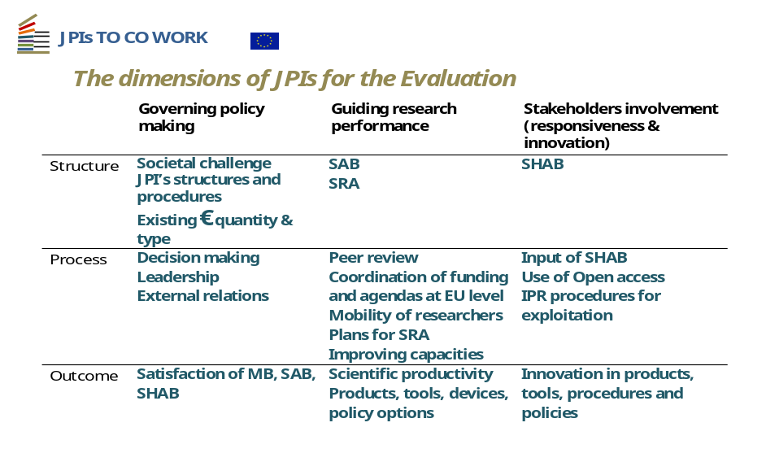
4.2 Possible Evaluation Criteria
Mr Segovia identified in his presentation 22 specific Criteria and Indicators to evaluate the 3x3 dimensions given above. Annex 1 presents them giving also the source of information for gathering these and related comments. It also includes five additional criteria/indicators resulting from the inclusion by the WG of elements taken by other documents it consulted such as the full Evaluation framework of JPIs (AMR, JPND, FACCE and Cultural Heritage). These are numbered +7, +12, +17, +26 and +27.
In particular, the group felt the need to communicate to the JPIs the need to define specific ‘outcome’ objectives for Responsiveness and Innovation / Involvement of Stakeholders which would relate to the specific objective of each JPI. As was requested in the original Commission Communication, this should be “SMART”. It appears few, if any at all, JPIs have defined such objectives and related Key Performance Indicator(s). This however might not be gathered through a simple self-assessment, but a baseline could be readied by each JPI for its evaluation in 2015.
The full Canvas is to be used as input to the Commission on how to evaluate JPIs. It summarizes all comments received and was finalised in the working session of 19 May. This was eventually reconciled with subsequent work undertaken to prepare the Selfie, with the eleven questions indicated in yellow in the matrix.

5. A template for the self-assessment of JPIs – the ‘Selfie’
5.1 Getting to the JPI ‘Selfie’
The CSA defined for each Criteria possible indicators and then sources of information. In its meetings since March 2014, the WG focused on the analysis of the indicators trying to identify the 7 to 10 which would be:
Most relevant for the self-assessment and feasible by summer 2014
Obtainable through a self-assessment by the JPI itself (i.e. not requiring external reviewers)

The overall Template was sent to the 'JPI to Co-Work' experts and comments were gathered in five categories:
Proposals to adapt the template to make it more meaningful / effective;
Take the opportunity for collective learning from the process;
Also evaluate contribution by JPIs to reducing fragmentation and their policy processes;
Analyse the contribution of JPIs, as Mini-ERAs, to the 6 dimensions of ERA;
Need for a much deeper evaluation looking at the objectives of the Joint Programming process, not only of each JPI SR(I)A (Strategic Research (and Innovation) Agenda).
The first type of comments was included in the Template, in particular the need to add a fourth ‘factual information’ category describing the JPI with more factual information. The last three points were kept for the later Full Evaluation to be undertaken by the Commission. WG members agreed on the opportunity for collective learning on how JPIs function and assess their activities in different Research and Innovation areas.
A further iteration in early April allowed to define a first version of the ‘Selfie’ to be sent to JPIs for their feed-back, as it was dubbed to insist on the ‘Quick and Easy’ (and therefore necessarily not perfect) nature of the exercise to be undertaken by JPIs in summer 2014 to report to the GPC.
The table counted the 27 factual descriptors/indicators which relate to the JPI achievements, with the ones to be used for the self-assessment highlighted. Also, it was mentioned that data on Joint Calls, available at the Commission (through its yearly survey of Joint Calls undertaken by Public-public partnerships) should be included in the pre-filled template. JPIs were in this way informed of which criteria would be asked in 2014 and which would be expected in 2015 for the full evaluation of JPIs.
The original table highlighted five questions to be addressed to members of the Board and a sixth last question on Intellectual Property Rights (IPR) to be replied to by each JPI secretariat. It was proposed that each JPI would provide a statistical survey through a simple questionnaire to be compiled by the JPI secretariat with, for each of the 5 questions a 4 degree Likert scale of the type (i) I fully agree (ii) I agree partially (iii) I disagree partially (iv) I totally disagree.

Seven of the JPIs (Neurodegenerative diseases, ‘A Healthy Diet for a Healthy Life’, Cultural Heritage, ‘More Years Better Lives’, JPI Water, JPI Climate and JPI Urban Europe) replied to the survey, allowing the WG to prepare a further, third ‘draft-final’ version to be submitted for comments/final decision to the GPC in its meeting of 19 May.
The more general comments can be grouped in five categories:
- The need to include a glossary of abbreviations and examples of answers to facilitate JPIs in replying. In particular the need to define ‘Joint Actions’ as different than Joint Calls was expressed and addressed using the definition proposed by 'JPI to Co-Work'.
- There are frequent misunderstandings of indicators and of their justification. One of the most important misunderstandings is taking the indicators as the evaluation itself. Thus interpreting the potential values of the indicator as implicit judgements. This is certainly not the case.
- Concern from some JPIs (rather in the first wave) that too little emphasis is put on outcome indicators and on how the JPI is impacting the major societal challenge it addresses. And by some ‘Second Wave’ JPIs that they cannot yet provide output indicators.

- Concern from JPIs that the indicators would be used to rank and file or compare JPIs.
- On indicator 11.2, two JPIs were concerned that the indicator focuses only on the alignment of national programmes on the agreed SR(I)A and not on how much national priorities were taken into account by the overall SR(I)A.

5.2 Discussion with the GPC.
The group chose to address point 1 above by including footnotes in the Canvas and in the Selfie.
To address points 2 to 4, the group addressed the issue of usage of the Self-Evaluation and of the overall Evaluation of JPIs in the discussion with the GPC plenary of 19 May 2014. After which the ‘Selfie’ would be finalised by written procedure. Three questions were put forward to the GPC:
To prepare for this, three questions were put to the GPC for the debate in plenary:
- Several JPIs are concerned that the self-assessment to be undertaken this summer to contribute to the GPC report, and/or the evaluation foreseen in 2015 will undertake a ranking of JPIs. The GPC should confirm that JPIs would be assessed with respect to the Vision they presented to the GPC for their recommendation to the Council and with respect to the Council Conclusions which launched them.
This was confirmed by the Chair when introducing the discussion and was not challenged by the GPC.
- It appears few JPIs have developed SMART* objectives for their impact on the major societal challenge they are addressing. The Commission in the communication of 2008 “Towards joint programming in research” insisted that the JPIs should endeavour finding such indicators, as was done later, for example, by the European Innovation Partnership on ‘Active and Healthy Ageing’, which aims at ‘increasing by 2 the average number of healthy life years in the European Union’.
A baseline measurement could be envisaged by now. Does the GPC think such indicators would be appropriate? Should the GPC send a message to the JPIs asking them to put in place one or more impact indicator(s)? * Specific, Measurable, Adequate/Achievable, Realistic/Relevant and Time-related (Peter Drucker, "Management Tasks, Responsibilities, Practices", Harper & Row, 1973)
The debate in the GPC mentioned the caution needed when setting such SMART objectives (in particular the relevance of the AHA EIP was criticised), but others mentioned they were better than nothing and that JPIs should indeed be alerted to this need by the Selfie exercise.
- Does the GPC agree that societal impact of Research and Innovation actions takes time to measure? The 'JPIs to Co-Work' Coordination and Support Action, additional experts consulted by the Working Group as well as the conclusions from the session on Evaluation of JPIs in the 2013 Presidency Conference on Joint Programming suggest a good 'proxy' (i.e. with a strong correlation with future societal impact) is the implication of key stakeholders in the definition and governance of the JPI. Does the GPC agree on using this as a key indicator for 'being on the right track' whilst waiting for results to be achieved and for outcome and impact to be measured?
This point was not taken up in the GPC, but it was much addressed in the debate on the Selfie, with two experts confirming that indeed, in absence of impact indicators, opinions by Stakeholders was a good proxy. However, they both agreed with the need to leave the sampling choice to JPIs, which is what was done for the Selfie. In the Canvas, a larger sampling will be possible and should be done in an unbiased way by the external evaluators.
5.3 The Final ‘Selfie’
The group decided to include an additional ‘cover page’ (now Part 1) where the JPIs would describe themselves and their EU Added value, thus allowing to include their reply directly as an annex to the Biennial Report. This part will be where the contribution on ERA and on Framework Conditions, requested by the GPC, will feature.
Part 2 is a much reduced subset of the key questions in Vs.2 of the Selfie, focusing on their contribution to information on the JPI and ease of access. Selfie Vs.3 counted 8 sets of data and questions to be put to members of the board. This was as close as possible as the wish expressed by JPIs for 7 to 10 "key indicators". And should be possible to gather or check (2 indicators would already be pre-filled by the Commission) in the 45 days JPIs should have to work on them.

It was also proposed to prepare a ‘Mock reply’, based on an imaginary JPI to be sent to the JPIs together with the Selfie, so that they would get a feeling of the type of answers expected. This practice was used successfully to evaluate SME proposals, which were a novelty for the EU and for the SMEs in the ‘90s.

For the record, Vs.3 was sent to the GPC Chair, Mr Esposito, as planned and he replied asking for the document to be put in a Word format and for addressing three additional questions related to the Alignment issue, thus bringing the number of questions to eleven:
Does the JPI governance structure ensure inclusion of people with decision making power at national level?
Has the JPI the instruments to measure the amounts saved in national funding by reducing fragmentation in the relevant research field?
Has the JPI the instruments to measure the amounts saved in national funding by reducing unnecessary duplications in the relevant research field?
Vs.4 was finalised on 28 May by the Rapporteur and the group secretary based on interaction with the GPC Chair. Following further interaction with the GPC Chair the Selfie was much amended, mainly for parts on governance and addition of the above questions. For this reason the Working Group was consulted again on a Vs.5 and on the ‘Mock-up’ completed Selfie. It was eventually decided to avoid using the ‘Mock-up’ as this could bias answers by JPIs.

The resulting version 6, slightly amended and much edited for layout, was circulated to the GPC on 16 June asking for replies or approval by 23rd June, so that the Selfie could be sent by end of June. Only one point was modified for the final version (7) which was adopted on 2nd July (see annex 2)
ANNEX 1 to ANNEX 4
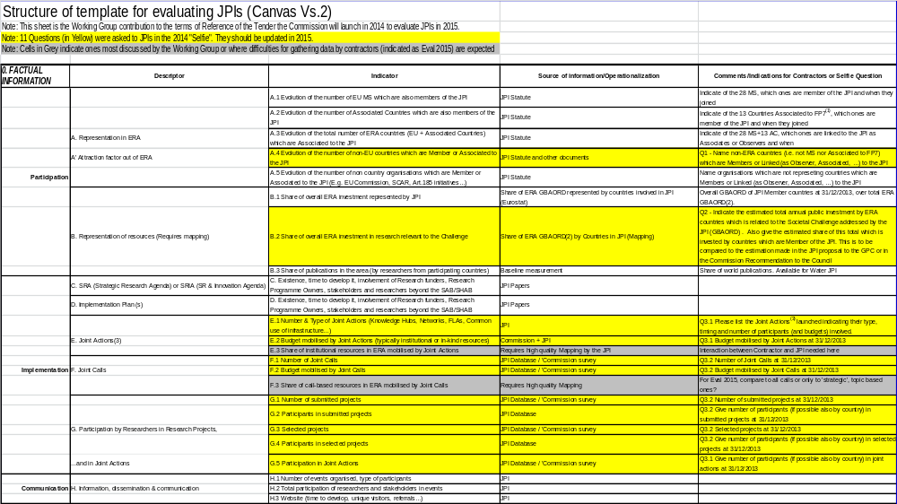
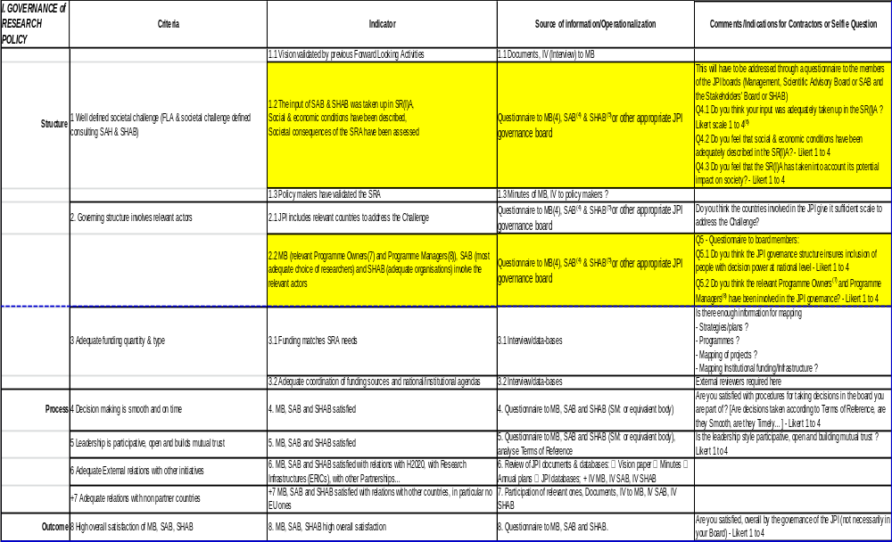
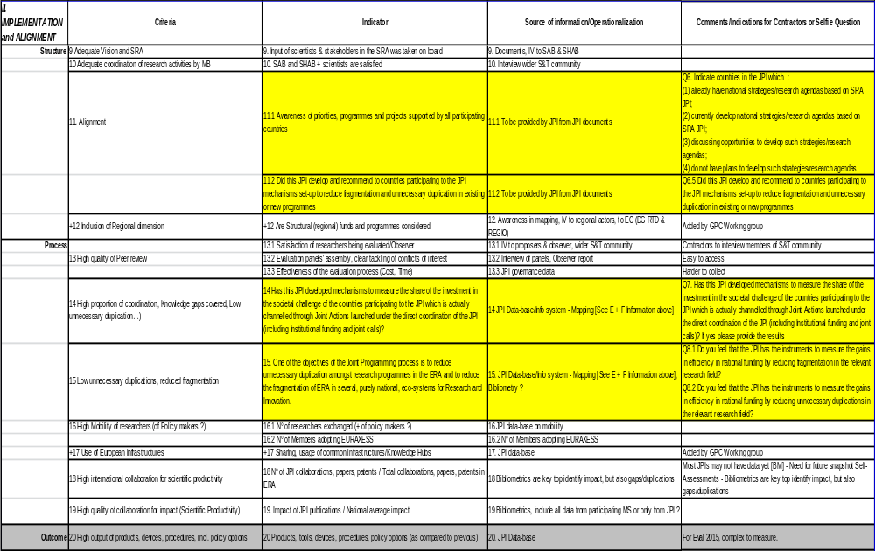
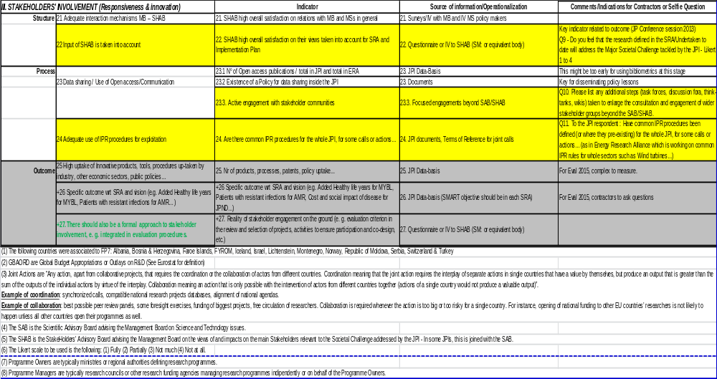
ANNEX 2 to ANNEX 4
GPC Biennial Report 2014 – JPI Self-Assessment

Name of the JPI
PART I - JPI description

Please describe the JPI in your own words following the indications below

Q1. The Challenge addressed
1.1 Describe the Challenge(s) addressed and the common agreed vision.
1.2 Describe the original Strategic Research (and Innovation) Agenda [the SR(I)A] and its timetable.
1.3 Were any SMART objectives defined by the JPI?
1.4 Did this JPI define any Indicator to assess its performance in relation to the objectives?
1.5 If yes, please list them
Pse use Time New Roman 11 fonts for your reply (200-300 words)

Q2. The EU Added Value of this JPI
Please specify in a few sentences the specific EU added value of this JPI over existing national and/or EU level actions.
2.1. Are there already concrete outcomes demonstrating the EU added value of this JPI?
2.2. If yes, please list them.
2.3. If not, are there expected concrete outcomes demonstrating the EU added value of this JPI? Which ones?

Pse use Time New Roman 11 fonts for your reply (200-300 words)

Q3. The contribution to ERA (European Research Area) of this JPI
Please give 1 to 3 concrete examples of how the JPI has or could contribute to the wider objectives of the European Research Area and its 5 priorities.

Pse use Time New Roman 11 fonts for your reply

Q4. Usage of the Framework Conditions for Joint Programming
Describe if and how this JPI has been using the Framework Conditions for Joint Programming.

Pse use Time New Roman 11 fonts for your reply

4.1 Forward Looking Activities.

4.2 Peer review procedures.

4.3 Funding of Cross-Border research.

4.4 Optimum dissemination and use of research findings.

4.5 Protection, management and sharing of IPR.

4.6 Evaluation of Joint Programmes.

Q5. Other relevant comments

Pse indicate who is the contact person responsible for preparing this report on behalf of the JPI and who can be contacted in case the GPC had any questions
Name:
E-mail address:
Telephone:

PART II – JPI data and indicators

2. JPI Factual Descriptors

Q1. Name third countries which are Members or Linked (as Observer, Associated…) to the JPI.
Pse use Time New Roman 11 fonts for your reply

Q2. Indicate the estimated total annual public investment by ERA countries which is related to the Societal Challenge addressed by the JPI (GBAORD). Also give the estimated share of this total which is invested by countries which are Member of the JPI.
Pse use Time New Roman 11 fonts for your reply

Q3. List the Joint Actions launched under the direct coordination of the JPI, indicating their type, timing and number of participants involved.

Q3.1. Indicate the budget mobilised by Joint Actions other than Joint Calls at 31/12/2013 and number of participants (if possible also by country) involved.
Pse use Time New Roman 11 fonts for your reply

Q3.2 Indicate the number of Joint Calls launched or foreseen and the budget they have or will each mobilise
Indicate how many projects were submitted and how many were selected under joint calls which closed before 31/12/2013. Give also the number of participants (if possible also by country) in submitted and selected projects at 31/12/2013.
Topic | Num  Countries | Public  Fund M€ | Submitted Proposals | Num  Partners | Selected Projects | Num  Partners
1. Call on …(Year)
2. Call on …(Year)
3. Call on …(Year)
TOTAL
Calls foreseen to be launched  4. Joint Call Year  5. Joint Call Year  6. Joint Call Year  7. Joint Call Year  … | XX  XX  XX  XX | XX M€  XX M€  XX M€  XX M€
Calls foreseen to be launched
TOTAL

3. JPI Governance of Research Policy

These questions (in red) will have either to be answered by the Chair(s) of the relevant JPI Management board(s) or addressed through a short questionnaire to the members of the JPI boards (Management, Scientific Advisory Board or SAB and the Stakeholders' Board or SHAB or equivalent bodies)

Q4.1 Do you feel that your input was adequately taken up in the SR(I)A?
(1) Fully (2) Partially (3) Not much (4) Not at all

Q4.2 Do you feel that social & economic conditions have been adequately described in the SR(I)A?
(1) Fully (2) Partially (3) Not much (4) Not at all

Q4.3 Do you feel that the SR(I)A has taken into account its potential impact on society?
(1) Fully (2) Partially (3) Not much (4) Not at all

Response form:
Q4.1 Do you feel that the boards’ input was adequately taken up in the SR(I)A?
(1) Fully xx % (2) Partially xx % (3) Not much xx % (4) Not at all xx %

Q4.2 Do you feel that social & economic conditions have been adequately described in the SR(I)A
(1) Fully xx % (2) Partially xx % (3) Not much xx % (4) Not at all xx %

Q4.3 Do you feel that the SR(I)A has taken into account its potential impact on society?
(1) Fully xx % (2) Partially xx % (3) Not much xx % (4) Not at all xx %

Please provide any relevant comments:

Q5. One of the major challenges of the JPIs is the recruitment in its boards of the relevant stakeholders and decision takers

Q5.1 Do you think the JPI governance structure insures inclusion of people with decision making power at national level?

Q5.2 Do you think the relevant Programme Owners and Programme Managers have been involved in the JPI governance?

Q5.1 Do you think the JPI governance structure insures inclusion of people with decision making power at national level?
(1) Fully xx % (2) Partially xx % (3) Not much xx % (4) Not at all xx %

Q5.2 Do you think the relevant Programme Owners and Programme Managers have been involved in the JPI governance?
(1) Fully xx % (2) Partially xx % (3) Not much xx % (4) Not at all xx %

Please provide any relevant comments:

4. Implementation Performance - Alignment

Q6. Please indicate countries participating to the JPI which:
6.1 Already have national strategies, research agendas, programmes, priorities taking into account the JPI SR(I)A:

6.2 Are demonstrably in the process of developing national strategies, research agendas, programmes, priorities taking into account the JPI SR(I)A:

6.3 Are discussing opportunities to develop national strategies, research agendas, programmes, priorities taking into account the JPI SR(I)A:

6.4 Do not have plans to develop national strategies, research agendas, programmes, priorities taking into account the JPI SR(I)A:

Pse feel free to mention below any relevant fact you would feel of interest to the GPC linked to the alignment of national programmes, priorities and activities to the SR(I)A of the JPI.

Q6.5 Did this JPI develop and recommend to countries participating to the JPI mechanisms set-up to reduce fragmentation and unnecessary duplication in existing or new programmes?

Q6.6. If yes, please give examples

Pse use Time New Roman 11 fonts for your reply

Q7. Has this JPI developed mechanisms to measure the share of the investment in the societal challenge of the countries participating to the JPI which is actually channelled through Joint Actions launched under the direct coordination of the JPI (including Institutional funding and joint calls)?
If possible you might also give its evolution over time since the launching of the JPI.
Q7.1. If yes, have these measurements already been done?
Q7.2. If yes, please provide results

Pse use Time New Roman 11 fonts for your reply

Q8. One of the objectives of the Joint Programming process is to reduce unnecessary duplication amongst research programmes in the ERA and to reduce the fragmentation of ERA in several, purely national, eco-systems for Research and Innovation.

Q8.1 Do you feel that the JPI has the instruments to measure the gains in efficiency in national funding by reducing fragmentation in the relevant research field?

Q8.2 Do you feel that the JPI has the instruments to measure the gains in efficiency in national funding by reducing unnecessary duplications in the relevant research field?
8.1 Do you feel that the JPI has the instruments to measure the gains in efficiency in national funding by reducing fragmentation in the relevant research field?
[Pse Cross replies that do not apply]
(1) Yes, completely (2) Yes, partly (3) Only partially (4) Not at all

8.2 Do you feel that the JPI has the instruments to measure the gains in efficiency in national funding by reducing unnecessary duplications in the relevant research field? [Pse cross replies that do not apply]
(1) Yes, completely (2) Yes, partly (3) Only partially (4) Not at all

Please provide any relevant comments:

5. Responsiveness and Innovation (or Involvement of Stakeholders)

Questionnaire to be answered by the Chair(s) of the relevant JPI Management board(s) or addressed through a short questionnaire to the members of the JPI boards
Q9. Do you feel that the research defined in the SR(I)A/Undertaken to date will address the Major Societal Challenge tackled by the JPI?
(1) Yes, completely xx% (2) Yes, partly xx% (3) Only partially xx% (4) Not at all xx%

Q10. List any additional steps (task forces, discussion fora, think-tanks, wikis…) taken to enlarge the consultation and engagement of wider stakeholder groups beyond the SAB/SHAB.
Pse use Time New Roman 11 fonts for your reply

Q11. Have common IPR procedures been defined (or where they pre-existing) for the whole JPI, for some calls or actions… (as in Energy Research Alliance which is working on common IPR rules for whole sectors such as Wind turbines…)?

Pse use Time New Roman 11 fonts for your reply

Comments
Please feel free to add any point you feel would more completely describe the JPI, its governance, implementation, impact…

Pse use Time New Roman 11 fonts for your reply

ANNEX 5
THE RESULTS OF THE SELF-ASSESSMENT EXERCISE OF THE HIGH LEVEL GROUP FOR JOINT PROGRAMMING (GPC)

A. Background of the GPC self-assessment
On 30 May 2013 the Council adopted a resolution on the advisory work for the European Research Area (doc. 10331/13) in which it agreed to review the ERA-related groups established by it:
5. AGREES that the statuses, the mandates and the reporting lines of those ERA-related groups that have been established by the Council should be reviewed by the end of 2014 and INVITES the Commission and the Committee itself to consider whether such a review is required in relation to the groups that they have established; such reviews could be carried out on the basis of (1) an assessment of the extent to which mutual cooperation, consultation and coordination as called for by the Council have effectively been achieved, (2) the timeliness and effectiveness of their advice, and (3) the efficiency of the functioning of these groups;
The GPC at its plenary meeting of 19 May 2014 had decided to undertake a self-assessment exercise of its activities. The following Council acts have been taken into account:
- The GPC mandate: Council conclusions of 3 December 2008 concerning joint programming of research in Europe in response to major societal challenges (OJ 2009/C 24/04).
- The Council conclusions regarding the activities of the GPC:
- Council conclusions on the Progress in the Joint Programming process (doc. 17166/10).
- Council conclusions on the development of the European Research Area (ERA) through ERA-related Groups (doc. 11032/11).
- Council conclusions on A Reinforced European Research Area Partnership for Excellence and Growth (doc. 17649/12).
- Council Conclusions on European Research Area Progress (doc. 6945/14).
- The Council resolution of 30 May 2013 on the advisory work of the European Research Area (doc. 10331/13).

Also, at the same plenary meeting it was decided to perform the self-assessment by means of a questionnaire. The delegations agreed also that on the basis of the results of the assessment, the status, the mandate and the reporting lines of the GPC should be reviewed. The following delegations provided answers to the questionnaire: Austria, Belgium, Czech Republic, Denmark, Finland, France, Greece, Hungary, Ireland, Italy, Malta, Norway, Slovakia, Sweden. More detailed analysis of the replies provided by the delegations is set out in the Annex.

B. Key messages of the GPC self-assessment
- The GPC found that all the activities it was entrusted with by the Council in its mandate were addressed. Some of the activities were either successfully completed or in progress, while others needed to be enhanced. Moreover, the respondents found that many of the GPC activities are of an ongoing nature.
- Although the GPC provides advice which contributes, either directly or indirectly, to the implementation and monitoring of progress of the Innovation Union, and more particularly the ERA, as well as to the debates of the Competitiveness Council, it was found that more high profile Council level debates on the joint programming process should be organised together with a more active advisory role of the GPC vis-à-vis the initiatives resulting from the Joint Programming Process (JPP).
- The cooperation between the GPC, the ERAC and the other ERA-related groups should be enhanced and redesigned according to more formal and structured lines. It should also be backed with an increased internal cooperation of all the relevant delegates at the national level.
- Although the GPC seems to function well, some changes could be useful. More delegates should be more actively involved, especially in the highly appreciated context of the well functioning system of the ad hoc working groups.

- The GPC would wish to see its mandate updated. Should that be decided, the GPC would see itself as a strategic forum discussing not only the JPP but also other relevant aspects of the European Research Area, in particular the area of transnational cooperation. The GPC would also like to have its role much strengthened in relation to the initiatives resulting from the JPP (hereafter "the initiatives").
- The GPC could participate in the preparation of the relevant aspects of the ERA roadmap.

C. Results of the GPC self-assessment questionnaire
Assessment of the GPC activities described in the GPC mandate
In general the GPC delegations found that all the GPC activities as described in the GPC mandate were addressed. Many activities of the GPC have been successfully completed. The respondents also listed many activities which are in progress, often because of the continuous nature of these activities. Moreover, some further activities have been found which, in the views of the delegations, would need to be deepened.
More particular, the following points were raised:
- The GPC has successfully completed the tasks of identifying the possible themes for joint programming as well as evaluating of the proposals for the JPP since altogether 10 joint programming initiatives have been launched so far:
- Alzheimer and other Neurodegenerative Diseases
- Agriculture, Food Security and Climate Change
- A Healthy Diet for a Healthy Life
- Cultural Heritage and Global Change: A New Challenge for Europe
- More Years, Better Lives – The Potential and Challenges of Demographic Change
- Healthy and Productive Seas and Oceans
- Urban Europe - Global Urban Challenges, Joint European Solutions
- Connecting Climate Knowledge for Europe
- Water Challenges for a Changing World
- The Microbial Challenge – An Emerging Threat to Human Health.

- The majority of the delegations were of the opinion that at this stage there seems not to be an urgent need for the identification of new themes for joint programming. However, should it change in the future, the GPC should continue to lead the process of the identification of the themes for the possible future new initiatives with a careful consideration of the best suitable themes and activities to be implemented as joint programming initiatives.
- The majority of delegations pointed out that the core activities of the GPC as described in its mandate, such as the peer review procedures, the consideration of a coherent approach to foresight activities, the evaluation of joint programming, funding of cross border research by national or regional authorities, the optimum dissemination and use of research findings, involvement of the various scientific and, where appropriate, research communities were addressed in Voluntary guidelines on framework conditions for joint programming in research 2010, and also in the Biennial Report adopted in 2012.
- It was also mentioned that the peer review procedures were undertaken at the level of the ongoing JPIs. They were as well debated by the JPIs to Co-Work project. Moreover, the peer review procedures are the subject for the work currently in progress undertaken by the GPC as they are being taken into account by the GPC ad hoc Working Groups on Framework Conditions and on Measuring Progress and Impact. Some delegations also underlined that though much has been already done, there is still a need to intensify this important activity.
- Regarding the foresight activities the delegations pointed out that in 2013 there were contacts between the GPC and the European Forum on Forward Looking Activities (EFFLA) and a joint workshop between the GPC and EFFLA took place in Brussels.
- The majority of the respondents perceived the evaluation of joint programming as an ongoing process which currently is specifically dealt with by the ad hoc GPC Working Group on Measuring Progress and Impact. Moreover, some delegations emphasised that the evaluation of the joint programming process is a very important activity and therefore should be given much attention, or even priority within the GPC.
- The respondents pointed out that the funding of cross border research by national or regional authorities is a very important but complex subject and it should be given further due consideration and time within the GPC and also in other international fora.

- As far as the effective measures to ensure the optimum dissemination and use of research findings are concerned, the delegations mentioned that at present they are part of the discussions conducted at the GPC ad hoc Working Group on Framework Conditions. As to the sharing of intellectual property rights (IPR), there were specific comments that the IPR aspects are mainly dealt with at the level of the JPIs and that the IPR management should be harmonised in the JPI projects.
- As regards the involvement of the various scientific and, where appropriate, industry communities, the delegations pointed out that the scientific and industry communities are involved at the level of the JPIs and that the GPC could play a supportive role in this aspect. The respondents noticed also that many speakers invited at the GPC plenary meetings come from academia.
- The delegations stressed that the GPC has successfully prepared in 2010 Voluntary guidelines on Framework Conditions for joint programming in research. Some respondents were of the view that the Framework Conditions have been addressed by the JPIs while others stressed their voluntary nature and found it difficult to assess their real impact. The respondents pointed also out that the Framework Conditions are currently under review by the GPC ad hoc Working Group on Framework Conditions.

Assessment of the GPC advice
As far as the assessment of the GPC advice is concerned the following remarks could be mentioned:
- The delegations were of the opinion that the GPC should function and in fact is functioning at the strategic level.
- The majority of the respondents found as well that the GPC continuously contributes towards supporting the implementation and monitoring of progress of the Innovation Union, in particular through the joint research activities of the initiatives.
- The GPC also continuously contributes to the preparation of the debates and decisions of the Competitiveness Council on joint programming. The following examples of such actions were given:
- the GPC Biennial Reports are presented to the Competitiveness Council;
- the GPC contributes to ERAC opinions;
- Member States, through their GPC delegates, arrange for policy debates on the JPP (e.g. under the Irish Presidency in 2013). In some delegates' opinions more debates on joint programming should be organised.
- The delegations noted as well the GPC's efforts in the area of the contribution to the monitoring of ERA progress based on the exchange of best practices and mutual learning from national actions and reforms made to achieve the ERA. The given examples included the presentations made by the delegates of their national and/or regional governance of the JPP with the aim of aligning national and regional strategies, programmes and activities with the strategic research agendas agreed at the EU level, and the oversight structures and the exchange of views that followed these presentations.
- Some delegations also stressed that the GPC has a decisive role in the guidance and monitoring of the initiatives but its advice in this area should be intensified, provided in a more timely manner and that there is a scope and need for closer cooperation between the GPC and the initiatives.

The GPC, the ERAC and the other ERA-related groups
The delegations found the issues relating to consultation, coordination and cooperation of the GPC and other ERA-related groups important and they made the following suggestions:
- Although some respondents were satisfied with the degree of cooperation, the majority were of the opinion that further efforts should be made to strengthen the cooperation and make it more efficient.
- The cooperation should be done on a more formal, systematic and pre-defined way (e.g. the Chairs of the ERA-related groups could be systematically invited to the meetings of the ERAC Steering Board in order to better coordinate with the work of the ERAC and the other groups).
- The need of an in-depth discussion between all the ERA-related groups in order to clarify the expected impact of cooperation and to discuss the mutual expectations of the groups was identified.

- The role of the internal cooperation of the delegates to the ERAC and all the ERA-related groups at the national level was specifically underlined. It should go hand in hand with the strengthening of cooperation between the groups themselves.
- The GPC could contribute to the ERA roadmap or at least should be consulted.
- Frequent invitations to the representatives of the other ERA-related groups (and also other relevant fora) as well as the correspondents' reports were found as a step in the right direction.
- The GPC could also specifically encourage the cooperation between the initiatives and the ESFRI infrastructures.

Functioning of the GPC
The delegations presented the following main remarks concerning the functioning of the GPC:
- There should be a stronger engagement from all the delegations.
- The role of the GPC towards the initiatives should be strengthened.
- The current practice of electing the Chair and the Vice-Chair from the Member States' representatives is working well.
- The Commission should play an active and supportive role.
- As regards the GPC rules of procedure: the respondents were of the opinion that the current ones are functional.
- Regarding the GPC working methods: the delegates found that discussions in the plenary meetings and the exchanges with the invited speakers are suitable working methods. Many delegations particularly stressed that the practice of forming ad hoc working groups has proved to be very efficient and productive and should be continued.

Mandate of the GPC
The delegations expressed their view that the GPC mandate, dating back to 2008, would need to be updated. Should that be the case, the following suggestions concerning the possible new mandate have been made:
- The GPC should be a strategic level forum. It could be the driver of the ERA objectives in the area of research related to common societal challenges, especially at the Member States' level. It could be a forum of foresight activities.
- The GPC could cover not only the joint programming but also all the relevant aspects of the "transnational cooperation" priority of the ERA (except the infrastructure part).
- The GPC could have an important role in the alignment processes. It could provide a forum for common discussion and prioritisation processes between Member States helping to optimise the scope of research programmes across Europe.
- The role of the GPC towards the initiatives should be enhanced. It should have a leading role in the guidance, monitoring and evaluation of those initiatives.
- The GPC should be responsible for developing good Framework Conditions for the initiatives.
- The GPC could take part in the preparation of the ERA roadmap.
- Better coordination and cooperation with ERAC and other ERA-related groups should be established.
ANNEX

This Annex presents an overview of the main results of the GPC self-assessment questionnaire concerning the core activities of the GPC as described in its mandate.
The questionnaire, prepared by the GPC and answered by the delegations, was composed of 24 questions aiming at assessing the GPC since its creation in 2008. The questions addressed the main activities of the GPC as described in the GPC mandate and various relevant Council conclusions. The questions were designed in a way to let the delegations express their views on whether the given activity was completed, is still in progress or remains to be done. It was also possible to provide free comments to each activity.

The core activities described in the GPC mandate
- Identification of the possible themes for joint programming and the evaluation of the proposals for joint programming
- Contribution to the preparation of the debates and decisions of the Competitiveness Council on joint programming
- Consideration of a coherent approach on the peer review procedures
- Consideration of a coherent approach for foresight activities and for evaluation of joint programming
- Consideration of a coherent approach to funding of cross boarder research by national or regional authorities
- Consideration of effective measures to ensure the optimum dissemination and use of research findings
- Consideration of involvement of the various scientific and, where appropriate, industry communities
- Preparation and regular review of the Framework Conditions on joint programming

- Identification of the possible themes for joint programming and the evaluation of the proposals for joint programming
All delegations were of the opinion that the GPC has identified the possible themes for joint programming and evaluated them as 10 of the Joint Programming Initiatives have been identified (and launched by the Council). Moreover, 15% of the respondents pointed out that the process may still continue in the future as the new initiatives may be identified.
The key comments:
- The process is currently not continuous as the number of the JPIs is considered sufficient for the time being. There has been no further identification of topics for new JPIs since the second wave was launched in 2011.
- The themes for the 10 first JPIs were identified following a bottom-up approach. There is no urgent need, at this stage, to identify new themes for new JPIs. Priority should be given first to: a foresight exercise considering challenges to be addressed at the European level, an analysis of the Member States' capacity to commit to new initiatives and the impact of the already existing ones, the evaluation of the ongoing JPIs.
- Preference is given to the support of the actual JPIs over the elaboration of the new ones.
- If in the future it would be decided to select new themes, it would be important to plan and define the process carefully and early enough and do it in an open and transparent way. There should be careful consideration which themes and activities could be best implemented as joint programming activities.

- Contribution to the preparation of the debates and decisions of the Competitiveness Council on joint programming

Almost 80% of the respondents assessed that the GPC has and is being contributed to the debates and decisions of the Competitiveness Council on joint programming.

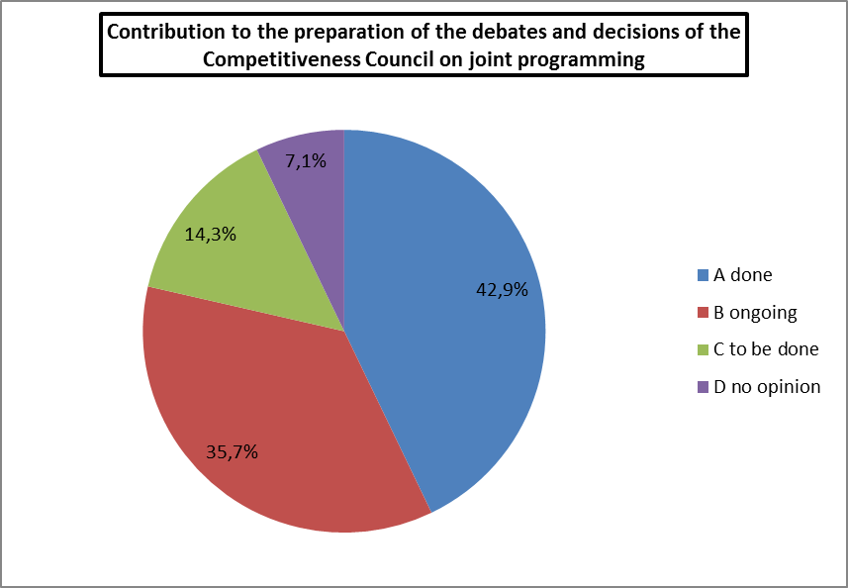

The key comments:
- Contribution to the preparation of the debates and decisions of the Competitiveness Council on joint programming is a continuous process and an ongoing function.
- New debates on joint programming are needed to encourage further implementation.
- The main contributions: Biennial Reports, contributions to ERAC opinions presented to the Council, preparation for discussions in the framework of the Presidency (e.g. the Irish Presidency in 2013).

- Consideration of a coherent approach on the peer review procedures
More than 20% of the respondents considered that the GPC addressed the peer review procedures, while half of the respondents saw the process as ongoing.

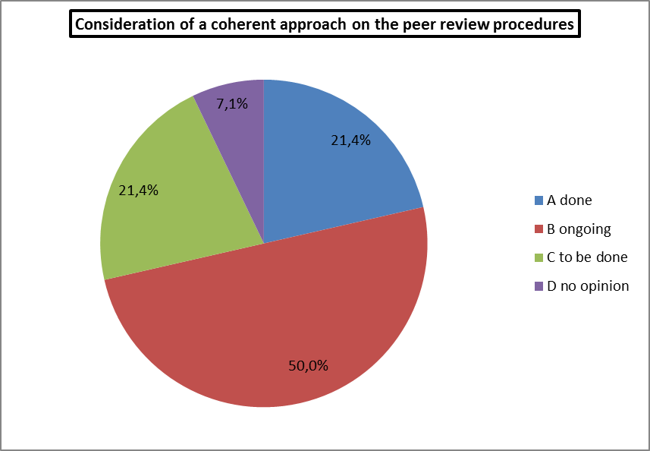

The key comments:
- This activity needs to be intensified in the GPC.
- In this respect, the use of the deliverables of the GPC to Co-Work project needs to be improved.
- This complex task is undertaken within the JPIs.

- Consideration of a coherent approach for foresight activities and for evaluation of joint programming

More than half of the delegations were of the opinion that the process of the consideration of the coherent approach for foresight activities and for evaluation of joint programming is underway.

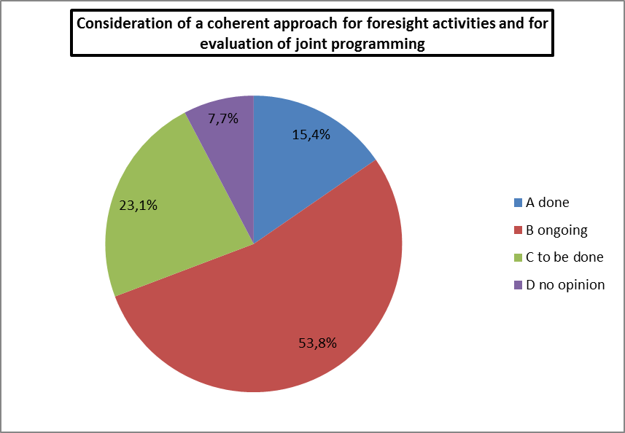

The key comments:
- The evaluation activities of the GPC need to be intensified.
- The evaluation of the JPIs should be one of the main areas of activities undertaken by the GPC.
- Self-evaluation processes have been driven by some JPIs.
- A more general foresight approach should be adopted by the GPC in order to assess the possible need for additional initiatives.
- Consideration of a coherent approach to funding of cross boarder research by national or regional authorities

The majority of the respondents found that the GPC is tackling with the coherent approach to funding of cross border research by national or regional authorities.

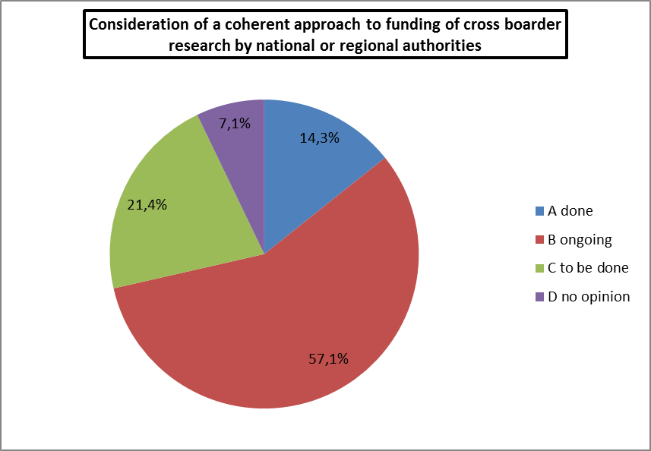

The key comments:
- The issues of funding of cross border research should be given due consideration within the GPC. The examples could include: options for harmonising rules for R&I funding, potential for establishing an ERA Mark Label for Programmes/Funders, options for alignment of the national R&I Strategies.
- If a coherent procedure is to be understood as a procedure giving open access to all research funds in all the Member States, it is not considered realistic to reach a common agreement within short time. It is an important decision but probably not an issue which could be solved by the GPC alone. It is however important to deal with this issue at the GPC level, as well as the level of other international fora.
- Consideration of effective measures to ensure the optimum dissemination and use of research findings

Every fifth delegation considered that the GPC has successfully dealt with the measures to ensure the optimum dissemination and use of research findings, while more than 40% of the respondents saw the process in progress.

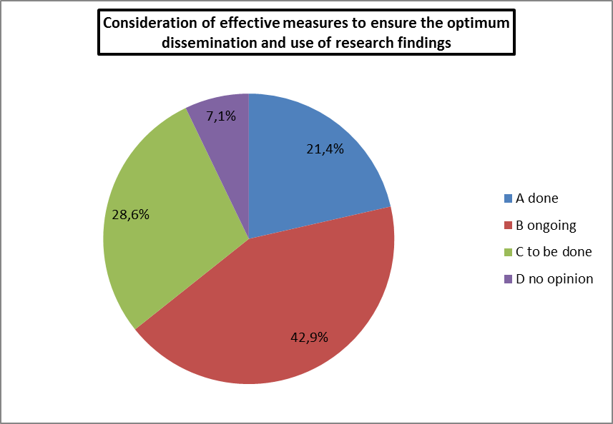

The key comments:
- While there has been consideration of measures to ensure the optimum dissemination and use of research findings, there has been less effort to ensure the implementation of such measures.
- This task is mainly performed at the level of the JPIs. There is a clear need to harmonise the IPR management in the JPI projects.
- It is important to ensure dissemination of the research results. Therefore, it is important to engage end users and industry in the research activities.
- The GPC should use its channels to support dissemination.
- Consideration of involvement of the various scientific and, where appropriate, industry communities

Almost 30% of the respondents considered that this task has been done, whereas more than 40% saw the task as being dealt with.

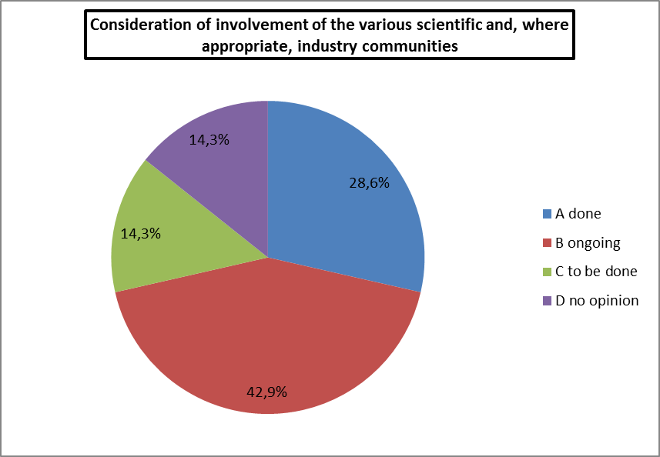

The key comments:
- Involvement of scientific and industry communities could be an activity for the JPIs and is undertaken by some, if not all, of them. The GPC could be supportive.
- Each Member State has the responsibility to engage the relevant research communities and industry in the ongoing work in the JPIs, including drafting of strategies and applications for funding.

- Most of the invited speakers in the GPC meetings come from academia.
- There are good examples at the level of the JPIs (e.g. JPI Urban Europe due to the requirement of funding schemes, such as ERA NET Smart Cities and Communities). Scientific and industry communities have been involved in the governance and processes of the ten JPIs.

- Preparation and regular review of the Framework Conditions on joint programming
The huge majority of the respondents remarked that the GPC prepares and reviews regularly the Framework Conditions on joint programming.

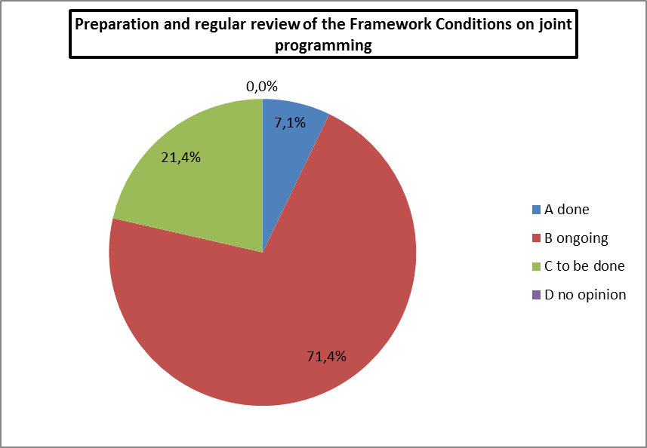

The key comments:
- The implementation of the Framework Conditions varies from one JPI to another.
- It is difficult to assess the GPC in the context of the use of the Framework Conditions because of their voluntary nature.
- The guidelines are a good starting point and the JPIs could benefit from a further development of the guidelines in the following years.
The ongoing work to update the Framework Conditions is a step forward. There is a need to give concrete guidelines and examples, how to achieve efficient cooperation and coordination of national programmes, including both institutional and competitive funding programmes.
ANNEX 6
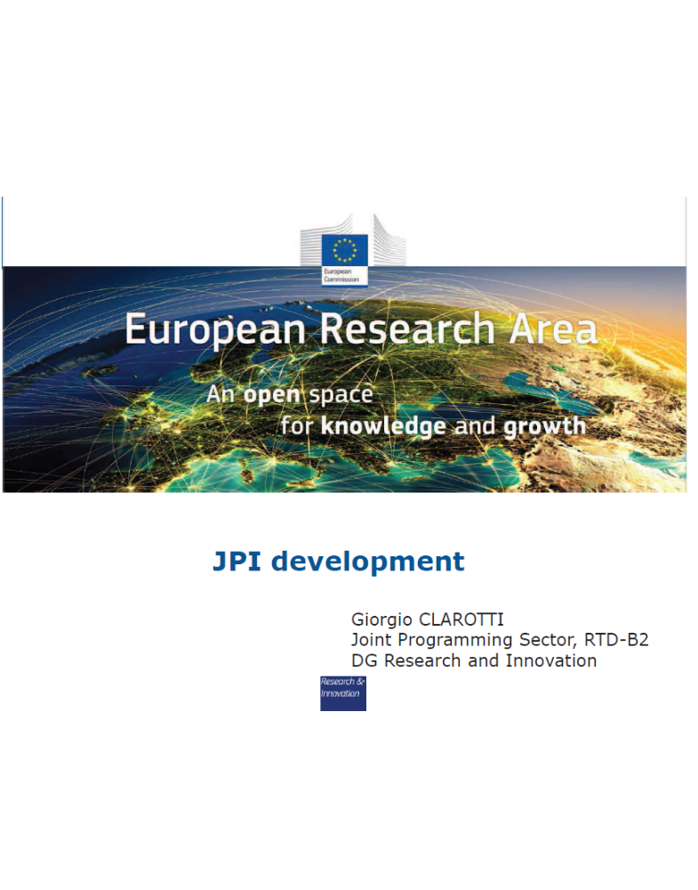
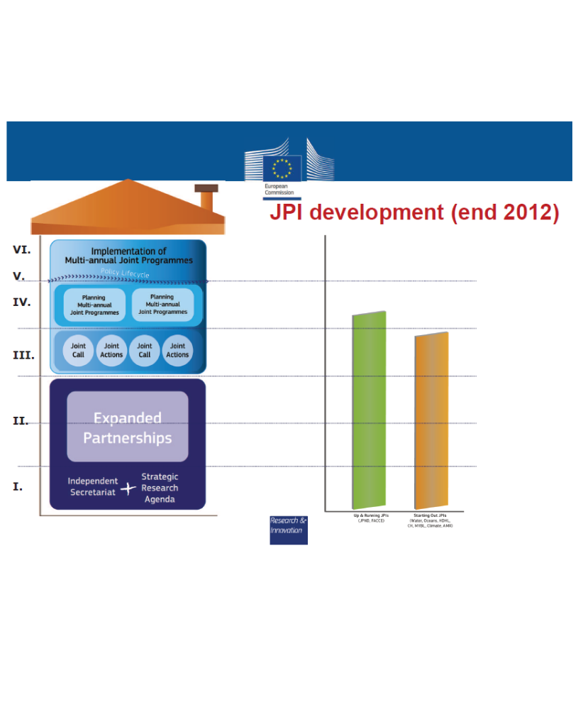
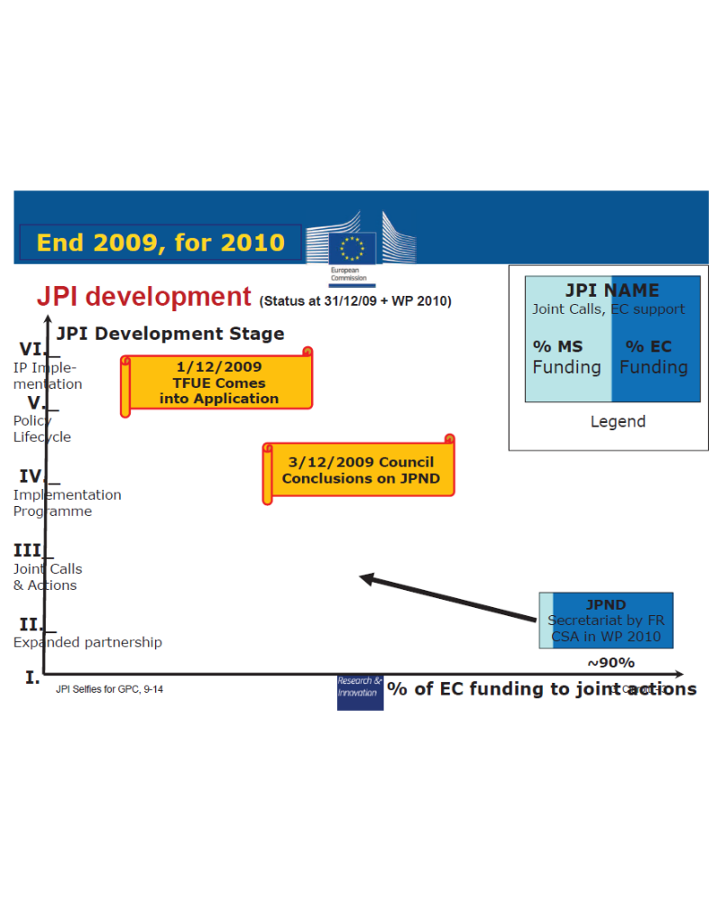
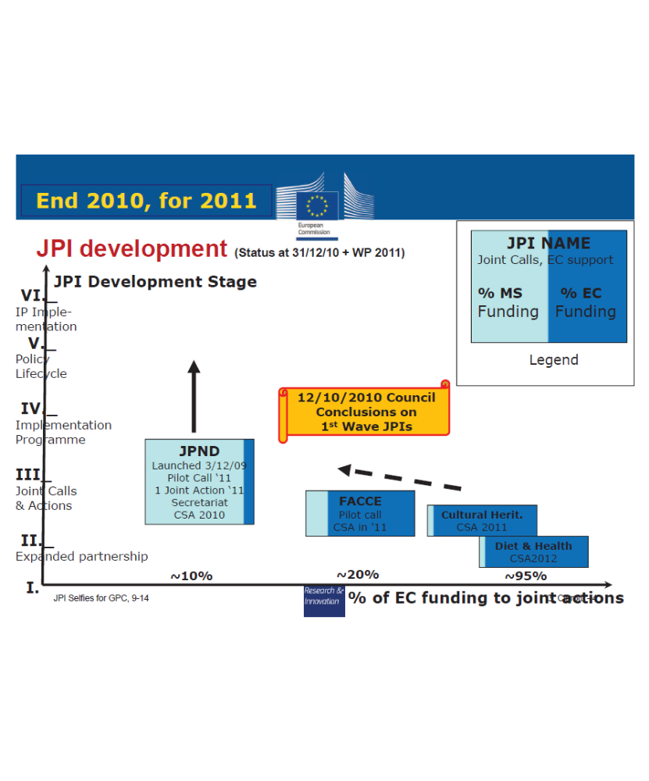
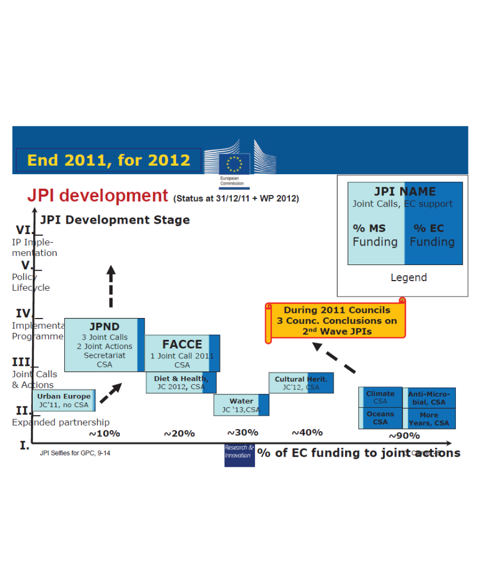
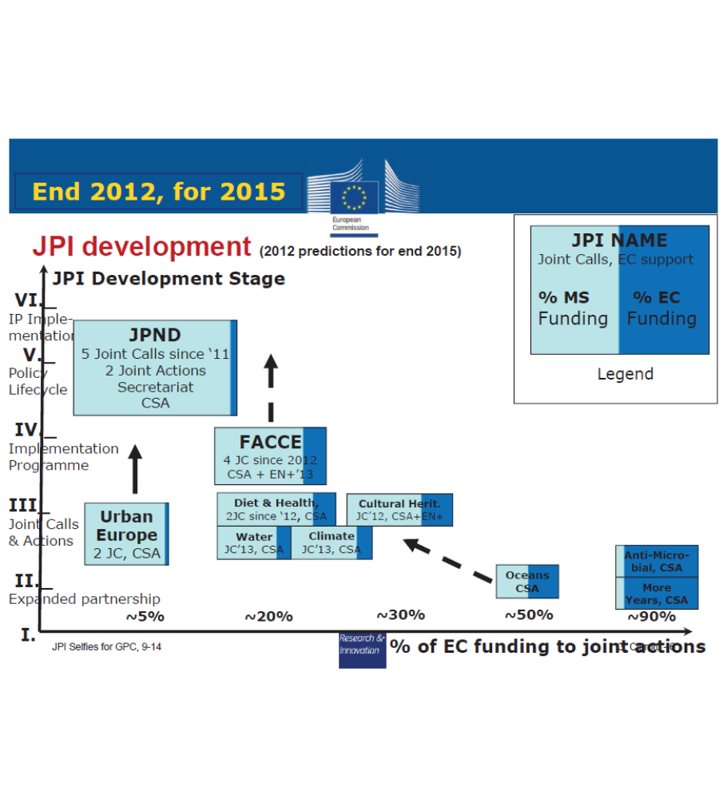
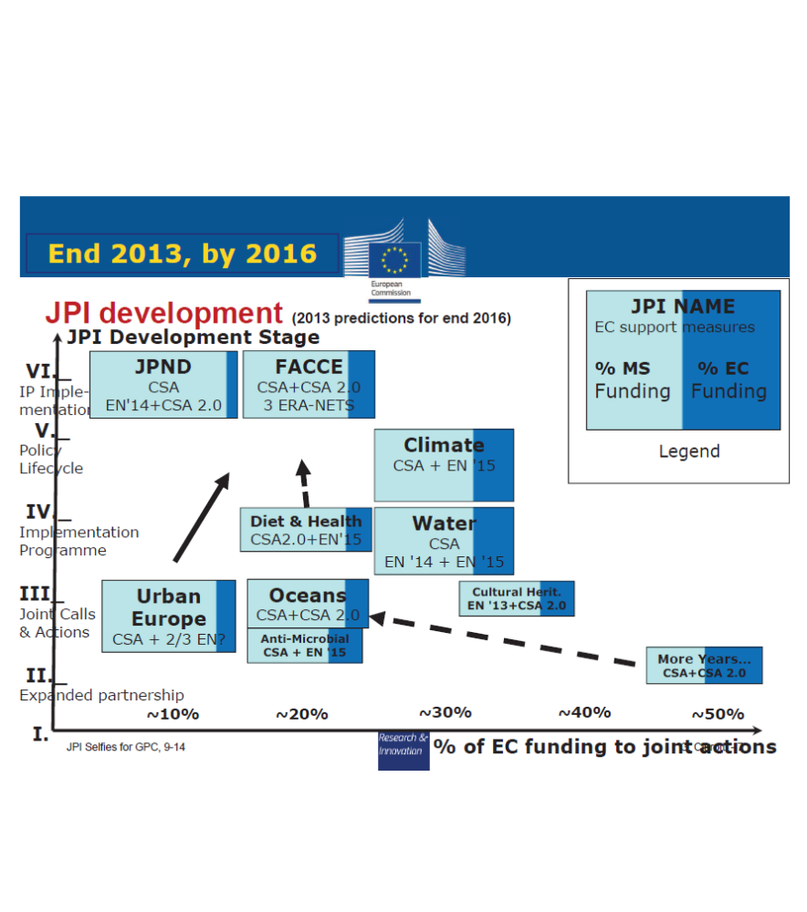
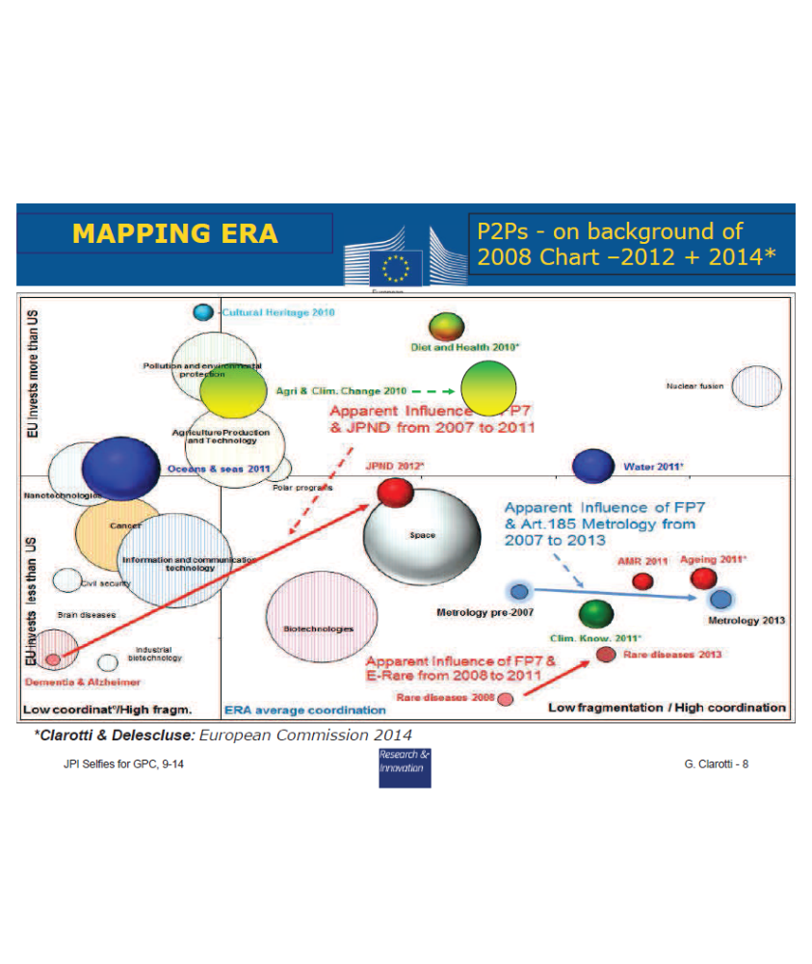
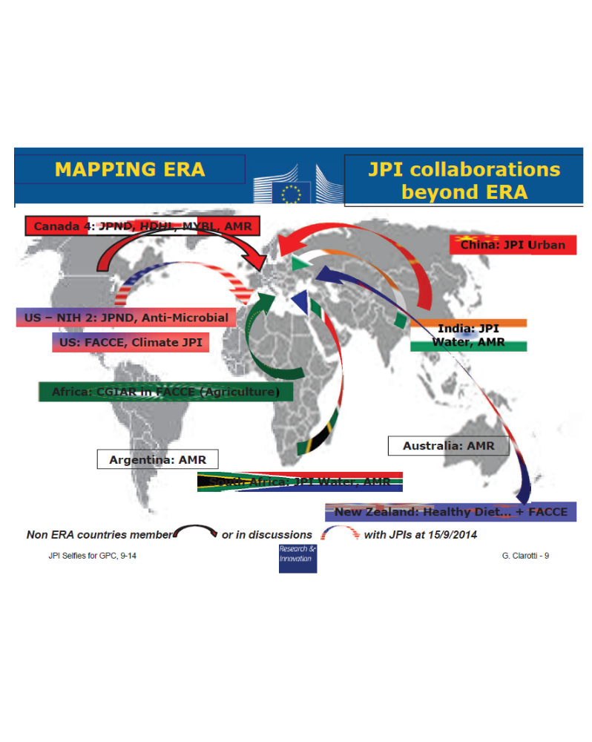

Specific, Measurable, Adequate/Achievable, Realistic/Relevant and Time-related (Peter Drucker, "Management Tasks, Responsibilities, Practices", Harper & Row, 1973)
Commission Recommendation of 16 September 2011, on the research Joint Programming Initiative ‘Healthy and Productive Seas and Oceans’, (2011/C 276/01)
Article 181 of TREATY ON EUROPEAN UNION (TEU) 1. The Union and the Member States shall coordinate their research and technological development activities so as to ensure that national policies and Union policy are mutually consistent. 2. In close cooperation with the Member State, the Commission may take any useful initiative to promote the coordination referred to in paragraph 1, in particular initiatives aiming at the establishment of guidelines and indicators, the organisation of exchange of best practice, and the preparation of the necessary elements or periodic monitoring and evaluation. The European Parliament shall be kept fully informed.
Article 13 Horizon 2020 - the Framework Programme for Research and Innovation 1. For the implementation of Horizon 2020, account shall be taken of the need to build appropriate synergies and complementarities between national and European research and innovation programmes, for example in areas where coordination efforts are made through the Joint Programming Initiatives. 2. Union support to Joint Programming Initiatives may be considered with any support to be delivered through the instruments referred to in Article 26, subject to the conditions and criteria laid down for such instruments.
Official Journal, 30.01.2009, C 24/6, Mandate of the High Level Group on Joint Programming (GPC)
COM (2012) 392 final, ERA Communication: A reinforced European Research Area Partnership of Excellence and Growth, Pg 7
Article 13 Horizon 2020 - the Framework Programme for Research and Innovation 1. For the implementation of Horizon 2020, account shall be taken of the need to build appropriate synergies and complementarities between national and European research and innovation programmes, for example in areas where coordination efforts are made through the Joint Programming Initiatives. 2. Union support to Joint Programming Initiatives may be considered with any support to be delivered through the instruments referred to in Article 26, subject to the conditions and criteria laid down for such instruments.
Source: Eurostat, DG Research and Innovation and IPTS calculations: Total EU-27 GBOARD minus funding for transnationally coordinated research, minus FP-programme funding (for 2010)
GBOARD: Government Budget Appropriations or Outlays for Research and Development
Arnold, Erik et alia: “Understanding the Long Term Impact of the Framework Programme” Final report, December 2011
IPTS' calculations based on EUROSTAT data for 2010, see ERA Communication Synthesis Report 2013: http://publications.jrc.ec.europa.eu/repository/bitstream/111111111/30386/1/ipts_erasynthesisreport_final.pdf; p. 24
Commission Communication COM(2008) 468 final: “TOWARDS JOINT PROGRAMMINGIN RESEARCH: Working together to tackle common challenges more effectively”
Report of the ERA Expert Group: Challenging Europe’s Research: Rationales of the European Research Area (ERA); 2008
The Lund Declaration: Europe must focus on the grand challenges of our time; July 2009
Acheson Helena et alia: "Review of the Joint Programming Process"; Final Report of the Expert Group (October 2012); http://ec.europa.eu/research/era/pdf/jp-expert-group-22102012-report_en.pdf
[ 1]As this is organised differently in the various Member States/Associated States, the responsibility lies with the national level to determine who these national programming authorities are.
Doc. 16775/08, 3 Dec. 2008
Briefing Paper of the Workshop in Warsaw, 18 – 19 December 2012 on “Framework Conditions of the Early Phase of Joint Programming Initiatives – GOVERNANCE and EVALUATION Principles”; JPIs To Co Work
OECD (2012), Meeting Global Challenges through Better Governance: International Co-operation in Science, Technology and Innovation, OECD Publishing.
The First three items taken from: Summary Paper of the Workshop in Warsaw, 18 – 19 December 2012 on “Framework Conditions of the Early Phase of Joint Programming Initiatives – GOVERNANCE and EVALUATION Principles”; JPIs To Co Work
OECD (2012), Meeting Global Challenges through Better Governance: International Co-operation in Science, Technology and Innovation, OECD Publishing.
European Commission (2011,) Framework Conditions for Joint Programming in Research — Voluntary Guidelines 2010
The main difference to online surveys is that participants can interact and therefore create more added value. For examples, see Haegeman et al (2012).
A citizens’ jury is a means for obtaining informed citizen input into policy decisions. For a full description, see Slocum (2003).
Voluntary Guidelines 2010
Voluntary Guidelines 2010
See also the VG 2010, “phases of the Joint Programming Cycle”, page 24
For an overview of design principles for embedding foresight in transnational research programming, see Könnölä & Haegeman (2012).
In the EU27, on average around half of GBAORD is estimated to be institutional funding (Doussineau et al, 2013).
According to the results of JPIs ToCoWork Work Package 5: IV Workshop (October 2013, Stockholm), http://www.jpis2cowork.eu/images/workshop/IV-WS/3-JPIsTOCO-WORK_survey_outcome.pdf
According to the results of JPIs ToCoWork Work Package 5: IV Workshop (October 2013, Stockholm), http://www.jpis2cowork.eu/images/workshop/IV-WS/3-JPIsTOCO-WORK_survey_outcome.pdf
OECD (2012), The OECD Innovation Strategy: Getting a Head Start on Tomorrow, OECD Publishing
As shown in the JOREP study
Specific, Measurable, Adequate/Achievable, Realistic/Relevant and Time-related (Peter Drucker, "Management Tasks, Responsibilities, Practices", Harper & Row, 1973)
‘Towards Joint Programming in Research’, COM(468) 15 July 2008
Specific, Measurable, Adequate/Achievable, Realistic/Relevant and Time-related (Peter Drucker, "Management Tasks, Responsibilities, Practices", Harper & Row, 1973)
Joint Actions are “Any action, apart from collaborative projects, that requires the coordination or the collaboration of actors from different countries. Coordination meaning that the joint action requires the interplay of separate actions in single countries that have a value by themselves, but produce an output that is greater than the sum of the outputs of the individual actions by virtue of the interplay. Collaboration meaning an action that is only possible with the intervention of actors from different countries together (actions of a single country would not produce a valuable output)”. Example of coordination: synchronized calls, compatible national research projects databases, alignment of national agendas. Example of collaboration: best possible peer review panels, some foresight exercises, funding of biggest projects, free circulation of researchers. Collaboration is required whenever the action is too big or too risky for a single country. For instance, opening of national funding to other EU countries’ researchers is not likely to happen unless all other countries open their programmes as well.
For instance, some JPIs appear to think that measuring joint calls or patents means that the GPC is implicitly suggesting that the more joint calls or the more patents, the better, irrespective of the context or the specific JPI.
SMART Objectives are Specific, Measurable, Adequate/Achievable, Realistic/Relevant and Time-related (Peter Drucker, 1973)
See ERA and its priorities: http://ec.europa.eu/research/era/index_en.htm
See the Guidelines on Framework Conditions for Joint Programming: http://ec.europa.eu/research/era/docs/en/voluntary_guidelines.pdf
Countries which are neither member of the EU or countries that were associated to FP7. The following countries were associated to FP7: Albania, Bosnia & Herzegovina, Faroe Islands, FYROM, Iceland, Israel, Lichtenstein, Montenegro, Norway, Republic of Moldova, Serbia, Switzerland & Turkey.
GBAORD are Global Budget Appropriations or Outlays on R&D (See Eurostat for definition)
Joint Actions are Joint Calls or “Any action, apart from collaborative projects, that requires the coordination or the collaboration of actors from different countries. Coordination meaning that the joint action requires the interplay of separate actions in single countries that have a value by themselves, but produces an output that is greater than the sum of the outputs of the individual actions by virtue of the interplay. Collaboration meaning an action that is only possible with the intervention of actors from different countries together (actions of a single country would not produce a valuable output)”. Example of coordination: synchronized calls, compatible national research projects databases, alignment of national agendas. Example of collaboration: best possible peer review panels, some foresight exercises, funding of biggest projects, free circulation of researchers. Collaboration is required whenever the action is too big or too risky for a single country. For instance, opening of national funding to other EU countries’ researchers is not likely to happen unless all other countries open their programmes as well.
The SAB is the Scientific Advisory Board advising the Management Board on Science and Technology issues. The SHAB is the StakeHolders' Advisory Board advising the Management Board on the views of and impacts on the main Stakeholders relevant to the Societal Challenge addressed by the JPI - In some JPIs, this is joined with the SAB.
Programme Owners are typically ministries or regional authorities defining research programmes. Programme Managers are typically research councils or other research funding agencies managing research programmes independently or on behalf of the Programme Owners.

